Final Report for World Bank and infoDev
The Network Revolution and the Developing World


Analysys Report Number 00-216
13 March 2003
Contents
The Network Revolution and
the Developing World
Final Report

0 Summary v
0.1 ‘New Networking’ will have a radical impact in the developed world vii
0.2 ‘New Networking’ Offers major opportunities to the developing world xii
0.3 ‘New Networking’ presents significant threats to the developing world xvi
0.4 The balance of threats and opportunities for developing countries xvii
0.5 Policies and programmes can materially improve developing world outcomes xx
1 The ‘Network Revolution’ 1
1.1 The changing role of networking in the economy and society 2
1.2 The structure of this report 4
2 ‘New Networking’ and the developed world 7
2.1 Supply-demand mechanisms 8
2.2 Mechanisms within the networking sector 23
2.3 Unpredictable outcomes 27
2.4 Quantifying the Network Revolution in the developed world 34
3 Networking and Development 41
3.1 ‘New Networking’ offers major opportunities to the developing world 44
3.2 ‘New Networking’ can present significant threats to the developing world 96
3.3 The balance of threats and opportunities for developing countries 102
3.4 Key issues arising in networking development 104
4 Developing world outcomes 107
4.1 Characterising country groups 108
4.2 Applying development scenarios 133
4.3 Quantified outcomes as projected by pyramid research 161
5 Policies and programmes 173
5.1 Why development policy and programme design is a problem 174
5.2 Approaches to overcoming policy and programme difficulties 184
5.3 Policy recommendations and suggestions 191
5.4 Recommendations and suggestions for networking programmes 207
Annex A: Literature review and bibliography A1
A.1 Introduction A1
A.2 The effect of telecoms on developing countries A3
A.3 Development trajectories A23
A.4 Policy implications A37
Annex B: Examples of worldwide initiatives on networking programs and projects
using information and communications technologies for development
Annex C: Country comparison analyses
Annex D: Bibliography

Preface
This report was commissioned and funded by the Information for Development Program (infoDev), The World Bank, to provide an update on the impact of networking on economic, social and institutional development. In many respects the report revisits the issues covered by Talero and Gaudette (1996). Many of the hypotheses and forecasts in this earlier work have stood up well over the past three years, and our work restates several of these projections with only minor changes of emphasis. However, the development clock has run on for three difficult years since Talero and Gaudette, but the pace of progress in the networking revolution has matched or exceeded their expectations. Therefore it falls to us, in 1999, to be more strident in our assertions concerning the urgent need for action and the bleak prospects for those that fail to prepare for the new global environment.
In preparing this report we have been struck by the magnitude of the threats and opportunities that co-exist for developing countries as a consequence of the networking revolution. We have also been struck by the simplicity of the basic policies and programmes needed to prepare for these threats and opportunities, even though these policies and programmes will often be challenging, unpalatable and complex to implement. The benefits of effective policy action, for national development, for national cohesion and for equality, more than justify overcoming these obstacles. The report will have achieved its goal if it encourages even a small number of protagonists to confront these difficulties and take action.

Summary
The majority population of the earth – the five billion people who live in developing countries – face a massive challenge from the networking revolution that is unfolding in the developed world. Part of the developing world will be projected into a turbulent period of rapid progress, but most will be left behind, locked into vicious circles of poverty and instability as the gap between rich and poor widens again. Even those countries that make significant progress will be exposed to stresses and strains as a consequence of the networking revolution. The right mix of national and supranational policies and programmes can enable some countries to move from being victims to beneficiaries, but only if networking development moves up the hierarchy of development priorities. The purpose of this report is to alert the unaware, convince the sceptical, and motivate those in power, so that the impact of the networking revolution on the developing world can be understood, and the most effective policies and programmes implemented.
Exhibit 0.1 (overleaf) illustrates the arguments made in this report. Many commentators continue to challenge the provocative diagnosis that underpins this report – indeed these are easy to criticise, since they cannot be based on any truly robust statistical observations or analyses. However, by the time that the shape and dynamics of the emerging networking revolution can be rigorously assessed it will be too late – the winners and losers will be fixed, and the opportunity to steer and influence outcomes will be passed. If the profile of networking development is to be raised, it must be on the basis of the available evidence, even though much of this is subjective, uncertain and contentious.
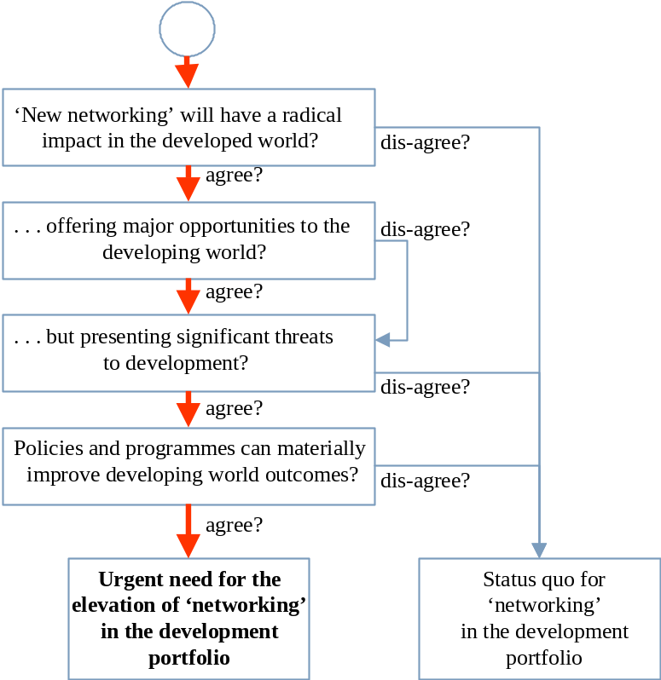 | Exhibit 0.1:  Schematic for the argument made in this report [Source: Analysys]

For those that doubt the projected benefits of networking for development, we hope to raise awareness of the dangers and threats in the coming period. A reluctant policy response to the networking revolution will further widen the development gap. An inappropriate mix of policies may significantly widen internal inequalities within a developing country.
As the Exhibit illustrates, our starting point is the impact of the networking revolution on the developed world. Although this revolution has enormous implications for the developing world, it will remain predominantly a developed world phenomenon. Its motive power and momentum in the developed world are sufficient to sustain its trajectory, because telecoms and networking are so skewed towards the developed world, as illustrated in Exhibit 0.2. However, this does not mean that the impact of the revolution will be restricted to the developed world. The impacts of new networking in the developing world will be significant, even though the mechanisms and manifestations will differ.
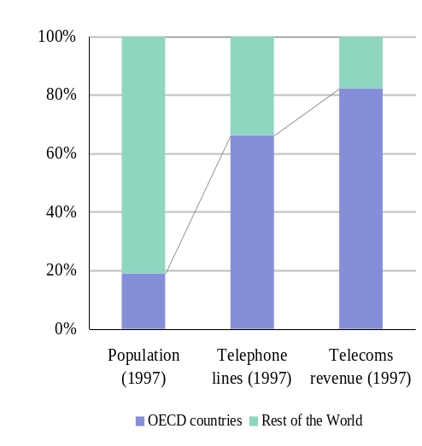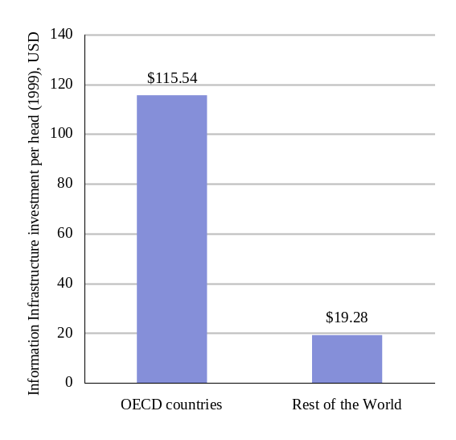
Exhibit 0.2: Telecoms and networking are massively skewed towards the developed world [Sources WDI’99, Pyramid]

‘New Networking’ will have a radical impact in the developed world
A combination of powerful technological, regulatory and demand-side developments is accelerating the development of ‘networking’. Established stable relationships are transforming into dynamic systems with ‘positive feedback’ characteristics. Such systems tend to demonstrate rapid rates of change, and extreme, unpredictable final outcomes.
Positive feedback mechanisms can be identified in nine main areas, six that link supply side and demand side effects, and three that operate within the networking sector itself. The supply-demand mechanisms are:
 | - technology cost, volume and innovation effects. The unit costs of many key networking technologies are falling at dramatic rates, due to continuing innovation and development and the economics of high-volume production. It is difficult to quantify the macro-economic impact of such rapid improvements in the cost and functionality of such important technologies, but it is plausible to suggest that there is a material impact.
 | - system development cost, risk and timescale effects. Corporations are finding that the new networking technologies are enabling complex applications to be developed more quickly, cheaply and reliably than was possible even a few years ago. This has triggered a positive feedback mechanism – large and small organisations are realising that they can embark on ambitious projects with a good prospect of success, rather than the expectation of delay, cost overrun and failure that formerly characterised such ventures. The macroscopic impacts of this step-change in corporate applications are dramatic and highly disruptive as drivers of corporate structure and strategy (see below).
 | - user expectations. As users become aware of what is possible, their expectations rise, and their dissatisfaction with inferior and obsolete products and services becomes a significant driver of demand. This effect forces technology to progress at an accelerated rate – products and services are replaced with a frequency dictated by fashion and impulse, rather than the slower evolution that would emerge from the rational trade-off of costs and benefits.
 | - competitive forces. The sight of entrepreneurs making a healthy return by creating businesses in all parts of the ‘networking’ value chain encourages other new entrants to participate. As a result, the level of innovation rises, and the increasing competitive intensity of the sector accelerates the micro-economic processes of efficiency, supply/demand balancing and price erosion to match marginal costs. This positive feedback mechanism is ultimately unsustainable and likely to lead to over-capacity, business failures, disappointing returns and consolidation, but will drive considerable progress over the next few years.
 | - ‘ecommerce’ and other network externality effects. As more suppliers and customers enter the ecommerce arena, so the benefits of participating in ecommerce grow, and the penalties for non-participation also increase. Although the saturation level is constrained – only those with access to the e-commerce space can participate – the macroscopic impacts will be enormous. The disruption will be significant, and the dynamics of the new electronic markets may be unstable and challenging.
- industry restructuring effects and financial market behaviour. Many major established corporations, in all sectors, are undertaking profound reviews of their role in the ‘new economy’. Large and small businesses are materially changing their strategies to address a changing environment. The diffusion dynamics of this process have passed the threshold point, and it is more likely that a vacillating player will choose to copy the movers rather than the sceptics.
An even more dramatic manifestation of this effect has appeared in the financial markets. Almost any corporation that can claim a linkage with new technologies or business models is able to gain an attractive valuation and easy access to funding. Of all of the positive feedback mechanisms listed here, the “irrational exuberance” of the financial markets is the most acute. The traditional mechanisms of corporate valuation are no longer being applied in a growing portion of the capital marketplace, and so far no robust alternative mechanism has emerged. The macro-economic impacts of this transition are already material and observable, particularly in the USA.
The effects that operate within the networking sector are:
 | - standardisation. Until the early 1990s networking and IT corporations had to be cajoled and coaxed away from proprietary solutions towards laboriously negotiated ‘open’ standards. However, the emergence in the 1990s of the Internet and Microsoft Windows as the two focal points for development has entirely transformed the dynamics of standardisation – key standards now have a life of their own, whether they are open (e.g. IP) or proprietary (e.g. Windows). The efficiency and innovation benefits of a standard-centric industry are massive, but the impact of these benefits have yet to be felt in full.
 | - liberalisation and re-regulation. The regulation of telecommunications, in particular, has rapidly switched from ubiquitous state-sanctioned monopoly, supported by respectable academic economists and the majority of public opinion (1980), to a widespread consensus on the benefits of liberalisation and competition (1999). This is another astonishing transition, with profound macroscopic impacts that are yet to be fully felt.
 | - confidence and risk assessment effects. Those who are witnessing the speed and scope of change – including suppliers, customers, regulators, financiers and politicians – are changing their expectations of what might be possible in the future. This may be the most subjective and contentious of all of the feedback effects listed here, and yet prove to be the most influential.
Taking all of these overlapping effects into account, we assert that the magnitude of the impact of new networking justifies the use of the term ‘revolution’, and this is the hypothesis on which this report is based.
The networking revolution can lead to a very wide range of positive and negative outcomes for developed-world economies, societies and institutions. As noted above, systems with positive feedback characteristics tend to give rise to extreme, unpredictable consequences. Examples of uncertain outcomes associated with the networking revolution include:
- Dis-intermediated markets? The easier creation of direct linkages between producers and customers implies a reduced role for intermediaries in many markets, including consumer goods, food, manufactured components and primary products. Dis-intermediation has been widely predicted by those forecasting the impact of new networking and, if occurs to any great extent, the implications for the structure and behaviour of developed economies would be very significant, and the transition period disruptive and volatile.
- Emergence of major new markets? Many commentators, corporations and entrepreneurs expect that entirely new markets will be born in the turmoil and fusion of new networking. It is hard to assess the probabilities of fulfilment of these expectations, but the atmosphere of anticipation is contributing to current volatility and disturbance.
- Destabilisation of financial markets and even whole economies? A wide range of destabilising pressures can arise in the transition to a new networking economy. New networking will have far-reaching impacts on trade patterns, on market behaviours (notably price dynamics), on patterns of corporate strategy, investment, employment and on corporate performance. Some sectors and regions will witness a concentration of corporate failures and it is conceivable that this could de-stabilise local or even national economies, requiring macro-economic interventions. The network revolution may trigger a wide range of disruptive micro- and macro-economic effects, including asset inflation or deflation, price inflation or deflation, unemployment, skills shortages, cutbacks in investment, investment ‘bubbles’, sudden loss of confidence (‘crashes’), capital flight and currency instability, balance-of-payment gaps and surpluses, and taxation shortfalls.
- Continued acceleration of technology functionality? Most scenarios for the future assume that technical functionality continues to develop at a linear rate that is comparable with the historical trend of the last few decades – technologies become cheaper, more reliable and easier to use, but remain recognisable. However, we have moved from a world where ‘everything happened more slowly than predicted’ to a world where some important trends – the rise of mobile telecoms, the diffusion of Internet usage and the rate of growth of ecommerce – have evolved much more rapidly than most experts predicted. A comprehensive assessment of the network revolution should recognise that many of the ‘science fiction’ scenarios are plausible, and their impact would be material.
- Significant change in public services and administration? Although the public sector is likely to continue to lag behind the leading edge of networking developments, the potential impact of new networking in the public sector is enormous, as it is directly relevant to all areas of the public sector. However, the combination of huge potential for change and powerful forces of resistance makes public sector outcomes extremely uncertain.
- Altered social patterns (work, family, education, etc.)? New networking is likely to accelerate many existing social trends through its impacts on day-to-day life. Impacts are being felt in the workplace, the home, and more broadly in society. A wide spectrum of untested hypotheses exists on the likely scale of these effects, or the balance of positive and negative consequences. However, it seems reasonable to predict that new networking will materially alter developed societies and, although they may lag behind the economic effects, these impacts may be profound in the medium term.
In summary, the developed world faces a period where the beneficial impacts of new networking are combined with disruption and upheaval as new structures and dynamics emerge. There is significant uncertainty surrounding the speed and intensity of change, and there are a wide range of plausible trajectories. The next section asserts that the uncertainty, opportunity and potential disruption in the developing world will be even greater.

‘New Networking’ Offers major opportunities to the developing world
The macro-level correlation of development progress and telecommunications progress is well established and a large body of specific evidence has been accumulated over recent decades, showing the importance of communications and information for development, both in the commercial and the public sectors. Exhibit 0.3 illustrates the relationship.
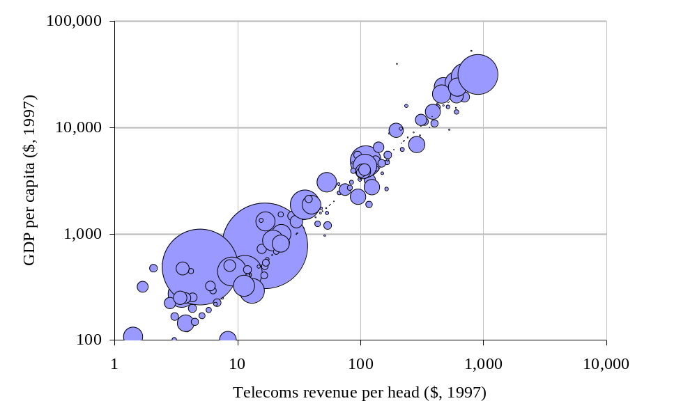
Exhibit 0.3: Telecommunications revenue per capita versus output per capita, 1997. Bubble size indicates country population. [Source WDI’99]
New networking has the potential to amplify many of the development benefits that have been observed and assessed in the past. However, it is also disrupting many of the observed historical relationships between network development parameters and economic and social development parameters, undermining the use of extrapolative techniques to predict future trajectories. Projections concerning the nature, magnitude and timing of the benefits of new networking must instead be based on qualitative hypotheses rather than established, tested quantitative relationships. Fortunately much of the existing qualitative work on the linkages between networks and developments is likely to continue to be robust in the new networking environment.
The impact of new networking differs from the observed historical impact of networking because of the increased capabilities and functionality of new network services and technologies, and because of its steadily improving affordability. For example, until the early 1990s, the networking options for a developing country were limited to narrowband copper telephony and crude narrowband fixed wireless telephony. International connectivity was generally provided by a very small number of satellite voice circuits, thin microwave links or, rarely, a submarine cable or international landline. However, over the last few years, the range of choice has expanded significantly. Individual developing countries have successfully deployed state-of-the-art mobile networks, broadband metropolitan area networks, advanced fixed wireless networks, paging networks, advanced satellite networks and high capacity submarine cables. The new network service portfolio is perhaps even more important than the expanded range of valuable technologies – for instance, the World Wide Web allows each connected user to participate fully in a single global space. This is a huge advance, magnifying the traditional impact of a simple phone line many times over.
The issue of how new networking will accelerate development is well covered in the literature – see Annexes A and D for more details and examples. In addition to the mechanisms discussed in Section 0.1 (above), many of which apply equally to developing countries, we highlight five specific areas.
- Improved economic efficiency and competitiveness. This is the traditional focus of work looking at network development and economic development causality. All important micro-economic processes benefit from improved information flows. A developing economy which has eliminated its networking bottlenecks should be able to acquire its imports more cheaply, organise its primary and secondary production more efficiently, operate its markets more efficiently (goods, assets, labour, capital), and exploit its intellectual and human capital more effectively. It should also be better able to attract and exploit foreign direct investment.
- More efficient and effective education, healthcare and public administration. Many commentators have asserted that the potential for networking to make an impact on the public sector matches or exceeds the potential in the commercial sector, although the force of these assertions is always diminished by their qualitative basis, and by the observed failure of networking to make a major impact on the public sector to date. However, these difficulties should not diminish the credibility of the overall argument – there is a strong match between the needs of the public sector and the beneficial characteristics of new networking. As ways are found to exploit networking in education, healthcare and public administration, then these would be highly beneficial in overall development terms:
- affordable networking enables the power of distance learning to be added to the educational portfolio. Distance learning is particularly well matched to the developing world, where specialist teaching resources are scarce, and teaching aides are not affordable. Distance learning makes specialist teaching with high-quality teaching aides available to any student with access to a network terminal. Networking can be a major amplifier of limited educational resources.
- scarce specialist healthcare resources can be deployed efficiently and effectively using networking techniques. This goes well beyond remote diagnosis and consultation – the logistics of healthcare and the interaction of health professionals benefit significantly from affordable networking.
- efficient public administration is increasingly predicated on affordable ubiquitous networking. The collection of taxes and the distribution of resources, local government and public services are all characterised by intensive information flows over wide areas. The benefits of effective networks are extremely significant both for the quality and the efficiency of the public sector.
- Opportunities to exploit low factor costs in international markets. This expectation is rooted in classical economics, but has proved to be a limited phenomenon in reality, to the consternation of early development economists. In reality, the factor cost advantages of developing countries are masked by the higher transaction costs that they experience due to geographical location, trading costs, etc., and their institutional and infrastructural shortcomings such as weak legal and administrative structures, skill shortages, transportation and communications problems. However, there are many examples of developing countries overcoming these obstacles and exploiting their low factor costs. These examples indicate that there is a strong threshold effect, i.e. a developing country can only achieve sustainable benefit from exploiting its low factor costs when skills, infrastructure and institutional development has passed a threshold level.
For developing countries that have passed this threshold, the networking revolution can broaden the base of products and services where low factor costs can be used as a source of competitive advantage. For example, India can extend the boundaries of its software industry from its origins – the coding of large systems – to include systems integration, packaged software, system specification and design and consultancy. Not only does this expand the volume of business, it also increases the value captured by India. New networking will have a material impact on the ability of many developing countries to exploit their low factor costs in global markets, with potentially large economic benefits.
- Opportunities to increase social capital. From a developed world perspective it is easy to forget the social benefits of ubiquitous affordable networking in developed societies, and so miss the potential for positive impact as developing countries achieve these levels of networking. The literature of telecoms development does give significant weight to the social capital impact of networking, but this has not been picked up in generic development policy development until very recently. The potential positive impact of new networking is particularly pronounced in the following areas:
- social cohesion, notably in societies with high levels of migrant labour, such as China or South Africa, where families and communities are severely strained by geographic separation
- information availability – easy access to a wide range of information is an essential prerequisite for living in a complex, stable and progressive society
- entertainment – it is hard to quantify the social benefits of widespread access to a range of entertainment through the media of multi-channel TV and radio, but this should not diminish recognition of its importance, particularly in societies that are stressed by poverty, instability and social change
- education, through access to information and access to teaching. Distance learning is a valuable tool in the struggle to overcome resource constraints in developing world education
- healthcare effectiveness and efficiency benefits from improved networking
- welfare development depends on distributed information systems, which in turn require a reasonable standard of affordable networking
- gender issues – where women have access to networking in the home or the workplace, it can contribute to equalising access to information, entertainment, education, as well as increased empowerment in the spheres of community and family
- active citizenship – ease of participation in political, administrative and other institutional life
- the fostering of international links – cross-border communication can develop personal and community ties that extend beyond narrow local concerns. Affordable voice, email and other media are beneficial in this area.
- Opportunities to bypass failing domestic institutions. Where citizens are confronted by inadequate domestic institutions or services, they may seek access to alternatives in other environments. Examples include access to banks, legal services, traders, brokers and information providers. For many decades this cross-border access has been the privilege of a wealthy minority in most developing countries. New networking will lower the cost threshold to the point where it becomes an option for many more citizens. The benefits to the individual citizen may be significant, although it should be noted that many of these cross border activities are currently in breach of national civil or even criminal laws.

‘New Networking’ presents significant threats to the developing world
Despite the opportunities which the network revolution offers the developing world, there are also many ways in which it could widen the development gap:
1 The transition to new networking, and specifically to ecommerce, exposes known weaknesses in most developing countries:
- inadequate legal and commercial frameworks
- shortfalls in education and knowledge development
- weak network services and infrastructures.
Where these constraints exist, they will slow the development of indigenous ecommerce, passing the initiative to offshore ecommerce providers and dissipating the benefits and opportunities that would flow from more rapid progress. If the domestic initiative is lost, and ecommerce structures establish themselves around an offshore model, it will be very hard to revert to a nationally focussed model. Although the national economy will see some benefits, the development gap will widen as the developed economies pull further ahead.
2 Increased tradeability in services will expose weak domestic service sectors such as finance, business services, professional services and retailing to the full force of international competition. The development of these sectors may be damaged, and in some cases they will be wiped out entirely by foreign players. Any threat to these activities is a threat to the long-term development of the country, since these embryonic service activities are essential to the economic, social and institutional development of all developing countries. They are a nursery for smaller enterprises, have a disproportionate impact on the development of institutional frameworks, foster a growing indigenous professional class and help to diversify the domestic economy. However, most of the actions that can protect these sectors carry an equal danger of harm to long-term development. Experience shows that most attempts to shield a specific sector from cross border competition are clumsy, unsuccessful and damaging to the wider economy in the medium term. The potential threat to development is real and material, and breaking out of this ‘Catch-22’ dilemma is a major challenge for policy development.
3 The global upheaval of industry and commerce carries risks of volatility and instability for developing economies. If the networking revolution hypothesis proves to be accurate, then the developing world will have to attempt to make progress in a turbulent and unpredictable global environment. Corporate strategies may become more short-term focussed, which may reduce investment in developing countries. Commodity prices may become more volatile, hurting the export earnings of many developing countries. There is even a danger that the development challenge may slip lower on the agenda of developed world politicians and institutions. Purely from a planning perspective, uncertainty and turmoil in the developed world significantly complicates the assessment of developing world scenarios.
This report addresses these and other potential difficulties for developing countries arising as a consequence of the networking revolution, such as income inequality effects, social issues, law enforcement issues and the ‘accounting rate’ problem.

The balance of threats and opportunities for developing countries
In this section we reach the conclusion that there is a subset of countries where the net development outcome is particularly sensitive to networking policies and programmes.
Considering the opportunities and threats from new networking in combination, we draw the following conclusions.
- There will be a wide range of net outcomes, from strongly negative to strongly positive, across developing countries, based on their current development status, their location, the structure of their economy, social factors and policy decisions. Although it is possible to build a hypothesis for each country based on a range of assumptions, the prediction of the net outcome is subject to significant uncertainty.
- There will be a wide range of outcomes for different groups within countries. In general, those who benefit most will be those that are affluent, urban, educated and who have the flexibility to adapt to new challenges. However, where the macroscopic impact of new networking on the national economy is particularly harmful, even these groups will suffer.
- Potential negative outcomes cannot be avoided simply by adopting a passive defensive approach. Failure to embrace the opportunities arising from new networking will not ensure insulation from the negative impacts.
In order to assess these potential outcomes in more depth, it is necessary to examine individual countries and groups of countries that appear to share important characteristics. We have segmented the countries of the world into five groups:
- Group A: developed countries. The development trajectory for developed countries is expected to continue upwards, accelerated by the impact of new networking.
- Group B: developing countries that are expected to make good progress, benefiting from the impact of new networking. It is expected that most members of this group start out with higher levels of development, and have reasonably liberalised networking regulations and an open approach to trade.
- Group C: developing countries where the balance of positive and negative impacts is uncertain. The optimum management of new networking can lead to a positive net impact on development, following the ‘Group B’ trajectory. Group C is subdivided into C1, C2 and C3 according to their current prospects:
- C1 countries have a good prospect of implementing the necessary reforms and programmes that would lead to a positive participation in the networking revolution, but less successful policy actions will lead to a widened development gap
- C2 countries are less well placed in terms of institutional status and performance, and these circumstances will need to change in the near future if they are to be beneficiaries of the networking revolution. Again, the range of outcomes is wide.
- C3 countries are the poorer developing countries where the net impact of new networking is expected to be small relative to the existing sources of poverty and instability. Networking development will probably remain low on the list of development priorities for these countries, and those networking programmes that are implemented in these countries will need to take account of the constraints imposed by other basic development requirements.
These generic development paths are illustrated in Exhibit 0.4.
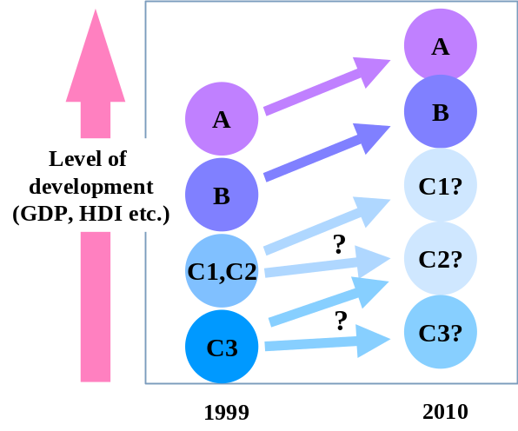 | Exhibit 0.4:  Segmentation of countries into four groups to characterise the impact of new networking on development [Source: Analysys]

The allocation of countries into these groups has been carried out on the basis of their current affluence, stability, institutional strength, human capital development, geographic location and network conditions. The following parameters are assessed as being the key determinants of national outcomes, with some further specific heuristic assessments incorporated to counter the lack of up-to-date data for some countries:
- prosperity, specifically, the percentage of the population that is sufficiently wealthy to participate in networking activity
- human capital development – used to modulate the prosperity assessment, using UNDP Human Development Indicator indices
- institutional status and performance – exploitation of new networking depends on the existence of stable, pragmatic institutions that act in the true interests of their people. This is essentially a heuristic assessment, since a 1999 ‘snapshot’ of institutional status and performance cannot capture the positive or negative developments that may occur in the coming years
- the status and performance of the networking sector – this parameter covers the existing level of communications infrastructure and services (including affordability), the current pace of improvement, the organisation of the sector (covering the spectrum from unregulated monopoly to well-regulated liberal competition), and prospects for future improvement (based on national demographics and geography as well as institutional aspects).
The results of the segmentation are shown in Exhibit 0.5. The purpose of the segmentation is to enable a clear focus on Groups C1 and C2, where the outcomes are most uncertain and where policy actions and programmes may be most effective. The policies and programmes required for Group C3 countries are likely to be different in character to those that are matched to Groups C1 and C2. Group B countries are not guaranteed to progress successfully, and their policies and development should certainly be monitored closely, if only to allow Group C countries to benefit from the lessons that are being learned.

Policies and programmes can materially improve developing world outcomes
In this section we offer some ideas and questions as the basis for a discussion of policy and programme development (as a summary of areas covered in the main body of the report). We concentrate on those countries where the potential benefits of effective policy and programme actions would be the greatest.
There is no shortage of policy advice in the literature of networking development, mostly centred on the new consensus that sector liberalisation is beneficial. However, translation of policy principles into policy implementation is the key challenge. For every administration that has successfully liberalised and privatised its networking sector, there are several who have either not acted, or have experienced difficulties and obstacles in attempting to follow this path.
In addition to alignment with the basic principles of liberalisation and competition, we argue that ‘best practice’ policies need to have the following attributes to be practicable:
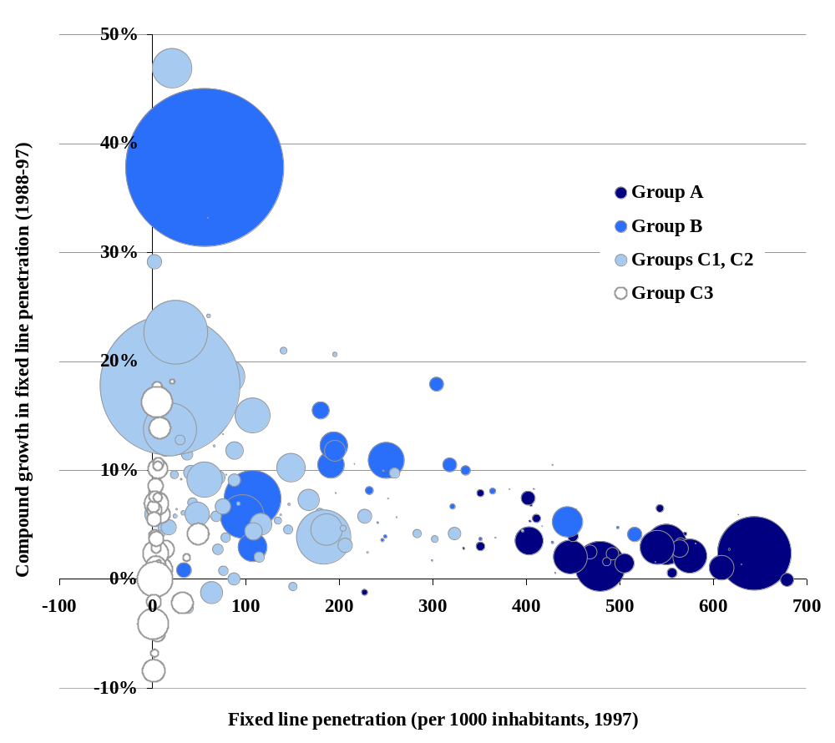
Exhibit 0.5: Segmentation of countries into four groups, spread by fixed line penetration and growth in penetration – bubble size is proportional to population [Sources WDI, ITU, Analysys, 1997]
- integration with appropriate programmes
- sensitivity to local conditions, risks and constraints
- including a strong innovative and opportunistic dimension, rather than attempting to repeat prescriptions that have been used elsewhere.
In isolation, policy prescriptions for developing countries are often unachievable. Many administrations have not liberalised and reformed their networking sector because of various practical difficulties – either institutional or environmental constraints, or difficulties of implementation (reconciling vested interests, resolving difficult trade-offs, etc.). In our view these difficulties can best be overcome by integrating appropriate programmes with policy formulation. For example, an administration that will not sacrifice the revenue stream it receives from its unregulated state-owned monopoly telecoms operator could be accused of short-termism, but is still confronted by a very real financial problem. In many cases, an appropriate transitional programme (with the necessary safeguards) may break the impasse. Another administration may wish to impose onerous universal service obligations (USOs) on bidders for a national licence, deterring potential bidders. Again, a transitional programme, combined with USO expertise, may be able to unblock the process.
The implication of integrating policy formulation with programme development is that programme resources may need to be substantially higher than has been the case in recent times, both in absolute terms and as a proportion of total development programme funding. This is a driver towards innovation and appropriate opportunism. We suggest that there is a substantial and growing opportunity to tap commercial funding and private not-for-profit funding of networking development initiatives. However, accessing this opportunity depends on a continuing growth of the energy, commitment and innovation levels within network development. It is also dependent on the importance of networking development rising in the wider development portfolio – non-networking development specialists need to be visibly aligned with networking development as a priority area. We note that there are extremely encouraging signs in this respect.
Exhibit 0.6 shows outcomes for a generic country in group C1, considering a range of policy and programme scenarios. The key message from these scenarios is that the optimum outcome requires the integration of policy reform with supporting programmes. If this is undertaken with creativity and sensitivity then the medium term outcome can be positive for both development and equality.
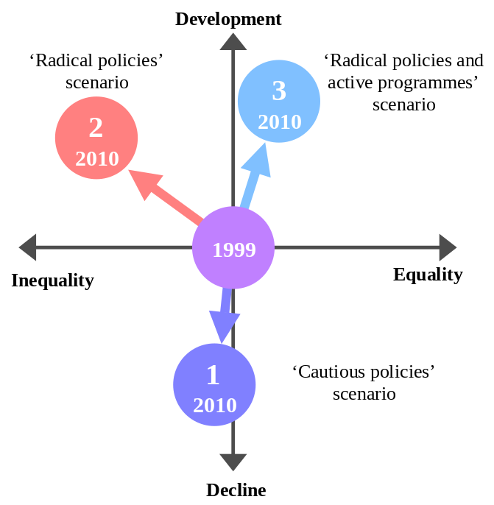 | Exhibit 0.6:  Schematic of scenario outcomes for a Group C1 country [Source: Analysys]

Our summarised recommended policy principles are that:
- administrations should follow developed world best practice for legislation and regulation that is related to ecommerce, including taxation, disclosure, privacy, encryption and contract law. This is a demanding objective – most developed countries are struggling to prepare their legal codes and regulatory frameworks to deal with the new challenge.
- other obstacles to ecommerce, such as foreign exchange restrictions and trade policy, should be reduced. Again, this is a challenging area for most developing countries which depend on exchange restrictions and trade constraints for their continuing national economic stability.
Specific recommendations for the networking sector are:
- networking (infrastructure and services) should be subject to independent regulation, whatever industry structure is in place. The independent regulator should have powers that cover at least pricing, interconnection, international accounting rates and USO, and a customer-focussed mandate.
- there should be a bias towards liberal licensing of network operators and, particularly, service operators. Multiple competitive service providers can provide some of the benefits of competition if the administration is unwilling to end the monopoly of the state operator, but the importance of the regulator is then even greater.
We highlight the following areas where additional specific programmes are necessary, although we note that these need to be tightly integrated with specific policy objectives and local circumstances:
- support for increased international connectivity. No country can expect to participate in the networking revolution if its international connectivity is restricted to a few hundred voice circuits. A co-ordinated programme of international connectivity upgrades could access significant benefits without massive public-sector funding.
- support for coverage of marginal areas. This is most efficiently achieved by a careful mix of policy development (licences, USO funding, etc.), private finance and public funding to fill key gaps.
- support for low-user initiatives (such as cheap cellular handsets). Close co-ordination with the private sector is essential here to minimise the distortion of market forces, but this is fertile ground for innovative development solutions.
- seedcorn finance for application service providers and other small, niche ventures with low capital needs. Again, public/private collaboration can be used to stimulate the growth of a healthy indigenous SME community.
- programmes that address specific capability gaps (such as IP configuration, HTML creation, etc.) Skills shortages will be a major constraint in many developing markets, and may be efficiently addressed through public/private collaborations.
We assert that a major effort to drive policy reform, complemented by effective, innovative support programmes can make a material impact on the development outcomes for many countries. This is a crucial period for development, and we predict a widening gap between those states that benefit from the networking revolution, and those that fail to benefit, continuing to be locked into vicious circles of deprivation and economic isolation.
In the field of programme development, the following questions remain particularly problematic, and worthy of exploration and debate.
- How to avoid the distortion of existing markets, by favouring a player through subsidies or penalising a player denied subsidies.
- How to minimise the risks and dangers of picking winners. This dilemma has a high profile as there is such a long track record of disappointment in the field of public selection of private ventures. In networking development, the problem is more to do with the picking of ‘winning’ technologies rather than individual players, and the track record is not good. The dilemma can be minimised by the design of programmes, but any development initiative remains vulnerable to some degree to this criticism.
- How to prioritise between and within programmes. Faced with a surplus of candidate programmes chasing a finite pool of resources, it is necessary to prioritise programmes. The criteria for prioritisation are very hard to get right. For example, a flawed programme that is pursued with vigour and enthusiasm must be judged against an elegant idea proposed by a less energetic agency. Large international projects must compete for funds with small local initiatives. Achieving and maintaining the optimum portfolio of programmes is a monumental task.
- How to manage programmes effectively. Funded programme are vulnerable to stagnation, bureaucracy, loss of energy, corruption, loss of focus and a host of other difficulties. Measuring the effectiveness of programmes is extremely difficult. Heavy handed programme oversight can kill the innovation and drive of the programme team, but too light a touch can result in the problems listed above.
- How to secure appropriate funding for programmes. Programmes have to be paid for. Almost all programmes, however innovative and streamlined, cost somebody some money. The clever combination of sources, and the matching of sources to risks and roles can ameliorate, but not eliminate, the problem of funding.
Although the challenge is great, none of the necessary steps are beyond the reach of the governments, agencies and networking players who are required to act, and an understanding of the consequences of inaction is sufficient motivation to meet this challenge.

The ‘Network Revolution’
The ‘networking revolution’ has finally arrived | A ‘networking revolution’ has long been prophesised by a diverse range of commentators. The intensity of these predictions has recently risen to become a frenzy of confusing hyperbole, where informed, rational analysis is drowned out by exuberant or self-interested wishful thinking. In the face of such a cacophony, many observers remain understandably sceptical of claims that the ongoing changes in the telecoms, IT and entertainment sectors should be described as a revolution.
 | However, as this report demonstrates, the impact of ‘networking’ is driving a radical transformation of developed economies and societies, and that the magnitude of this phenomenon fully justifies the use of the term ‘revolution’.
 | Furthermore, the majority population of the earth – the five billion people who live in developing countries – face a massive challenge from the networking revolution that is unfolding in the developed world. Part of the developing world will be projected into a turbulent period of rapid progress, but most will be left behind, locked into vicious circles of poverty and instability as the gap between rich and poor widens again. Even those countries that make significant progress will be exposed to stresses and strains as a consequence of the networking revolution. The right mix of national and supranational policies and programmes can enable some countries to move from being victims to beneficiaries, but only if networking development moves up the hierarchy of development priorities.
 | The purpose of this report is therefore to alert the unaware, convince the sceptical, and motivate those in power, so that the impact of the networking revolution on the developing world can be understood, and the most effective policies and programmes implemented.

The changing role of networking in the economy and society
The interaction of networking with the economy and with society as whole can be viewed as a dynamic system … | The interaction of networking with the economy and with society as whole can be viewed as a dynamic system, even though the linkages and parameters that describe this system are difficult to quantify:  - networking is highly correlated with economic activity. This is statistically observable as well as being intuitively understandable. The flow of information has always been integral to the activities of production, trade, and investment, and to the operation of markets. Economic development and networking development have historically progressed together in a stable relationship, as illustrated in Exhibit 1.1.  - networking is linked to social and institutional development. Although this is less accessible to statistical analysis than the relationship between networking and economic activity, its importance in the development of modern social and institutional structures is clear and the interaction has been essentially stable and incremental.
… with new network dynamics now taking shape | However, the dynamics of networking have changed significantly in recent years due to a combination of technological, regulatory and demand-side developments. As a result, established stable relationships are transforming into ‘positive feedback’ mechanisms, as illustrated in Exhibit 1.2.
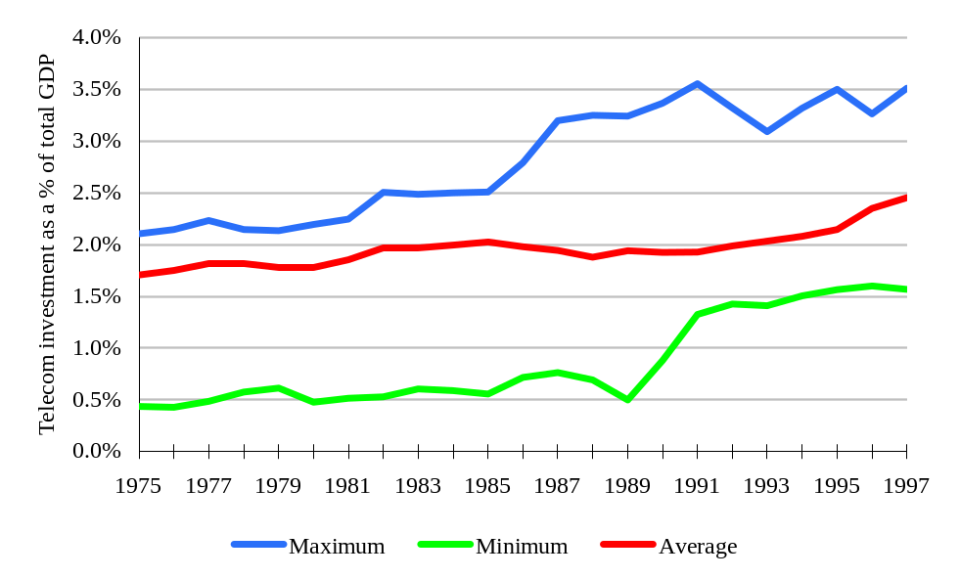
Exhibit 1.7: Telecoms Revenue as a Proportion of GDP for OECD Countries [Source: ITU, Analysys]
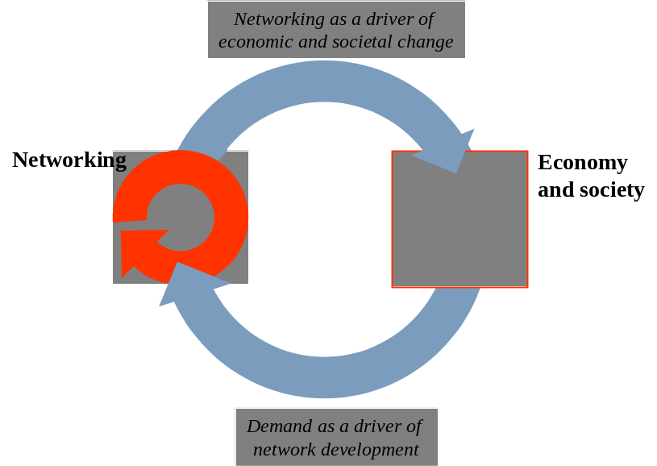
Exhibit 1.8: Positive feedback mechanisms driving change in the economy and society [Source: Analysys]
Positive feedback mechanisms have dramatic and unforeseeable outcomes | Dynamic systems with positive feedback characteristics tend to demonstrate rapid rates of change, and extreme, unpredictable final outcomes, meriting the use of the term ‘revolution’ is justifiable – the established structures and relationships will be overturned, and new, unknown mechanisms will appear in their place. The far-reaching scope of this revolution has been charted by many commentators - academics, broadcasters, financial analysts, politicians and business leaders, to the point where revolutionary prediction has become something of a cliché.

The structure of this report
Our starting point is the impact of the networking revolution on the developed world | Although this revolution has enormous implications for the developing world, it will remain predominantly a developed world phenomenon. Its motive power and momentum in the developed world can sustain its trajectory because telecoms and networking are so skewed, as illustrated in Exhibits 1.3 and 1.4. However, this does not mean that the impact of the revolution will be restricted to the developed world. The impacts of new networking in the developing world will be significant, even though the mechanisms and manifestations will differ.
Exhibit 1.5 (overleaf) illustrates the logical development of the arguments made in this report, which creates the following report structure:
- Chapter 2 highlights the impact of the networking revolution in the developed world
- Chapter 3 examines the opportunities and threats which new networking presents for countries in the developing world
- Chapter 4 assesses the range of outcomes for developing countries, and focuses on the group of countries where the outcome appears to be in the balance
- Chapter 5 reviews the policies and programmes that can be deployed to optimise networking development outcomes in the developing world.
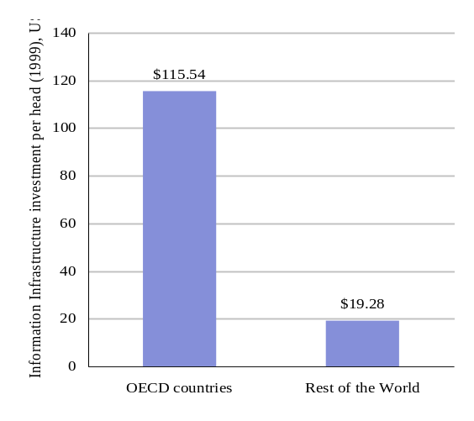
Exhibit 1.9: Telecoms and networking are massively skewed towards the developed world [Sources WDI’99, Pyramid Research]
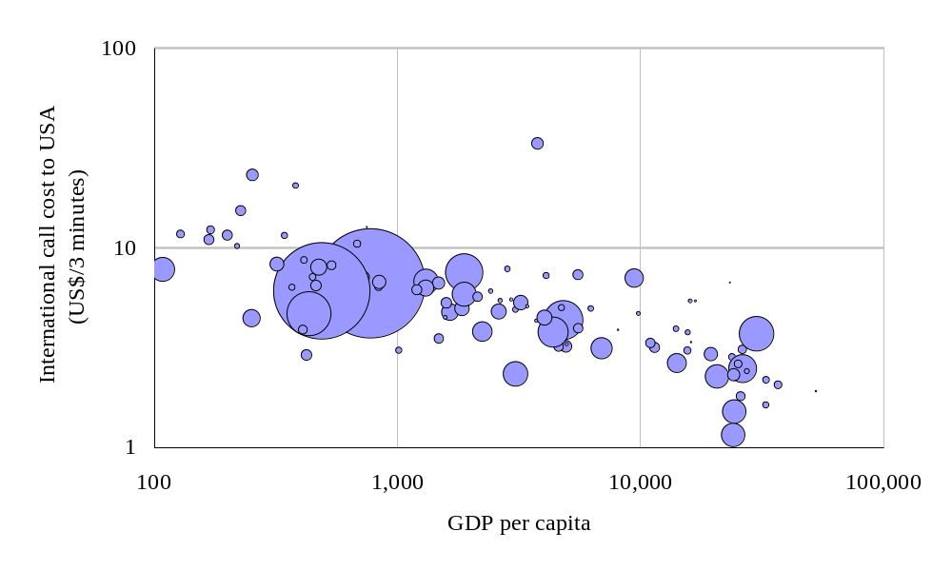
Exhibit 1.10: Developing countries pay significantly more for international communications [Source: WDI 99, ITU] (Size of bubble denotes country population)
Exhibit 1.11:
Schematic for the argument made in this report

The annexes to the report contain a literature review and bibliography, additional materials on the relationship between networking and development and summaries of the activities of various key development programmes and agencies.

‘New Networking’ and the developed world
Summary. A combination of powerful forces is accelerating the development of ‘networking’. The magnitude of the impact of new networking justifies the use of the term ‘revolution’. Although this revolution has major implications for the developing world it is essentially a developed world phenomenon. The networking revolution can lead to a very wide range of outcomes in the developed world. New networking offers a mix of positive and negative potentialities for developed-world economies, societies and institutions.
Several developments are accelerating the development of ‘networking’ … | As noted in Chapter 1, profound changes in the relationships between telecoms, the economy and society are now underway, driven by various positive feedback mechanisms. These mechanisms can be identified in nine main areas, six that link supply-side and demand-side effects, and three that operate within the networking sector itself.
…both on the supply and demand side … | The supply-demand mechanisms are:  - technology cost, volume and innovation effects  - system development cost, risk and timescale effects  - user expectations  - competitive forces  - industry restructuring effects and financial market behaviour  - ecommerce and other network externality effects.
…and within the networking sector | The effects that operate within the networking sector are:  - standardisation  - liberalisation and re-regulation  - confidence and risk assessment effects.

Supply-demand mechanisms
Key mechanisms include … | We look in turn at each of the areas listed above where positive feedback mechanisms are postulated.
… technology cost, volume and innovation effects … | The unit costs of many key networking technologies are falling at dramatic rates, due to continuing innovation and development and the economics of high-volume production. Falling unit costs are known to stimulate increased demand and higher volumes – the evolution of cellular handsets provides a good illustration of this positive feedback effect in action. It is difficult to quantify the macro-economic impact of such rapid improvements in the cost and functionality of such important technologies, but it is plausible to suggest that there is a material impact.
… system development cost, risk and timescale effects … | Corporations are finding that the new networking technologies are enabling complex applications to be developed more quickly, cheaply and reliably than was possible even a few years ago. The combination of intranet technologies, browsers, client-server architectures, modular design, rapid prototyping and so on, has provided a massive boost to applications development. This has triggered a positive feedback mechanism – large and small organisations are realising that they can embark on ambitious projects with a good prospect of success, rather than the expectation of delay, cost overrun and failure that formerly characterised such ventures. Growth in activity then drives further improvements in technology – the toolkits improve, shaky package interfaces are fixed, new releases are brought forwards. The macroscopic impacts of this step-change in corporate applications are dramatic and highly disruptive as drivers of corporate structure and strategy (see below).
… user expectations … | As users become aware of what is possible, their expectations rise, and their dissatisfaction with inferior and obsolete products and services becomes a significant driver of demand. For example, business users of the Internet expect their home access to the Internet to be as fast as that available to them in the office, thus driving demand for high-speed residential services such as cable modems and digital subscriber lines. Meanwhile, their children expect their Internet experience at school to be as fast and slick as their experience at home. This effect forces technology to progress at an accelerated rate – products and services are replaced with a frequency dictated by fashion and impulse, rather than the slower evolution that would emerge from the rational trade-off of costs and benefits.
… competitive forces … | The sight of entrepreneurs making a healthy return by creating businesses in all parts of the ‘networking’ value chain encourages other new entrants to participate. As a result, the level of innovation rises, and the increasing competitive intensity of the sector accelerates the micro-economic processes of efficiency, supply/demand balancing and price erosion to match marginal costs. This positive feedback mechanism is ultimately unsustainable and likely to lead to over-capacity, business failures, disappointing returns and consolidation, but will drive considerable progress over the next few years. Although much of the networking sector has been highly competitive for many years, the telecoms industry has been sheltered from the disruptive energies of competition, and has considerable scope for radical reformation and progress.
… ecommerce and other network externality effects … | As more suppliers and customers enter the ecommerce arena, so the benefits of participating in ecommerce grow, and the penalties for non-participation also increase. This is a classic network externality which, in the developed world, will soon pass the threshold level at which growth accelerates to saturation. Business-to-business and business-to-consumer electronic transactions are both growing exponentially. Although the saturation level is constrained – only those with access to the ecommerce space can participate – the macroscopic impacts will be enormous. Established value chains, cost structures and consumer behaviours are transformed, and new, unknown replacements must be discovered. The disruption will be significant, and the dynamics of the new electronic markets may be unstable and challenging.
… and industry restructuring effects and financial market behaviour | Many major established corporations, in all sectors, are undertaking profound reviews of their role in the ‘new economy’. Banks, supermarkets, drug companies, oil companies, utilities, auto makers to name but a few are concerned about competitors with new and unusual business models, radical modifications of their value-chains and opportunities for expansion. This is an astonishing phenomenon, already far more substantial than any of the management fads that have appeared and disappeared in recent decades. Large and small businesses are materially changing their strategies to address a changing environment. The diffusion dynamics of this process have passed the threshold point, and it is more likely that a vacillating player will choose to copy the movers rather than the sceptics.  An even more dramatic manifestation of this effect has appeared in the financial markets. Almost any corporation that can claim a linkage with new technologies or business models is able to gain an attractive valuation and easy access to funding. Those that substantiate these claims over a few quarters of solid development are able to achieve market capitalisation that exceeds that of their established, profitable ‘bricks and mortar’ rivals by an order of magnitude. Of all of the positive feedback mechanisms listed here, the “irrational exuberance” of the financial markets is the most acute. The traditional mechanisms of corporate valuation are no longer being applied in a growing portion of the capital marketplace, and so far no robust alternative mechanism has emerged. The macro-economic impacts of this transition are already material and observable, particularly in the USA.

Mechanisms within the networking sector
Remarkable change in the fields of … | There has been a striking change of pace within several key areas of the networking sector. Log-jams have been cleared and a great deal of traditional thinking has been swept away. However, in some cases new thinking has yet to mature.
… standardisation … | Until the early 1990s network standardisation was the preserve of highly specialised technicians. Networking and IT corporations had to be cajoled and coaxed away from proprietary solutions towards laboriously negotiated ‘open’ standards. However, the emergence in the 1990s of the Internet and Microsoft Windows as the two focal points for development has entirely transformed the dynamics of standardisation – key standards now have a life of their own, whether they are open (e.g. IP) or proprietary (e.g. Windows). Entrepreneurs now know that they must align their products and services with the key standards if they are to succeed. Progress towards the standardisation of third generation mobile telephony is a clear example of the enhanced importance of standardisation. The efficiency and innovation benefits of a standard-centric industry are massive, but the impact of these benefits have yet to be felt in full.
… liberalisation and re-regulation … | The regulation of telecommunications, in particular, has rapidly switched from ubiquitous state-sanctioned monopoly, supported by respectable academic economists and the majority of public opinion (1980), to a widespread consensus on the benefits of liberalisation and competition (1999). Liberalisers now claim the high ground of academic respectability, and the defence of restrictive regulations now tends to be based on ‘special local circumstances’ rather than generic principles. Many administrations that were previously ardent monopolists now exhibit a strong bias towards competition – part of a virtuous circle of reform. This is another astonishing transition, with profound macroscopic impacts that are yet to be fully felt.
… and confidence and risk assessment effects | Those who are witnessing the speed and scope of change – including suppliers, customers, regulators, financiers and politicians – are changing their expectations of what might be possible in the future. The phenomena of the Internet and mobile telephony have, in themselves, changed the minds of many who doubted the that the dynamics of the networking sector could ever deliver rapid change and growth. This may be the most subjective and contentious of all of the feedback effects listed here, and yet prove to be the most influential. Certainly this was the experience in the eighteenth century, when the realisation that ‘the rules had changed’ was essential to the growth of momentum which turned many disparate manufacturing advances into the Industrial Revolution.

Unpredictable outcomes
Positive feedback mechanisms could lead to unpredictable consequences … | The positive feedback mechanisms inherent in networking revolution can lead to a very wide range of positive and negative outcomes for developed-world economies, societies and institutions. Examples of uncertain outcomes associated with the networking revolution are described below.
… disintermediated markets? | The easier creation of direct linkages between producers and customers implies a reduced role for intermediaries in many markets, including consumer goods, food, manufactured components and primary products. Disintermediation has been widely predicted by those forecasting the impact of new networking. If occurring to any great extent, the implications for the structure and behaviour of developed economies would be very significant, and the transition period disruptive and volatile.
… the emergence of major new markets? | Many commentators, corporations and entrepreneurs expect that entirely new markets will be born in the turmoil and fusion of new networking. By definition it is difficult to describe and quantify these new activities before their births, but the expectation is reflected in the valuations of companies that are seen as being well positioned to benefit from new markets – such valuations often exceed the level which can be justified based on the expected cash flows from their existing activities. It is hard to assess the probabilities of fulfilment of these expectations, but the atmosphere of anticipation is contributing to current volatility and disturbance.

… destabilisation of financial markets and even whole economies? | A wide range of destabilising pressures can arise in the transition to a new networking economy. An early example is the impact of ‘day-traders’ who use the Internet to trade equities, bonds and derivatives. The presence of growing numbers of small traders in US financial markets has raised serious concerns over the current and future dynamics of these vital markets.  New networking will have far-reaching impacts on trade patterns, on market behaviours (notably price dynamics), on patterns of corporate strategy, investment, employment and on corporate performance. Some sectors and regions will witness a concentration of corporate failures and it is conceivable that this could de-stabilise local or even national economies, requiring macro-economic interventions. The network revolution may trigger a wide range of disruptive micro- and macro-economic effects, including asset inflation or deflation, price inflation or deflation, unemployment, skills shortages, cutbacks in investment, investment ‘bubbles’, sudden loss of confidence (‘crashes’), capital flight and currency instability, balance-of-payment gaps and surpluses, and taxation shortfalls.
… excessive concentrations of market power (and institutional interventions in response)? | In the new environment, a variety of factors make it easier for a successful business to achieve high levels of market power. For example, in an environment of perfect price information, with low transaction costs and no intermediaries, the lowest cost producer may be able capture a much higher market share much more rapidly than we are currently used to. Such a change to the behaviour of markets would almost certainly lead to a change in institutional involvement with the regulation of markets. It is likely that supranational regulation would need to increase, and the climate of business regulation could be materially altered.
… continued acceleration of technology functionality? | Nobody knows whether the recent period of accelerating technology functionality is a transitional blip, a sustainable linear trend or an exponential phenomenon. Most scenarios for the future assume that technical functionality continues to develop at a linear rate that is comparable with the historical trend of the last few decades – technologies become cheaper, more reliable and  easier to use, but remain recognisable. The ‘continuing acceleration’ scenario has been left to the science fiction community to explore.  However, we have moved from a world where ‘everything happened more slowly than predicted’ to a world where some important trends – the rise of mobile telecoms, the diffusion of Internet usage and the rate of growth of ecommerce – have evolved much more rapidly than most experts predicted. A comprehensive assessment of the network revolution should recognise that many of the ‘science fiction’ scenarios are plausible, and their impact would be material.
… significant change in public services and administration? | Although the public sector is likely to continue to lag behind the leading edge of networking developments, the potential impact of new networking in the public sector is enormous, as it is directly relevant to all areas of the public sector. There is potential for dramatic reductions in the cost of delivering services and on the organisation of administrative and political institutions. However, the combination of huge potential for change and powerful forces of resistance makes public sector outcomes extremely uncertain.
… altered social patterns (work, family, education, etc.)? | New networking is likely to accelerate many existing social trends through its impacts on day-to-day life. Impacts are being felt in the workplace, the home, and more broadly in society. Many of these trends are a cause for concern (such as the decline of ‘family life’, the increased polarisation of society into rich and poor, the perceived growth of insecurity and stress), but new networking can also increase access to education, information and entertainment. A wide spectrum of untested hypotheses exists on the likely scale of these effects, or the balance of positive and negative consequences. However, it seems reasonable to predict that new networking will materially alter developed societies and, although they may lag behind the economic effects, these impacts may be profound in the medium term.
 | In summary, the developed world faces a period where the beneficial impacts of new networking are combined with disruption and upheaval as new structures and dynamics emerge. There is significant uncertainty surrounding the speed and intensity of change, with a wide range of plausible trajectories.

Quantifying the Network Revolution in the developed world
A wide range of quantified scenarios co-exist | It is extraordinarily difficult to translate the qualitative diagnosis of the networking revolution into a quantitative prognosis. A huge range of quantifications exist, ranging from explosive revenue and profit growth to disastrous price erosion, loss of margins and revenue collapse. We have chosen various quantified results from the sister project to our own, undertaken by Pyramid Research, to illustrate a particular quantitative view of the future for the developing world, using the OECD as a surrogate grouping.  The Pyramid scenario illustrates the point that the networking revolution need not be a revenue feast or famine – Pyramid shows service revenue growth saturating in Europe over the next decade, and predicts a decline in infrastructure investment levels to match this saturation. This is less optimistic than most projections, but does not imply a disaster in the sector.
OECD revenue saturation | Pyramid predicts OECD telecoms services revenues growing from $620 billion in 1999 to over $1000 billion by 2010 (nominal), as illustrated in Exhibit 2.1 (overleaf). Pyramid forecasts that mobile revenues will stabilise at about 22% of total service revenue, from 19% today. This relatively modest trajectory for revenues goes hand in hand with a radical view of the changes in mix, price and usage characteristics underway in OECD markets in the period – well aligned with the revolutionary hypotheses described in this report.
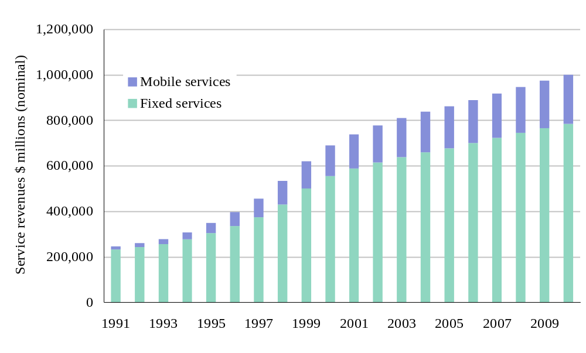
Exhibit 2.12: OECD fixed and mobile telecoms service revenues, 1991 –2010 [Source: Pyramid Research, 1999]
Exhibit 2.2 illustrates another key Pyramid prediction concerning the stabilisation of average spending for fixed and mobile telecoms subscribers. Again, projecting this important parameter is extremely challenging, and a wide range of plausible trajectories can be defended. The flattening of mobile revenues at $400 per subscriber indicates that dilution of the customer base, price erosion and new service development are all in balance after 2004.
Pyramid’s analysis leads to the striking prediction that OECD investments in information infrastructure will be shown to have peaked in 1998 at about $100 billion (nominal), and will decline steadily in nominal terms until 2010, as illustrated in Exhibit 2.3 (overleaf). This projection relates investment to the predicted saturation of revenue growth – Pyramid expect OECD telecoms revenues to be almost static in real terms after 2004.
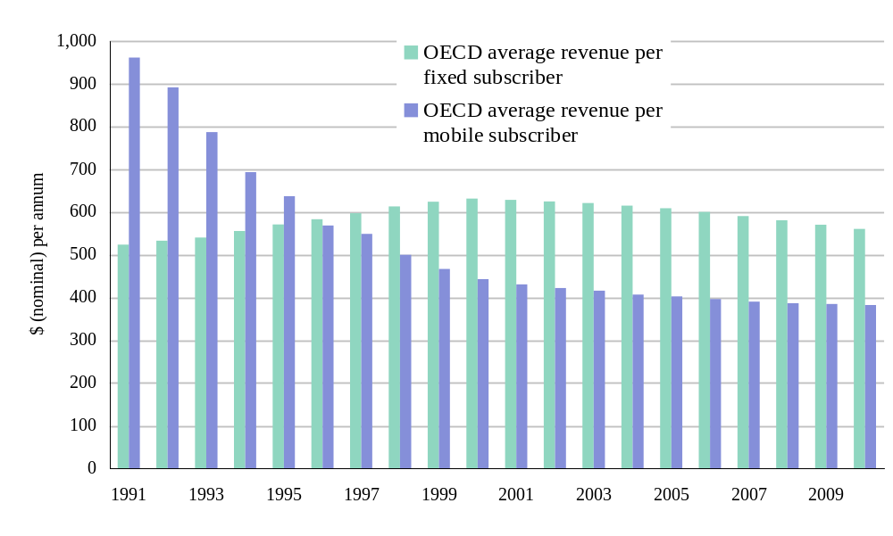
Exhibit 2.13: OECD fixed and mobile telecoms service revenue per subscriber, 1991 –2010 [Source: Pyramid Research, 1999]
Pyramid projects a very challenging picture for developed world networking in the next decade. This projection is based on a coherent bottom-up analysis and assumptions about supply and demand trends within the sector. However, it is only one plausible scenario among a wide range in existence within the industry today. As we see in the next section, the forecasting challenge in the developing world is even more striking, where the networking revolution becomes entangled with the uncertainties of economic, political and social development.
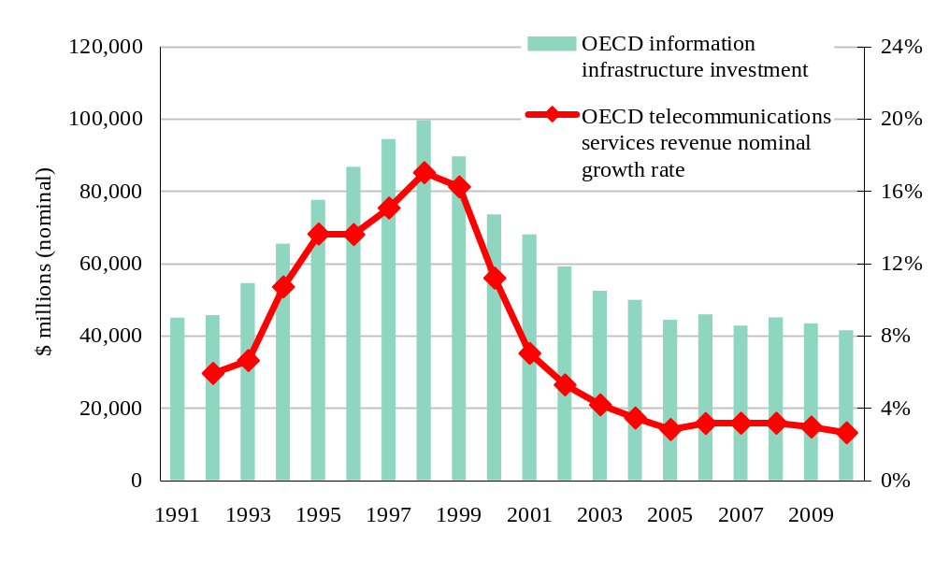
Exhibit 2.14: OECD information infrastructure investment and service revenue growth rates, 1991 –2010 [Source: Pyramid Research, 1999]

Networking and Development
Summary. Development ‘best practice’ is under review in the light of hard lessons learned over recent decades. A comprehensive development framework is required rather than the traditional ‘single lever’ approach. Networking fits well into this integrated approach to development, opening up development opportunities in a wide range of areas. However, the network revolution also carries threats for the developing world, and the balance of threat and opportunity is highly variable for different countries, and for different groups within a country.
The introduction to the 1999 World Bank Report finds that the “broad picture of development outcomes is worrisome”. Policies that have focussed on single issues in economic development have not delivered sustainable success. There is a “need to reach beyond economics to address societal issues in a holistic fashion”. “A comprehensive approach to development” requires more sensitive nurturing of development across a variety of fronts with multiple goals:
- sustainable development needs to encompass all aspects of the society, economy and environment
- development initiatives need to complement each other and be integrated under one policy
- there is no simple roadmap for development, and governments must have freedom to manoeuvre within a basic set of policy fundamentals
- good implementation processes are essential.
This transition is also leading to a swing away from programmes with a government focus towards those that work with a diverse range of actors in the public and private sectors: “Governments, the private sector, civil society, and donor organisations need to work together in support of broad-based development”. The emphasis on processes and governance is steadily increasing to ensure the successful implementation of policy. The result is a more balanced portfolio within development programmes.
The introduction makes reference to the “revolution in information and communications technology” and how it is causing the “economic vision to become less accurate each year” as economies become more “footloose”. Networking technologies are seen to be one factor that has “facilitated the rapid increase in global trade and financial flows.”
This chapter explores the major opportunities which new networking can offer countries in the developing world (Section 3.1); the threats which it also represents (Section 3.2); the likely balance of these threats and opportunities (Section 3.3); and the issues arising for networking development (Section 3.4).

‘New Networking’ offers major opportunities to the developing world
A large body of evidence confirms the macro-level correlation of development progress and telecoms progress |  | The macro-level correlation of development progress and telecoms progress is well established and a large body of specific evidence has been accumulated over recent decades, showing the importance of communications and information for development, both in the commercial and the public sectors.  New networking has the potential to amplify many of the development benefits that have been observed and assessed in the past. However, as in the developed world, it is also disrupting many of the historical relationships between network parameters and economic and social parameters, undermining the use of extrapolative techniques to predict future trajectories. Projections concerning the nature, magnitude and timing of the benefits of new networking must instead be based on qualitative hypotheses rather than established, tested quantitative relationships. Fortunately much of the existing qualitative work on the linkages between networks and developments is likely to continue to be robust in the new networking environment.
The impact of new networking differs from the observed historical impact of networking because of:
- the increased capabilities and functionality of new network services and technologies
- its steadily improving affordability.
The impact of this combination of factors in the developing world can be marked. For example, until the early 1990s, the networking options for a developing country were limited to narrowband copper telephony and crude narrowband fixed wireless telephony. International connectivity was generally provided by a very small number of satellite voice circuits, thin microwave links or, rarely, a submarine cable or international landline.
However, over the last few years, the range of choice has expanded significantly – individual developing countries have successfully deployed state-of-the-art mobile networks, broadband metropolitan area networks, advanced fixed wireless networks, paging networks, advanced satellite networks and high capacity submarine cables.
Moreover, the new network service portfolio is perhaps even more important than the expanded range of valuable technologies – for instance, the World Wide Web allows each connected user to participate fully in a single global space (see Box overleaf). This is a huge advance, magnifying the traditional impact of deploying a simple phone line many times over.
This section examines the technological dimension of networking and development in greater depth.
Before the invention of the World Wide Web (WWW) in 1989, only science fiction enthusiasts would have given credence to the idea that, by 1999, there could be a single global space, accessible and affordable to anyone with basic telecoms connectivity, using simple, powerful and ubiquitous tools for navigation, communication and transactions, and populated by all the world’s leading institutions and corporations. Experts in the field knew that there would be huge obstacles and delays hindering the creation of such a network, even given the existence of the academic Internet and other capabilities that proved to be key ingredients for the WWW phenomenon. With hindsight, the experts had missed one key ingredient – demand. The astonishing exponential growth in demand for the WWW is what swept away the obstacles and delays in a torrent of innovation and evolution.
The WWW model is particularly relevant to the developing world because of its characteristics of accessibility, affordability, usability, universality and flexibility. It has almost no geographic dimension – location and distance are irrelevant. It is essentially an ‘inclusive’ phenomenon, with very low barriers to participation. It is an excellent representation of the step change from traditional networking to new networking.

Networking technologies and development
History reveals a mixed experience … | The interrelationship of networking technologies and development over recent decades is a fascinating patchwork of achievements and disappointments, false optimism and unforeseen breakthroughs.
… of successes … | The success stories include:  - broadcast TV and radio services, which reach a huge proportion of the population, bringing enormous benefits for very little investment  - the Intelsat satellite system (and its peers), which provide international voice circuits to virtually every country on earth, at a reasonable price  - cellular mobile services  - the World Wide Web.
… and disappointments | Disappointments include:  - the public switched telephony network (PSTN), which has proved to be poorly matched to the constraints and needs of the developing world. In spite of massive efforts to tailor developed world systems (copper access lines and automatic exchanges) to developing country environments, they have remained too expensive to achieve mass market penetration, as can be seen from the persistence of low telecoms penetration in developing countries.  - ‘special systems’ created for the developing world. Despite the considerable effort which has been devoted to the creation of networking solutions that are specifically tailored to the needs of ‘low-density’ markets, including developing country markets, no breakthrough has been achieved, and little momentum has been created. A key reason for this lack of return must be the disconnection of this field from the mainstream of networking innovation and progress.
Slow progress has given rise to scepticism … | The magnitude of the networking challenge in the developing world is so great that ‘breakthroughs’ are essential if progress is to accelerate. However, in general, the costs of purchasing, installing and operating telecommunications networks in the developing world have been underestimated. The skills required to build and operate networks have been underestimated (engineering skills, organisational, administrative and commercial skills). Networking projects have also proved to be highly vulnerable to economic, institutional and military crises. As a result progress has generally been slower than predicted. Over the years, this has bred a distinctly sceptical, and even cynical, attitude to networking projects among many key groups, including bankers, managers, vendors, consultants and even some in developing world administrations.
… but the mobile phenomenon offers great hope … | This weary scepticism would be much more prevalent were it not for the unexpected phenomenon of mobile cellular networks in the developing world. Cellular systems such as GSM have proved to be excellently matched to the developing world marketplace – a remarkable occurrence given that the cellphone was seen as a status symbol in developed societies as late as the mid 1990s. Mobile service revenues in the non-OECD world have grown very strongly over the last decade, and now represent a third of global mobile service revenues, as illustrated in Exhibit 3.1 (overleaf). This compares with an equivalent figure for fixed services of one quarter.
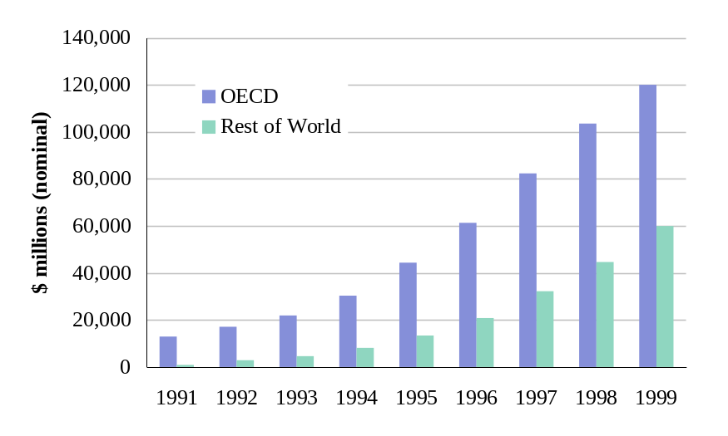
Exhibit 3.15: The growth of mobile service revenues, 1990 to 1999 [Source: Pyramid Research]
… and suggests some interesting success factors | The impact of mobile services on developing world communications infrastructure has been greater than any other initiative. Given this success it is worth noting some key features of the mobile experience.  - The networks have been created on a commercial basis. Even though many investments have been made by state-owned operators, and some have been supported by development banks and other semi-commercial sources, almost all developing world cellular networks are run for commercial profit.  - The networks are based on technologies and standards that were designed for the developed world. There was no ‘development’ dimension to the creation of these standards. The benefits of using identical technologies have been very high – rapidly falling costs (due to volume growth) and relentless innovation, and far outweigh the mismatches between the technology and the local environment.
- Success has stimulated innovation and progress in many directions. Operators have innovated in the design, distribution and marketing of mobile services to match market conditions. Users have innovated to control their expenditure and to gain maximum benefit from their cellphone. Regulators have introduced competition in mobile services far more widely than in fixed services, and have created innovative licences to maximise the benefits to their societies.
It is also worth noting that mobile services have, at least initially, contributed to inequality in the countries where they are deployed. Mobile services always penetrate the affluent customer base before diffusing more widely in society. Diffusion is happening, but it will be many years before the average citizen of the developing world can afford access to mobile services.
A range of other technologies may emulate this success | With over 100 million mobile subscribers added in the developing world in the last decade, the success of mobile services in the developing world demonstrates that networking technologies can bring real benefits in a short time period. After the cellular breakthrough, there is no place for reflex cynicism in this field, and below we consider a range of other technologies emerging in the developed world, which also have the potential to deliver real benefits to the developing world:
- fixed wireless services
- mobile wireless services
- satellite services
- the Internet Protocol and related developments
- high capacity fibre trunking systems
- wireline technologies.
Of course, this does not mean that all networking technologies being promoted will find success – there will still be disappointments as well as surprises.

Fixed wireless services
Progress in the developing world depends on outcomes in the USA and Europe | Independent observers agree that wireless should be able to provide a commercially attractive networking service. Wireless technology should, in theory, be able to serve a given area more cheaply than a wireline network for all but the densest demand hotspots. The risk profile should also be better for a wireless network, since user terminals need only be provided to those who wish to take the service, whereas wireline networks must be built to pass all potential customers, even those who do not take the service.
 | Fixed wireless economics are particularly well matched to developing markets, where demand for network services is often very thinly spread even in dense urban areas. Based on these well matched economics, there are many fixed wireless initiatives underway in the developing world today. However, in contrast to mobile wireless, where successful developed world systems translated easily into developing markets, to date fixed wireless has had no real momentum in the developed world, and therefore little has built up in the developing world.
 | It is possible that developed world momentum is now beginning to grow in the area of fixed wireless services. Interest in a family of wireless technologies known as Local Multipoint Distribution System (LMDS) has grown in recent years in the USA, and now equipment vendors and operators are gaining confidence in the capabilities and cost-effectiveness of this new generation of broadband wireless access equipment. Interest is spilling over into European markets, and many European administrations are now licensing fixed wireless operators working with broadband wireless access technologies. Analysts believe that the technology has good prospects, and if these expectations are correct then a wave of deployments in developing countries could follow rapidly.
 | Cells of a few kilometres diameter could be established in the main business districts of developing world cities, and business sites would be connected by a roof-mounted terminal costing less that $1000. Services could range from a few voice circuits to many Megabits per second of data or video. As global manufacturing volumes rise beyond the first million units, the cost of the terminal should fall to a few hundred dollars, and the base station cost would also fall significantly. Coverage could grow to include less affluent business zones and residential districts. The parallels with mobile service diffusion are clear – high-speed access that is still a rarity in the developed world could become commonplace in the developing world within a few years.
 | It is important to note that no development initiative can make the difference between success and failure for the current generation of fixed wireless technologies. If they succeed in developed markets then they will spread rapidly to the rest of the world. If not, then they will limp on in the developing world on a completely different trajectory. Development initiatives can optimise the outcome, but cannot change the outcome if we are heading for another false dawn for fixed wireless in the developed world.

Mobile wireless services
Mobile wireless technologies offer a range of exciting possibilities |  | Alternatively, a number of potential trajectories for existing ‘second generation’ (2G) cellular mobile systems could lead to mobile wireless technologies invading the space targeted by fixed wireless. 2G systems do not have the capacity to offer high speed data services to end users, but a range of enhanced 2G technologies (2G+) can increase the data rate for users to levels equivalent to a modem on a good fixed line. Moreover, the cost of upgrading to 2G+ is relatively low (see Box overleaf).  2G+ does not increase the overall capacity of a cellular network – indeed it makes things worse – and so to achieve a high capacity network that can support a large customer base at high data rates, it is necessary to move to ‘third generation’ (3G) technologies. This move is expensive, and the business case for 3G services is less proven than for 2G+. In the developing world, 2G+ therefore provides a very effective way forward since, in most developing countries, it is still possible to increase the capacity of the network by further investments (sectorisation, smaller cells, etc.). However, 3G may prove to be usable in developing markets as a fixed wireless substitute technology. 3G will not be optimised for this, and may require some unusual local implementations, but if fixed wireless does not develop as planned, and 3G takes off in the developed world, this may become the most pragmatic alternative for fixed services.  A further development in mobile wireless is the emergence of technologies that are specifically designed for developing markets. Now that developing countries represent a significant proportion of the mobile equipment market, it has become worthwhile to create products that specifically address developing world needs. Examples include Motorola’s long-range cellular base station aimed at covering large areas of sparse demand, and whole families of base stations, power supplies, microwave trunking, low specification handsets and other innovations sized and priced for developing markets. This is a world away from the ‘special systems’ referred to above – it keeps the developing world locked into the mainstream of innovation while understanding and meeting its specific needs.
 | High expectations have become almost universal for mobile telephony in the developing world. For example, a recent Economist telecoms supplement is focussed on mobile telephony and highlights the way in which “mobiles have become a powerful tool for bringing the poor and isolated into the global economy”. This is because mobile networks in developing countries can be more reliable than the fixed network, faster to roll-out, and easier to maintain. They also bypass what can be extremely lengthy waiting lists for fixed lines. Prepaid tariffs are making mobile phones accessible to low income groups. The Economist sees “Mobile phones not only releasing a wave of entrepreneurialism; they are also helping people to escape the greed of middlemen by providing them with the information that they need to strike better bargains”. The advent of the “mobile information society” will bring new flexibility and speed to business, while forming the “virtual family nucleus” for increasingly dispersed social networks. The demand for content that is formatted for microbrowsers and software to enable data sharing will cause “entirely new categories of business will spring up”. This explains the report’s views that “wireless is the most exciting area of the telecommunications industry”. The high expectations for mobile telecoms amongst non-telecoms specialists is a key development underpinning the accelerated deployment and development of mobile services.

Satellite services
The future is in the balance after the commercial failure of Iridium turns investors against satellite … |  | Satellites provide uniform coverage of huge areas for a few dollars per square kilometre, but require enormous up-front investments for their design, construction and launch. They are extremely well matched to the networking demand characteristics of the developing world, but badly mismatched to the funding realities of the developing world, where only incremental, low risk strategies can be funded commercially. Indeed, for two decades the only satellite services in the developing world were supplied by treaty organisations such as Intelsat.
 |  | Satellite networking is now at a crossroads. Until 1998 there was a growing wave of enthusiasm for commercial satellite projects, many of which offered huge potential benefits to the developing world, as well as promising attractive returns to their investors. However, the commercial failure of the Iridium system has grievously wounded the whole sector. Depending on the commercial performance of two or three other systems – Globalstar, Thuraya (see Box), and possibly ICO – it may now be years before investor confidence returns and the full development benefits can be accessed. It is essential in this area to disentangle sentiment from rational analysis, but also to remember that sentiment is the key driver of satellite investments. Exhibit 3.2 (overleaf) provides a very high-level review of the issues.
Thuraya is a venture to offer mobile voice services in Africa, Asia and the Middle East using a geostationary satellite. Based in the UAE, the venture is backed by a wide range of investors from the footprint area and beyond. Thuraya has made different trade-offs to its satellite rivals – the use of a single geostationary satellite gives Thuraya a lower cost base than that of its multi-satellite low earth orbit system rivals, but the distance to the satellite introduces an audible delay for users.
The footprint covers an extraordinarily diverse range of markets, some of which have little or no terrestrial networking, but also some thriving cellular markets where there is high demand to roam beyond the covered area. Although Thuraya is a commercial project, the development impact of affordable universal voice services in the footprint area will be very significant. Commercial service is scheduled to begin in September 2000, and the venture is fully funded. See www.thuraya.com

… and the developing world has a key role to play in determining the sector’s success |  |  | As described in the Exhibit, there is a certain symmetry in the linkage between narrowband and broadband satellite destinies. The success of the current generation of funded narrowband systems will be determined in the developing world. If success is achieved, then it is likely that one or more broadband systems will be able to obtain funding. The developing world would then see huge benefits from an operational broadband satellite system such as Teledesic (see Box), Skybridge or Spaceway.
 |  | Geostationary  satellite systems |  | Non-geostationary  satellite systems
 | Broadcast systems | The new generation of broadcast satellites (DirectPC, Astra, etc.) has the capacity to be used for hybrid interactive services (where the user is also connected to a terrestrial network). This is a valuable option for developing country users who have access to a phone, but services are not yet mature in any market. |  | –
 | Interactive narrowband systems (mobile voice, paging, etc.) | For Inmarsat, Thuraya and other regional systems, the technology challenges have been overcome, and the new services are at reasonable price points, but the marketing and operational challenges are significant. Demonstrating success in meeting these challenges would boost the whole satellite sector.  The outcome will be determined in the developing world |  | Of the operators in this category, (Iridium, ICO, Globalstar, Ellipso, etc.) only Globalstar is currently fully funded. Its planned price points seem well matched to its markets, but the technology challenge is still very real, and marketing and distribution dependent on regional gateways. Success for Globalstar would boost the sector.  The outcome will be determined in the developing world
 | Interactive broadband systems (fixed multimedia) | Spaceway, Intelsat Ka and others Teledesic and Skybridge  These systems have made slow progress because of the lack of clear demand for their services and concerns over the technical trade-offs and the technical, financial, regulatory and other risks entailed, although these issues are different for geostationary systems (latency and capacity worries) and non-geostationary systems (technical and financial worries). However, the successful entry into service of any of the global broadband systems would have a huge benefit for the developing world. Prospects for raising the funds to build a global broadband system are dependent on the success of one or more of the narrowband systems (above), even though there is little real linkage between these business cases.
Exhibit 3.16: Key satellite segments and prospects [Source: Analysys]
It is worth concluding this section with a note about the affordability of satellite services. All of the services mentioned above, with the exception of Iridium, claim to be affordable for developing markets, but none will be affordable by the average developing world citizen. Satellite services, like mobile services, will first be taken up by affluent business or private customers and will then gradually diffuse to other market segments. For this diffusion process to be short-circuited (for example to support rural village payphones) then this will require subsidy and intervention. Commercial satellite services may be the ‘philosopher’s stone’ for networking development but they will not change the economics of poverty.
Teledesic plans to offer high-speed fixed services worldwide, using a large constellation of low-earth orbit satellites. The objective is to offer a seamless fibre-like service so that ordinary network applications can behave as though running across a modern fibre network (with low latency and error rates). Bill Gates and Craig McCaw are among the backers of Teledesic, which is based in Seattle.
The satellite system is expected cost $9 billion or more, a sum which would set a new record in the industry. The venture has made important regulatory progress but has yet to finalise the major procurement contract for the system, reflecting the technical challenge of the objectives, and the huge financial considerations. Even though Teledesic shares very few features with Iridium, the funding challenge for Teledesic is materially increased by Iridium’s failure. Commercial service is planned to begin in 2004.
The development impact of a system such as Teledesic would be enormous, through a variety of mechanisms. In the corporate market, the ‘inclusion’ benefit of affordable seamless networking would alter the behaviour patterns of multinational corporations to the benefit of developing countries. The ‘projection’ benefit for indigenous corporations would be substantial. Teledesic has argued that the ‘development impact per dollar spent’ would be higher for Teledesic than for any other networking investment, however large or small. See www.teledesic.com

The Internet Protocol and related developments
IP – an opportunity and a challenge for the developing world | As a truly open universal networking standard and focus for global innovation, the Internet Protocol (IP) is already at the core of major development opportunities for the developing world. However, as an accelerator of change, IP also indirectly sets a challenge for the developing world. Because of the effect of IP, it is now essential for any city, country or region that aspires to participate in the networking revolution to have high-speed, high-specification network connections into the global ‘Internet cloud’. This is a difficult objective for many developing countries whose current international connectivity is just a thin satellite path. Ironically, given the death of distance in the developed world, accidents of geography will be key determinants of progress in this area. A country with an affluent and well connected neighbour may only need to invest a few million dollars to achieve a high speed connection. A country passed by a planned submarine cable may persuade its constructors to lay a spur to their coastline, or even land the cable on their territory. For many, however, the cost of hundreds or even thousands of kilometres of high capacity trunking will be hundreds of millions of dollars.
The economics of networks dictate that a hub and spoke architecture will emerge for networks, and this process is intensified through the impact of the IP. The process by which hubs emerge and grow will be a mix of economics, politics and, ideally, planning. However, there is a great deal of pride and paranoia in the politics of network hubbing. Many are reluctant to see their neighbour emerge as the regional hub, with all of the prestige and even leverage that appears to imply. However, for most developing countries and cities it will be more beneficial to achieve a rapid transition to an effective hub-and-spoke model than to compete with a neighbour to become the regional hub. Those that are concerned about dependence on a neighbour for connectivity can look to connect with other hubs for security, or look to supranational institutions to ensure fair treatment.
The IP raises a wide range of other issues for the developing world, which grows larger as the revolution intensifies. On balance, the IP-driven opportunities outweigh the IP-related problems, but the dilemmas of IP peering, IP6 and others are real and important concerns.

High capacity fibre trunking systems
Submarine or overland fibre connectivity is a pre-requisite for participation in the revolution | As discussed above, high capacity connectivity is important for participation in the networking revolution. Long route fibre is being laid at an ever growing rate around the world, particularly on the axial routes linking developed regions. Cables have ever rising capacity – multiple Gigabits per second connections are a commonplace. The key technology enabler is Dense Wave Division Multiplexing (D-WDM), a concatenation of breakthroughs in the physics, the organisation and the manufacturing of optical fibre and its associated components. Even though the cost of laying long route fibre remains expensive – over $100 000 per kilometre is typical – this cost is falling while capacity is climbing, driving unit costs down at a rapid rate.
Although the cable boom is not a purely developed world phenomenon, due to cables such as FLAG, the SEA-MEA-WE series, the trans-Siberian fibre and short haul cables in Asia and the Caribbean, it is also by no means an inclusive phenomenon. Much of the world is either not part of any funded cable plan, or is hoping that a project such as Africa One (see Box overleaf) or Oxygen finds its funding and goes ahead.
In an encapsulation of the wider networking challenge, achieving high capacity international connectivity holds the prospect of great benefits – unchaining a country’s businesses, universities, schools and others in the global information space – but the postponement of this connectivity can block off this path for a country at a crucial period.
Africa ONE is a US$1.6 billion project to build a 39 000km submarine fibre-optic ring along the African coast by 2002. The network will form a self-healing 40 Gigabit per second ring around the continent and will connect more than 24 coastal-country landing points. Countries without landing points will use terrestrial fibre, microwave, or satellite to link to Africa ONE.  The concept of Africa ONE was first proposed in 1993. At a meeting of Directors-General of African telecommunications carriers held in February 1999 in Djerba, Tunisia, under the auspices of the ITU, African support for the resumption of Africa ONE as a private cable was confirmed. Thirty African countries have formally indicated their interest in participating in the project. Although Africa One appears to be a financially viable project, it has not yet been able to attract the hundreds of millions of dollars of committed investment that it needs to proceed. | 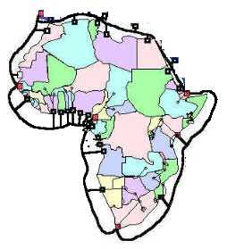  Schematic of the Africa ONE system [Source: Africa ONE]  See www.africaonesystem.com

Wireline access technologies
Wireline has a limited role in the network development portfolio | Wireline access technologies divide into ‘greenfield’ technologies such as metropolitan area networks (MANs) that require high concentrations of demand to be viable, and upgrade technologies such as ISDN, digital subscriber line technologies (xDSL) or cable modems.
Most developing world country capitals and major cities will have an area of their main business district that can justify the investment in a MAN, covering a few square kilometres and a few axial routes. This will need to connect to the main international gateways, and perhaps to other MANs in the country.
The difficulty with MANs is their limited viable coverage and the sharp cut-off beyond this limit of viability. A $20 million MAN covering a 10km ring may be viable, but the next 10km ring may not be viable at any cost above $2 million. MANs are not, in general, viable for the less affluent districts where most of the employment and activity occurs in most developing economies, unless good dry ducting already exists. Extended MANs can be used as part of a larger strategic plan to catalyse growth or change the shape of a national economy (as in Malaysia’s Multimedia Supercorridor), but the cost-benefit equation here is much more complex and challenging, and such networks still only serve a small proportion of the population.
There is significant debate within the industry concerning the advisability of building any new wireline networks to serve suburban areas, other than in areas of new construction where ducting can be incorporated in the build. This is prompted by a long list of recent cable TV investments that have not provided the expected rate of return, generally due to local competition conditions. In developing markets, where a slice of demand has already been captured by cellular systems, wireline investments may be largely confined to infilling in existing network areas and providing services to new buildings.
Upgrade technologies are all constrained by the deployment of existing networks, which is very limited in most developing environments. A Digital Subscriber Line upgrade is only possible where there is a high quality copper network already in existence, and many longer lines cannot be upgraded economically. Similarly, cable modem upgrades require a high standard digital cable TV network, and many cable network topologies are expensive to upgrade. Few developing countries should expect to see much benefit from wireline upgrade technologies.
It is important not to confuse the ‘death of distance’ with the ‘death of geography’. The ‘death of distance’ is a term commonly used to refer to the elimination of distance as a material cost driver for communications between two connected points. This phenomenon manifests itself where national, cross-border and intercontinental telecoms charges fall to a common level (notably on high-traffic routes between major cities). The ‘death of distance’ is rooted in the basic cost economics of modern communications networks and the dynamics of the competitive marketplace. Any location that has good high capacity connectivity into the core global network (see above) will experience the phenomenon. A growing number of developing world locations are seeing distance diminish as a driver of their communications costs (either due to their proximity to the core global networks or due to specific investments in international connectivity).
However, geography (location) is still a key determinant of communications costs and functionality. A user in an area of low demand density (either due to sparse population, low spending on communications or a combination of these) will still tend to have proportionately higher communications costs and lower available functionality. This phenomenon is also firmly rooted in the basic cost economics of networks. The death of distance and the longevity of geography can and will continue to coexist in the developed and the developing worlds.

Conclusions on technology issues
Key messages for the developing world are emerging | There is a growing range of technology-based opportunities for the developing world, including some areas that have disappointed in the past. Rational analysis is required to make sense of the complex and shifting technology landscape. This complexity increases technology risk, and thus the importance of letting this risk rest with competing commercial participants in the marketplace. This implies a technology neutral basis for the regulation and administration of networking, wherever this can be achieved, and a liberal policy for licensing operators.
 | However, some technologies will require the active involvement of policy makers and administrations if they are to be deployed, presenting the classic development intervention dilemma. The laying of high-capacity fibre cables and the initiation of major satellite projects are two areas where international co-operation and facilitation are necessary, but the risks of such large projects are generally too great for deeper public involvement. These issues are addressed in more depth in Chapter 5.

Mechanisms by which networking can contribute to development benefits
There are five key mechanisms by which networking can contribute to development benefits … |  | The issue of how new networking will accelerate development is well covered in the literature – for example, Talero and Gaudette [1996] identified nine areas of ‘opportunity for extraordinary gains’ (see Box). We highlight five specific areas:  - improved economic efficiency and competitiveness  - more efficient public services and administration  - exploitation of low factor costs in international markets  - opportunities to increase social capital  - opportunities to bypass failing domestic institutions.  These mechanisms are discussed below.
‘Opportunity for extraordinary gains’ from Talero and Gaudette [1996]:
- Educate more people and support lifelong learning
- Make governments more efficient, transparent and accountable
- Increase the effectiveness of economic reforms
- Monitor and protect the environment
- Reduce information and income inequalities
- Overcome natural disadvantages
- Diversify into information intensive industries
- Promote small and medium enterprises
- Participate in global trade and competition.

… improved economic efficiency and competitiveness … |  | This is the traditional focus of work looking at network development and economic development causality. All important micro-economic processes benefit from improved information flows. A developing economy which has eliminated its networking bottlenecks should be able to acquire its imports more cheaply, organise its primary and secondary production more efficiently, operate its markets more efficiently (goods, assets, labour, capital), and exploit its intellectual and human capital more effectively. It should also be better able to attract and exploit foreign direct investment.
… more efficient and effective education, healthcare and public administration … |  | Many commentators have asserted that the potential for networking to make an impact on the public sector matches or exceeds the potential in the commercial sector, although the force of these assertions is always diminished by their qualitative basis, and by the observed failure of networking to make a major impact the public sector to date. However, these difficulties should not diminish the credibility of the overall argument – there is a strong match between the needs of the public sector and the beneficial characteristics of new networking. If ways can be found to exploit networking in education, healthcare and public administration, then these would be highly beneficial in overall development terms.
… opportunities to exploit low factor costs in international markets … |  | This expectation is rooted in classical economics, but has proved to be a limited phenomenon in reality, to the consternation of early development economists. In reality, the factor cost advantages of developing countries are masked by the higher transaction costs that they experience due to geographical location, trading costs, etc., and their institutional and infrastructural shortcomings such as weak legal and administrative structures, skill shortages, transportation and communications problems. However, there are many examples of developing countries overcoming these obstacles and exploiting their low factor costs (see Box). These examples indicate that there is a strong threshold effect, i.e. a developing country can only achieve sustainable benefit from exploiting its low factor costs when skills, infrastructure and institutional development has passed a threshold level.
 | Examples of successful exploitation of low factor costs: Mexico has benefited from its proximity to the US market – its northern belt of industrial development is only a truck-ride away from its main customer base. The ease of transporting textile and footware products (and their simple upstream supply chain) has enabled low-cost Asian suppliers to capture a significant share of manufacturing volume. India has exploited its high skills base, its low labour costs and the inherent transportability of software to penetrate the international software development sector.

 | For developing countries that have passed this threshold, the networking revolution can broaden the base of products and services where low factor costs can be used as a source of competitive advantage. For example, India can extend the boundaries of its software industry from its origins – the coding of large systems – to include systems integration, packaged software, system specification and design and consultancy. Not only does this expand the volume of business, it also increases the value captured by India. New networking will have a material impact on the ability of many developing countries to exploit their low factor costs in global markets, with potentially large economic benefits.
… opportunities to increase social capital … | From a developed world perspective it is easy to forget the social benefits of ubiquitous affordable networking in developed societies, and so miss the potential for positive impact as developing countries achieve these levels of networking. The literature of telecoms development does give significant weight to the social capital impact of networking, but this has not been picked up in generic development policy development until very recently. The potential positive impact of new networking is particularly pronounced in the following areas:
- social cohesion, notably in societies with high levels of migrant labour, such as China or South Africa, where families and communities are severely strained by geographic separation
- information availability – easy access to a wide range of information is an essential prerequisite for living in a complex, stable and progressive society
- entertainment – it is hard to quantify the social benefits of widespread access to entertainment through the media of multi-channel TV and radio, but this should not diminish recognition of its importance, particularly in societies that are stressed by poverty, instability and social change
- education, through access to information and access to teaching. Distance learning is a valuable tool in the struggle to overcome resource constraints in developing world education
- healthcare effectiveness and efficiency benefits from improved networking
- welfare development depends on distributed information systems, which in turn require a reasonable standard of affordable networking
- gender issues – where women have access to networking in the home or workplace, it can contribute to equalising access to information, entertainment, education, as well as increased empowerment in the spheres of community and family
- active citizenship – ease of participation in political, administrative and other institutional life
- the fostering of international link – cross-border communication can develop personal and community ties that extend beyond narrow local concerns. Affordable voice, email and other media are beneficial in this area.
… and opportunities to bypass failing domestic institutions | Where citizens are confronted by inadequate domestic institutions or services, they may seek access to alternatives in other environments. Examples include access to banks, legal services, traders, brokers and information providers. For many decades this cross-border access has been the privilege of a wealthy minority in most developing countries. New networking will lower the cost threshold to the point where it becomes an option for many more citizens. The benefits to the individual citizen may be significant, although it should be noted that many of these cross border activities are currently in breach of national civil or even criminal laws.

‘New Networking’ can present significant threats to the developing world
The network revolution could widen the development gap |  | Despite the opportunities which the network revolution offers, there are also many ways in which it could widen the development gap. The development gap represents relative development, so it quite possible for new networking to drive increases in absolute development at the same time as widening the development gap if it has a greater impact in the developed world. This section is primarily concerned with the effects of the networking revolution that may constrain its impact on absolute development in the developing world, and hence act to widen the development gap.  Firstly, the transition to new networking, and specifically to ecommerce, exposes known weaknesses in most developing countries:  - inadequate legal and commercial frameworks  - shortfalls in education and knowledge development  - weak network services and infrastructures.  Where these constraints exist, they will slow the development of indigenous ecommerce, passing the initiative to offshore ecommerce providers and dissipating the benefits and opportunities that would flow from more rapid progress. If the domestic initiative is lost, and ecommerce structures establish themselves around an offshore model, it will be very hard to revert to a nationally focussed model. Although the national economy will see some benefits, the development gap will widen as the developed economies pull further ahead.
Increased tradeability in services may expose weak domestic service sectors such as finance services, legal services and retailing to greater international competition. The development of these sectors may be damaged, as foreign providers are able to reach into domestic markets more easily and more effectively. Although there is not yet any robust evidence of this phenomenon it is worthy of concern. Any threat to these classes of activity is a threat to the long-term development of the country, since these embryonic service activities are essential to the economic, social and institutional progress of all developing countries: they are a nursery for smaller enterprises; have a disproportionate impact on the development of institutional frameworks; foster a growing indigenous professional class; and help to diversify the domestic economy.
However, most of the actions that can protect these sectors carry an equal danger of harm to long-term development. Experience shows that many attempts to shield a specific sector from cross-border competition have been unsuccessful and damaging to the wider economy in the medium term.
In our assessment, the potential threat to development is real and material. Breaking out of this Catch-22 dilemma is a major challenge for policy development. We fear that concern over domestic service sector development will form part of a flawed rationale for resisting the networking revolution in developing countries. Whatever the evidence of risk, this effect cannot justify a slow response to the networking challenge.
Finally, the global upheaval of industry and commerce carries risks of volatility and instability for developing economies. If the networking revolution hypothesis proves to be accurate, then the developing world will have to attempt to make progress in a turbulent and unpredictable global environment. Corporate strategies may become more short-term focussed, which may reduce investment in developing countries. Commodity prices may become more volatile, hurting the export earnings of many developing countries. There is even a danger that the development challenge may slip lower on the agenda of developed world politicians and institutions. Purely from a planning perspective, uncertainty and turmoil in the developed world significantly complicates the assessment of developing world scenarios.
For reference, Talero & Gaudette categorised their ‘threats’ under the following headings in 1996:
‘Hazards’ from Talero and Gaudette [1996]:
- Cultural threat
- Social disruption
- Social and employment inequities.

The balance of threats and opportunities for developing countries
There will be a wide range of net outcomes, from strongly negative to strongly positive, across developing countries, based on their current development status, their location, the structure of their economy, social factors and policy decisions. Although it is possible to build a hypothesis for each country based on a range of assumptions, the prediction of the net outcome is subject to significant uncertainty.
There will be a wide range of outcomes for different groups within countries. In general, those who benefit most will be those that are affluent, urban, educated and who have the flexibility to adapt to new challenges. However, where the macroscopic impact of new networking on the national economy is particularly harmful, even these groups will suffer.
Potential negative outcomes cannot be avoided simply by adopting a passive defensive approach. Failure to embrace the opportunities arising from new networking will not ensure insulation from the negative impacts. Section 4, below, addresses the range of outcomes that are plausible for different categories of developing country.

Key issues arising in networking development
Optimising networking development involves balancing the impact of different types of inequality | The following issues and dilemmas arise when considering the impact of networking development.  - Equality of network provisioning between countries for potential users of equivalent affluence and behaviour. Where users of equivalent economic, social or institutional status have widely differing access to network services (either due to availability or affordability) then there will be differences in effectiveness and efficiency that will be reflected in the development trajectories of countries.
- Equality of network provisioning within countries. In the developed world, traditional fixed operators are generally obliged to provide a ‘universal service’ – the offering of a set of services at a standard (‘affordable’) price to all citizens, wherever they are located and whatever their income. The social and developmental benefits of USOs are significant. Effective, operable USOs are still rare in the developing world, although they are increasingly included in sector reform programmes. The costs and benefits of introducing USOs in the developing world are still poorly understood – only in the last few years has USO analysis in the developed world achieved any real maturity.
- The trade-off of international inequality and national inequality. It is extremely hard for a developing country to allocate its resources and focus its policy measures to achieve the optimum balance between these two problems. At one extreme, all resources could be focussed on the provision of high-quality services to a tiny fraction of the population, elevating this group to close the international inequality gap, and bringing certain development benefits. At the other extreme, all resources could be focussed on providing the most basic communications services to the largest possible number of citizens, bringing quite different development benefits. Clearly, most administrations chose a middle path between these extremes, but the optimisation problem is extremely challenging and generally unsolved. The issue is significantly complicated by the wide range of technologies available to address each area of need, and the uncertainty over the evolution of many of these technologies.
These issues are considered in more depth in Chapter 4, which looks at the range of plausible outcomes for networking development and broader economic and social development, and in Chapter 5, which considers policy and programme options.

Developing world outcomes
Summary. Based on a hypothesis for the determinants of success for networking development, countries can be grouped according to their likely range of outcomes. A group exists where the range of outcomes is particularly wide, uncertain and vulnerable where policies are not optimal. This range of outcomes is illustrated for a hypothetical country. The outcome expectations of the Pyramid Research (from a sister project ) are presented and discussed.

Characterising country groups
Countries are grouped according to their expected development outcome | This chapter sets out to characterise the range of plausible networking development outcomes for developing countries, and assess the determinants of these outcomes. Ideally, networking and development outcome scenarios would be developed for every country, based on the specific situation of each country, since the key lesson from the last decades of development experience is the importance of locally specific diagnosis and prognosis. However, constraints of time and resources dictate a less specific assessment in this report.
We have thus grouped countries according to their expected networking and development outcomes. This enables us to focus more detailed assessment on those groups where the outcomes are most uncertain, and most dependent on the efficacy of networking policies and programmes.
Several determinants of development outcomes have been included | The first stage in this segmentation process is to propose hypotheses for the determination of networking and development outcomes. We have worked with the hypothesis that the following factors are the key determinants of networking and development outcomes at the national level.
- Prosperity – specifically, the percentage of the population that is sufficiently wealthy to participate in networking activity. This hypothesis is based on the strong historical correlation between prosperity and networking, and the assertion that this correlation will be maintained to a material degree, however disruptive the networking revolution becomes.
- Human capital development – used to modulate the prosperity assessment, using UNDP Human Development Indicator indices. This hypothesis is based on the assertion that a human capital deficit can hold back networking development and reduce its impact on wider development. This cannot be demonstrated robustly from a historical analysis, but does reflect the predictions of many observers.
- Institutional status and performance – exploitation of new networking depends on the existence of stable, pragmatic institutions that act in the true interests of their people. This assertion is based on a qualitative review of the correlation between institutional status and networking development.
- The status and performance of the networking sector – this parameter covers the existing level of communications infrastructure and services including affordability, the current pace of improvement, the organisation of the sector (covering the spectrum from unregulated monopoly to well regulated liberal competition), and prospects for future improvement (based on national demographics and geography as well as institutional aspects). The geographic dimension is particularly important – a country can benefit significantly from being close to a highly developed neighbour, since the cost of upgrading international connectivity is still distance-dependent.
Although the following are also key determinants of networking outcomes, they are not used in the segmentation:
- policies for networking and related matters
- programmes for networking development and impact optimisation.
Instead, these two parameters are used as scenario variables. We assume that any country could introduce beneficial policies and programmes, and we can examine the impact of these beneficial policies and programmes on the outcome.
Four country groups are identified | We use the determinants to assess the likely range of outcomes for each country, and then look for groups of countries where the outcomes share common characteristics (particularly in terms of certainty or uncertainty). This process results in four main groupings, described below:
- Group A: developed countries. The development trajectory for developed countries is expected to continue upwards, accelerated by the impact of new networking.
- Group B: developing countries that are expected to make good progress, benefiting from the impact of new networking. It is expected that most members of this group start out with higher levels of development, and have reasonably liberalised networking regulations and an open approach to trade.
- Group C: developing countries where the balance of positive and negative impacts is uncertain. The optimum management of new networking can lead to a positive net impact on development, following the ‘Group B’ trajectory. Group C is subdivided into C1, C2 and C3 according to their current prospects:
- C1 countries have a good prospect of implementing the necessary reforms and programmes that would lead to a positive participation in the networking revolution, but less successful policy actions will lead to a widened development gap.
- C2 countries are less well placed in terms of institutional status and performance, and these circumstances will need to change in the near future if they are to be beneficiaries of the networking revolution. Again, the range of outcomes is wide.
- C3 countries are the poorer developing countries where the net impact of new networking is expected to be small relative to the existing sources of poverty and instability. Networking development will probably remain low on the list of development priorities for these countries, and those networking programmes that are implemented in these countries will need to take account of the constraints imposed by other basic development requirements.
These generic development paths are illustrated in Exhibit 4.1.
Exhibit 4.17:
Segmentation of countries into four groups to characterise the impact of new networking on development [Source: Analysys]

As discussed above, four parameters are assessed as being the key determinants of national outcomes:
- prosperity is assessed using the income distribution for the country where this information is available, and estimating the participation share based on GDP or consumption where it is not available.
- human capital development – in practice this only changes the group assignment of a very small number of countries, where the Human Development Index is significantly out of line with the prosperity level of the country (positive or negative).
- institutional status and performance – this is a heuristic assessment, not least because a 1999 ‘snapshot’ of institutional status and performance cannot capture positive or negative developments that may occur in the coming years.
- the status and performance of the networking sector – this parameter covers the existing level of communications infrastructure and services (including affordability), the current pace of improvement, the organisation of the sector (covering the spectrum from unregulated monopoly to well regulated liberal competition), and prospects for future improvement (based on population density and income density, the distance from major global communications nodes and institutional aspects such as WTO telecoms status, and accounting rate status).
The results of the segmentation, spread by fixed line penetration and fixed line growth rates, are shown in Exhibit 4.2 (overleaf). These axes were chosen because they illustrate the clustering of the segments and also highlight the infrastructure gulf between Group A and the other groups.
The Groups have clear differentiating characteristics | Group A contains countries that account for only 15% of world population but 78% of world economic output. Whilst networking policies and programmes in this group may have a significant impact on economic and social outcomes, they will not have a great deal of impact on domestic development outcomes, simply due to the relatively low levels of poverty and deprivation within this group.
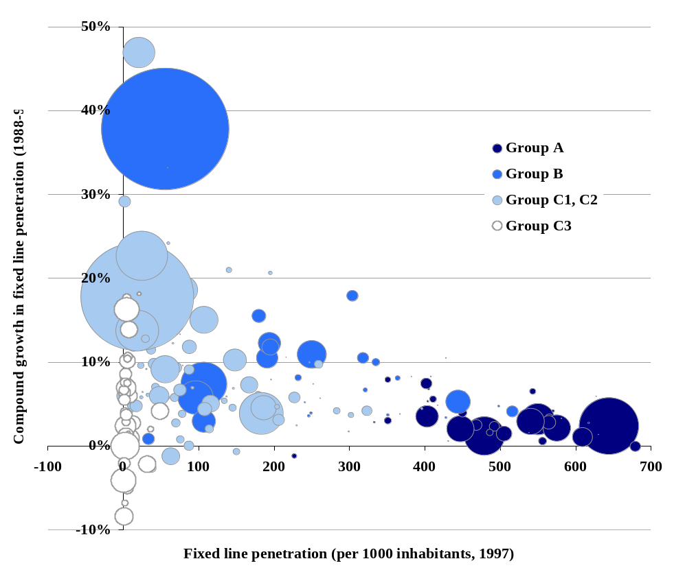
Exhibit 4.18: Segmentation of countries into four groups, spread by fixed line penetration and growth in penetration – bubble size is proportional to population [Sources WDI, ITU, Analysys, 1997]
Group B countries account for 31% of world population but only 14% of economic output. These countries are assessed as being very likely to keep up with Group A, based on their existing level of development and/or their positioning for challenges to come. We have included China in this group based on the prospects for urban China. As China is such a large country it is necessary to distinguish between the prospects for China’s 300 million urban population and the 900 million rural inhabitants. However, for the purposes of this simple segmentation we have been swayed by the positive networking prospects of urban China. As noted earlier, Group B countries are not guaranteed to progress successfully, and their policies and development should certainly be monitored closely.
Group C1 and C2 countries account for 41% of world population but only 7% of economic output. A key purpose of the segmentation is to enable a clear focus on Groups C1 and C2, where the outcomes are most uncertain and where policy actions and programmes may be most effective. Our hypothesis is that both groups C1 and C2 will show a wide spread of outcomes, based on the range of responses to the challenge. A country in Group C2 that optimised its policy responses to the networking challenge would have every chance of outperforming a Group C1 country that did not react effectively.
Group C3 countries account for 15% of world population but only 1% of economic output. The policies and programmes required for Group C3 countries are likely to differ from those matched to Groups C1 and C2, with much greater dependency on other development areas (economic, institutional, healthcare, etc.).
Exhibits 4.3 to 4.8 show the segments split by various different parameters to illustrate the clustering (and lack of clustering) of the four groups.
National population density is not correlated with country grouping | As Exhibit 4.3 (overleaf) shows, national population density is not correlated with current output per capita or our country segmentation. National networking outcomes are determined by national economic activity rather than the length of the tail of the national population density distribution. This an interesting observation, as population density within a country is a strong determinant of networking provision (i.e. urban areas have better provision than rural areas), and the variation of provision within a country must be taken into account in any country-specific networking scenario development.
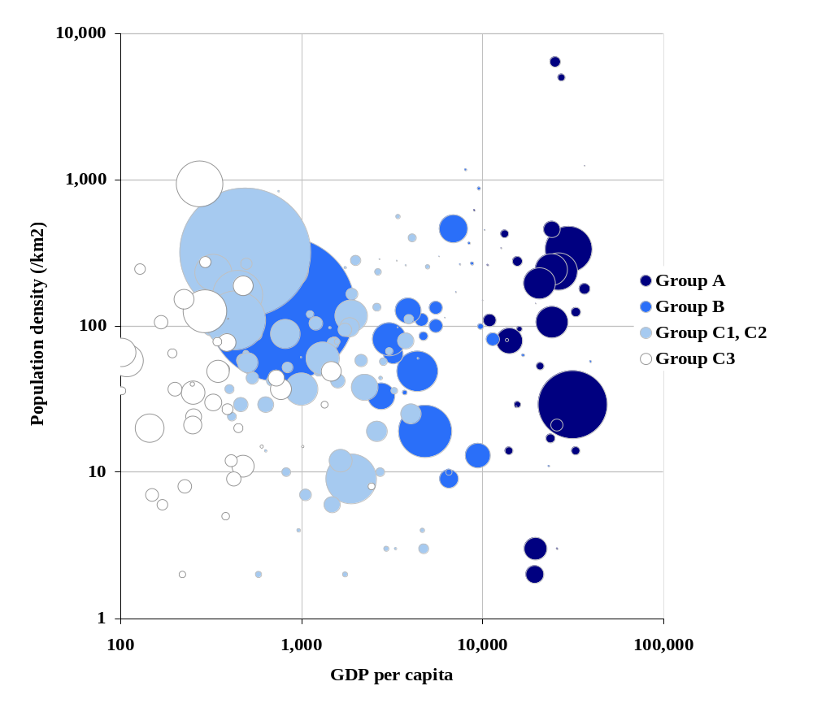
Exhibit 4.19: Segments spread by population density and GDP per head – bubble size is proportional to population, 1997 data [Sources WDI, ITU, Analysys, 1997]
Exhibit 4.4 illustrates the estimated geographic distribution of current telecoms revenue for two countries where population density is an important determinant of network development. In both these countries the geographic distribution of demand has played a major part in determining the scale and shape of network investment in recent years – in the USA, for MAN deployment, cable TV upgrades, satellite services and high-speed wireless services, and in India for the deployment of mobile telephony and basic PSTN networks.

Exhibit 4.20: Estimated distribution of telecommunications revenue per square kilometre, USA and India 1997 [Source: Analysys]

Income inequality may continue to be a necessary stage in accelerated development | Exhibit 4.5 illustrates the hypothesis that accelerated development and increased internal income inequality are related. As discussed earlier in this report, it is our hypothesis that accelerated network development will generally increase inequality within a country, at least during its early phases. The exhibit shows that Group B countries – those that are expected to close the development gap with Group A through accelerated network development – tend to have higher levels of income inequality than any other group. (The small cluster of East European Group B states do not fit this hypothesis).
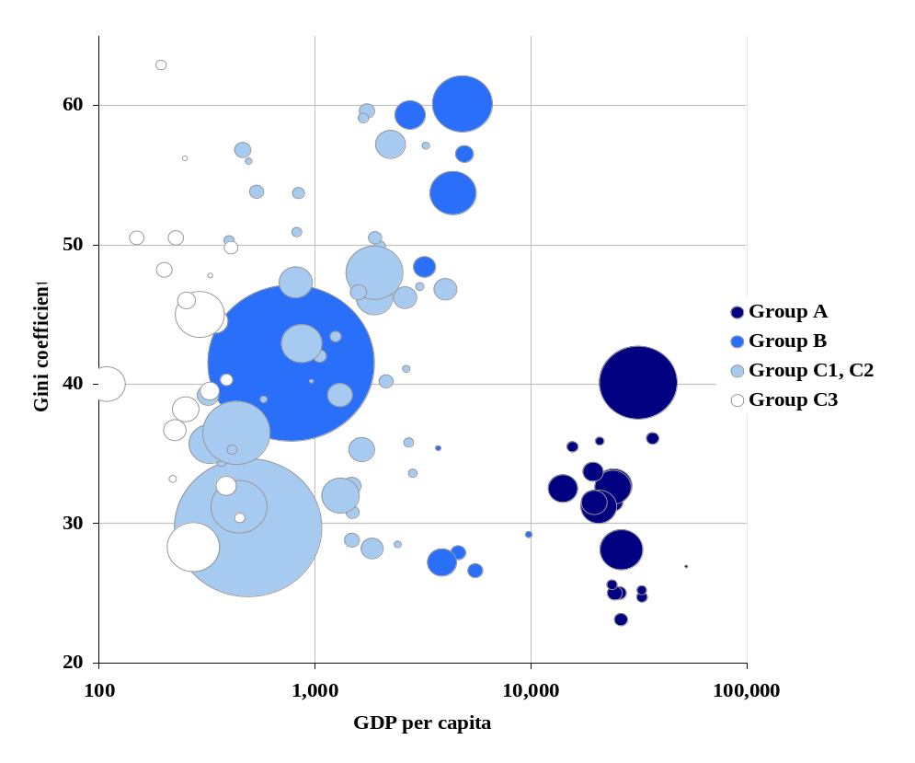
Exhibit 4.21: Segments spread by income inequality (GINI coefficient) and GDP per head – bubble size is proportional to population, 1997 data [Sources WDI, ITU, Analysys, 1997]
The poorest  pay the most for international calls | As Exhibit 4.6 illustrates, the price of international calls is inversely correlated with output per capita. There is also some inverse relationship with predicted networking outcomes – Group B countries have lower US call prices than Group C1 and C2 countries (where the outcome is in the balance), and Group C3 countries lie above the C1/C2 trend.
The dynamics of these relationships are highly complex, involving accounting rate issues, regulation, geography, call routing, and calling intensity, but the simple observation of inverse correlation with wealth still reveals a material brake on development. A major driver of this inverse relationship is developing country policy (addressed in section 4, below). (It should be noted that there are a large number of countries missing from this dataset.)
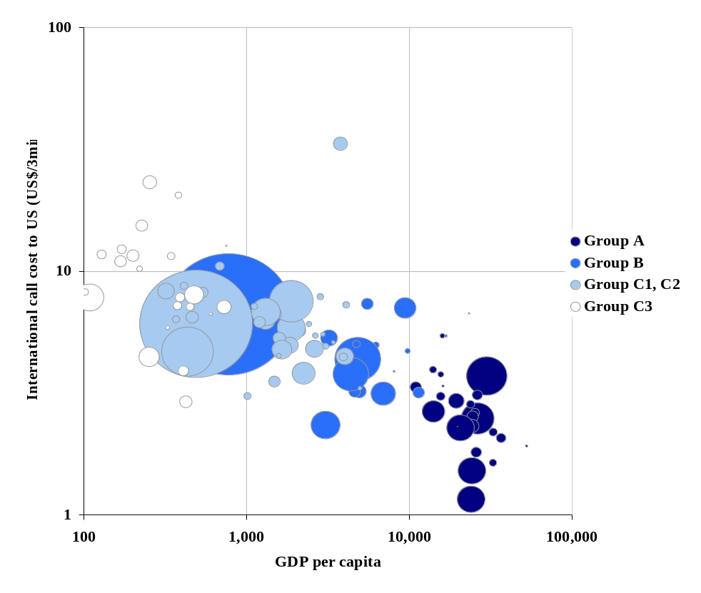
Exhibit 4.22: Segments spread by the cost of a 3 minute call to the USA and GDP/head – bubble size is proportional to population, 1997 data [Sources WDI, ITU, Analysys]
Group B countries have made most progress with mobile services | Exhibit 4.7 illustrates a clear difference between Group B countries (where we expect the networking development outcome to be positive) and Group C countries (where the network development outcome is in the balance). Group B countries in 1997 show around one in four telecommunications subscribers taking a mobile service – about the same ratio as Group A. For Groups C1 and C2 the ratio is less than one subscriber in ten. This is correlation rather than causality, but still striking.
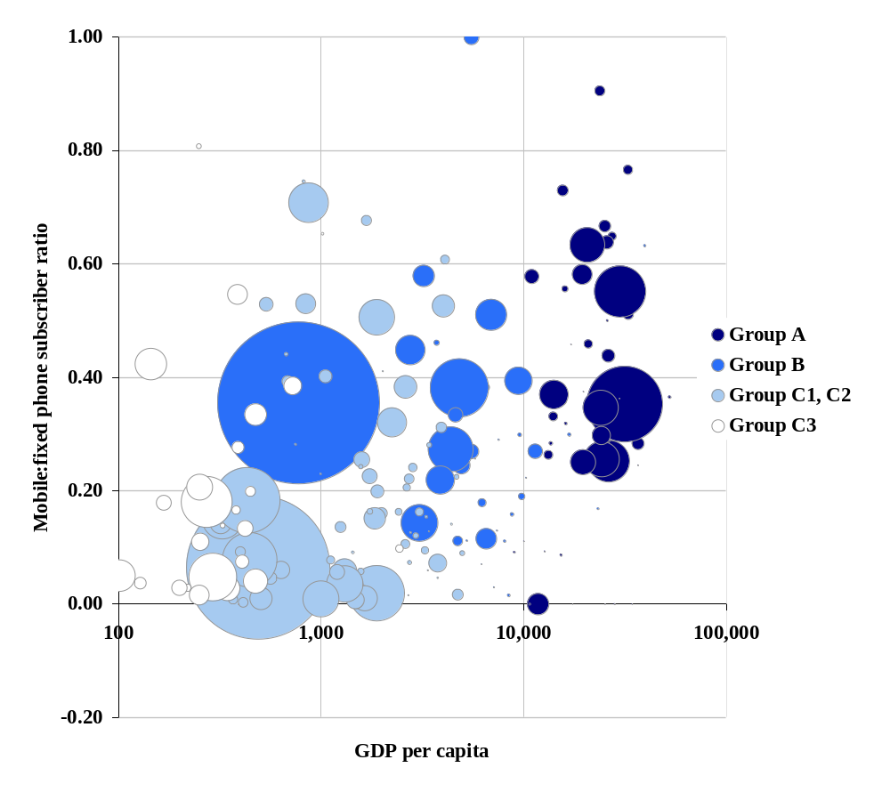
Exhibit 4.23: Segments spread by the ratio of mobile and fixed subscribers and GDP/head – bubble size is proportional to population, 1997 data [Sources WDI, ITU, Analysys]
Groups C1 and C2 are categorised according to the probability of a positive or negative networking development outcome | Groups C1 and C2 are split according to their current institutional status and existing networking policies. Exhibit 4.8 shows the two categories, where C2 countries are those most at risk of a negative network development outcome based on their current institutional and policy status. There is no correlation between the current economic or network development levels of C2 countries and their higher risk of a negative outcome, as the exhibit illustrates.
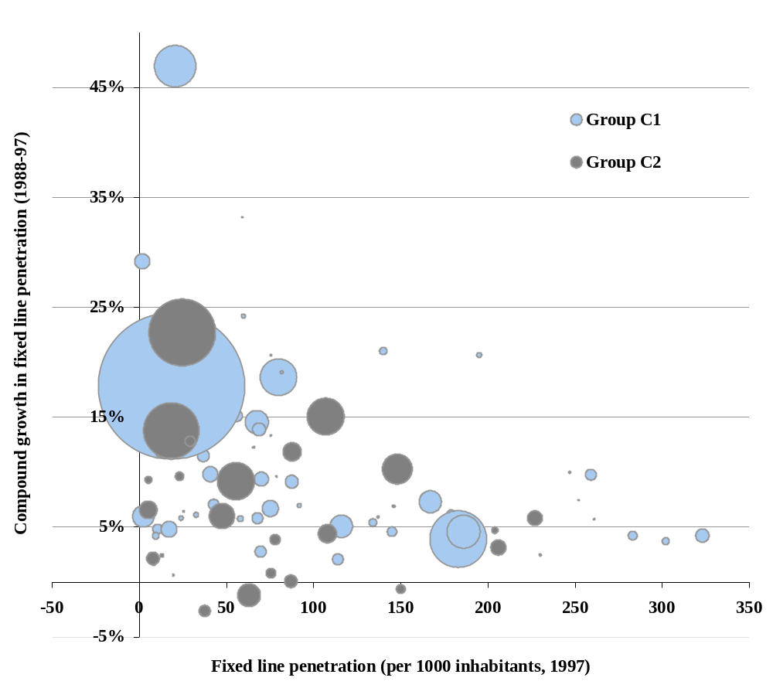
Exhibit 4.24: Division of Groups C1 and C2 according to risk of negative outcome, spread by fixed line penetration and growth in penetration – bubble size is proportional to population [Sources WDI, ITU, Analysys, 1997]

Applying development scenarios
We have created a framework for outcome scenarios | In considering the range of networking development outcomes for a country, we have taken two aspects of development as our framework for scenario outcomes, illustrated in Exhibit 4.9:
- the development axis refers to the level of national development relative to international benchmarks. Of necessity this is a hybrid of economic, social and institutional development parameters. A country is assessed as having developed if its output and human development indicators have improved relative to the rest of the world; a country with below average improvement is deemed to have declined, even though it may have improved in absolute terms.
- the equality axis refers to the internal distribution of wealth and human development. Clearly this is not independent of national development indicators, but the relationship between the two axes is extremely complex and has significant temporal dynamics. It is possible for a country to move over the entire space according to the balance of impacts it experiences.
We have used this framework to consider the networking and development outcomes for a range of Group C countries according to a range of policy and programme assumptions encapsulated in three scenarios:
- Scenario 1: ‘cautious policies’
- Scenario 2: ‘radical policies’
- Scenario 3: ‘radical policies and active programmes’
We illustrate these scenarios by reference to ‘country X’ | Country X is an invented country in Group C1. Exhibit 4.10 (overleaf) shows the key development and networking parameters for X in 1999. In terms of economic and human capital development, X is slightly above average for Group C. It has had a democratic government since 1994, although the organised opposition is very weak.
 |  | Exhibit 4.25:  Scenario framework for assessment of Group C networking development outcomes [Source: Analysys]

X is now self sufficient in food production. The economy of X is highly dependent on primary products (coffee, timber, copper, and diamonds and other minerals) but has good mix of primary production. The manufacturing sector is weak and the services sector is extremely underdeveloped. X has tight currency controls and applies high tariffs to many imported goods. The country is not highly indebted.
X has a state monopoly telecoms operator, XPTT, which offers a basic portfolio of fixed and mobile services. Large parts of the country do not have access to either fixed or mobile services, although there has been a moderately successful programme to develop village payphones. Mobile service coverage is about 5% of the land area, and subscriber growth has been limited by the high prices. There is a long waiting list for fixed phone lines. Fixed service prices are priced to be affordable, with the exception of international calls, which are extremely expensive. This has created a market for foreign call-back operators, even though call-back is illegal in X.

Population  Output (1999 $bn)  Services output (1999 $bn)  Agricultural output (1999 $bn)  Exports (1999 $bn)  Imports (1999 $bn)  Balance of trade (1999 $bn)  Foreign Investment (1999 $bn)  Human Development Index  GINI coefficient (measure of income inequality)  Telecoms revenue (1999 $ m)  Fixed lines  Mobile lines  Telephone waiting list  Net settlement receipt (1999 $m)  Output/head (1999 $)  Services as % of Output  Agriculture as % of Output  Balance of trade/Output  Foreign Investment/Output  Telecoms revenue/head (1999 $)  Telecoms revenue/sub (1999 $)  Fixed line penetration  Mobile penetration  Telephone waiting list (weeks)  Net settlement payment /head ($) | 10,000,000  30.0  9.0  4.5  6.0  7.5  -1.5  0.6  0.70  45  400  500,000  50,000  50,000  10.0  3,000  30%  15%  -5%  2%  40  727  5.0%  0.5%  65  1.00 |  |  | Exhibit 4.26: ‘Country X’ in 1999 – key networking and development parameters [Source: Analysys]

International connectivity is via an Intelsat earth station (150 voice circuits) and a microwave link to neighbouring Country Y (8Mbit/s). These links carry all international public voice and Internet traffic. Most Internet traffic is routed over the microwave link to Country Y. About 20 private VSAT sites, licensed by XPTT, are used for international corporate communications.
Internet usage in X is quite limited – XPTT is the only authorised service provider, subscription charges are high (partly because of the high peering charges in Country Y), and service is very poor due to congestion and network quality.
The government has announced its intentions to reform, reinforced by its agreement to the 1998 World Trade Organisation telecoms reform agenda. A new Telecommunications and Broadcasting Act is planned for 2000, coinciding with XPTT’s partial privatisation, and the licensing of a second cellular operator and possibly of new fixed service providers.
There is a possibility that a high capacity submarine fibre could be landed in X in 2001. This would be laid as part of a multi-national project, but is dependent on overall fundraising – $400 million is required for the whole project, and the country X landing would require about $20 million of investment from some source. At present the project is still uncertain.
Scenario 1: ‘Cautious policies’ | Country X proceeds with reform of its telecoms and broadcasting sectors, but at a conservative pace, balancing the benefits of reform against the concerns of vested interests and the risks of uncertainty and upheaval.
The Telecommunications and Broadcasting Act is finally enacted in 2001, and XPTT is partially privatised (20%) in 2002, including the sale of a 25% stake to a leading US operator (raising $100m for the government). The state retains a 55% stake. An independent regulator is established in 2002, and an auction takes place for a second GSM operator. The winning bidder pays the government a $50 million fee and promises 10% area coverage by the end of 2003. Two ‘non-infrastructure’ licences for fixed services are granted in 2002, although these do not include authorisation to carry international traffic, which remains the monopoly of XPTT. After two years of disputes over interconnection terms and other charges, these licences are converted to full infrastructure licences in 2004, when the international settlement regime finally disintegrates.
There is no reform of currency or tariff regimes, and no progress is made in the preparations of X’s legal codes to match with the demands of cross border ecommerce.
Internet services remain very limited until a cross border fibre to country Y is constructed in 2003 at a cost of $20 million. Peering costs in Country Y remain high.
Although output grows at 3% compound over the period to 2010, this is from a low base and represents a widening development gap. Education, healthcare, infrastructure and welfare development are all constrained by the level of economic progress. A significant factor is the volatility of global commodity prices over the period (partially caused by the disruption of internet-related disintermediation of many commodity supply chains). Revenue from primary production fluctuates dramatically year-on-year, reducing investment and development in these sectors. Weak growth in manufacturing drives continuing growth in the value of imported goods, and trade in services is also increasingly negative. X’s trade balance widens as a result.
By 2010 the past decade is seen as a great disappointment, confirming the difficulty of the development challenge. All of the hard work in each field of development – economic and social – has resulted in only modest national progress. Exhibit 4.11 illustrates the key parameters that characterise this scenario for country X.
 | 1999 | 2010 | CAGR
Population  Output (1999 $ bn)  Services output (1999 $bn)  Agricultural output (1999 $bn)  Exports (1999 $bn)  Imports (1999 $bn)  Balance of trade (1999 $bn)  Foreign Investment (1999 $bn)  Human Development Index  GINI coefficient (measure of income inequality)  Telecoms revenue (1999 $ m)  Fixed lines  Mobile lines  Telephone waiting list  Net settlement receipt (1999 $m)  Output/head (1999 $)  Services as % of Output  Agriculture as % of Output  Balance of trade/Output  Foreign Investment/Output  Telecoms revenue/head (1999 $)  Telecoms revenue/sub (1999 $)  Fixed line penetration  Mobile penetration  Telephone waiting list (weeks)  Net settlement payment /head ($) | 10,000,000  30.0  9.0  4.5  6.0  7.5  -1.5  0.6  0.70  45  400  500,000  50,000  50,000  10.0  3,000  30%  15%  -5%  2%  40  727  5.0%  0.5%  65  1.00 | 12,433,743  42  12.5  5.6  9.2  14.2  -5.0  0.8  0.72  45  842  1,165,819  896,080  80,000  0.0  3,340  30%  13%  -12%  2%  68  408  9.4%  7.2%  45  0.00 | 2%  3%  3%  2%  4%  6%  3%  7%  8%  30%
Exhibit 4.27: Outcomes for Country X under Scenario 1, ‘cautious policies’ – key networking and development parameters [Source: Analysys]

Scenario 2: ‘Radical policies’ | Country X proceeds with reform of its networking sector with vigour and determination, taking many chances and experiencing a mix of positive and negative consequences.
The Telecommunications and Broadcasting Act is enacted in 2000 and XPTT is partially privatised (40%) in 2000, including the sale of a 25% stake to a leading US operator (raising $40 million for the government). The state retains a 35% stake. An independent regulator is established in 2000, and an auction takes place for a second GSM operator. Bidders are evaluated on their coverage and pricing promises. The winning bidder pays no fee but promises 20% area coverage by the end of 2002 and a $20/month bundled package for ordinary users. Call-back services are legalised and two new infrastructure licences for fixed services are granted. All new licences carry full international rights. Internet service providers are permitted to operate under a class licence with only modest restrictions.
In a complex addition to existing currency and tariff law, special provisions are made for ecommerce activities, including extra allowances and accelerated customs procedures.
XPTT’s new US partner also invests $40 million in the submarine cable project in 2000, ensuring that the rest of the funds can be raised and the cable is laid in 2001 with a landing in X. This provides XPTT with over 500Mbits/second of capacity to a large IP and voice exchange point, where peering costs are relatively low. The regulator obliges XPTT to lease some of this capacity to the new entrants at a reasonable rate.
XPTT sees a sharp fall in its revenues and profits in 2001 as its share of international call volumes falls and it is forced to slash its international rates by 80%. As a result it makes no tax payments in 2001, causing a major gap in public finances. Neither XPTT nor the government expected such dramatic changes based on the international experience of liberalisation in the 1990s, although some commentators had predicted that the impact of liberalisation later in the networking revolution would occur more suddenly than observed among the earlier liberalisers. The new entrants invest over $100 million in that year (mostly in the new mobile network) but do not pay any tax either.

 | 1999 | 2010 | CAGR
Population  Output (1999 $ bn)  Services output (1999 $bn)  Agricultural output (1999 $bn)  Exports (1999 $bn)  Imports (1999 $bn)  Balance of trade (1999 $bn)  Foreign Investment (1999 $bn)  Human Development Index  GINI coefficient (measure of income inequality)  Telecoms revenue (1999 $ m)  Fixed lines  Mobile lines  Telephone waiting list  Net settlement receipt (1999 $m)  Output/head (1999 $)  Services as % of Output  Agriculture as % of Output  Balance of trade/Output  Foreign Investment/Output  Telecoms revenue/head (1999 $)  Telecoms revenue/sub (1999 $)  Fixed line penetration  Mobile penetration  Telephone waiting list (weeks)  Net settlement payment /head ($) | 10,000,000  30.0  9.0  4.5  6.0  7.5  -1.5  0.6  0.70  45  400  500,000  50,000  50,000  10.0  3,000  30%  15%  -5%  2%  40  727  5.0%  0.5%  65  1.00 | 12,433,743  51.3  21.0  5.6  10.3  12.8  -2.6  1.0  0.74  50  1,141  1,575,879  1,357,193  40,000  0.0  4,127  41%  11%  -5%  2%  92  389  12.7%  10.9%  12  0.00 | 2%  5%  8%  2%  5%  5%  5%  10%  11%  35%
Exhibit 4.28: Outcomes for Country X in Scenario 2, ‘radical policies’ – key networking and development parameters [Source: Analysys]
2001 also sees a sharp worsening in the balance of trade, due to a combination of increased exports (many covered by the new ecommerce-friendly exemptions) and sharp falls in export earnings from diamonds and timber, partially caused by the networking-related disruption of the established global structures in these markets. In diamonds, the global cartel breaks down, and increased efficiency in the timber supply chain results in price pressure on producers. However, foreign investment flows into X rise sharply.
By 2002 most urban businesses and affluent urban citizens have good fixed and mobile communications, including ‘midband’ Internet access, generally through one of the competing fixed wireless access networks. However, away from the two main cities fixed communications are still very sparse, and mobile coverage is also limited to 20% of the land area.
Parts of the services sector are hard hit by foreign competition. For example, by 2004 there are no independent commercial legal firms based in X – almost all commercial legal work is conducted in the developed world, often by expatriate natives of X. Local affiliates are used when an in-country presence is essential (notably in litigation), but almost all of the value is captured offshore, even though X’s legal codes are unique to the country. In contrast, a civil engineering practice in X has captured a large share of the project contracting market in country Y, exploiting the lower costs and geographic proximity of X, and making full use of the new networks in X and Y. On balance, X benefits from the competitive turmoil in these newly tradable services, largely because of its education and institutional performance.
Institutional stability is tested however – the period to 2010 is characterised by crisis in the public finances, a widening trade gap but reasonably healthy growth in output. Only towards the end of the period does the growth of the tax base compensate for the losses of revenue (and foreign exchange) from duties, from XPTT profits and from the export of commodities.
There is a marked widening of the income distribution, and progress in areas such as education, healthcare etc is very modest – constrained by the weakness of the public finances. This divergence of incomes is felt particularly in the cities, and a is one factor behind general rise in urban tension and crime.
Although average output per head rises past $4000 (in 1999 terms) median incomes do not rise at all in real terms – all of the benefits of economic growth are captured by the upper income centiles of the population. However, for this group there is a significant closing of the gap with the developed world.
Scenario 3: ‘Radical policies and active programmes’ | Country X follows policies that are very close to those outlined in Scenario 2, but in addition there is a significant effort to spread the benefits of networking more widely through the population through a mix of innovative policy measures and targeted programmes.
In 2000 GSM licensing process bidders are asked how much they would charge the state to deliver a defined area coverage profile – 30% by the end of 2002, 40% by end 2003 and 50% by end 2004. To everyone’s surprise the lowest request is for only $5 million. The winning bidder (based on a combination of low tariff promises and a low coverage subsidy request) asks for $8 million, much less than earlier estimates of the required subsidy. Through an energetic, innovative campaign, this sum is raised from a combination of state funds, bilateral aid, development bank funding and a US development fund whose benefactors’ were convinced of the benefits of the exercise.
Based on the success of the GSM subsidy ‘reverse auction’, the same mechanism is adapted for one of the national fixed licences. In this case the winning bidder proposes an aggressive roll-out of fixed wireless coverage for no subsidy, beating rivals with various coverage/subsidy proposals. This wireless network is used as the basis for an extensive schools Internet programme, soon integrated with a distance learning and telemedicine initiative. Significant international aid funding is secured to support these initiatives.
 | 1999 | 2010 | CAGR
Population  Output (1999 $ bn)  Services output (1999 $bn)  Agricultural output (1999 $bn)  Exports (1999 $bn)  Imports (1999 $bn)  Balance of trade (1999 $bn)  Foreign Investment (1999 $bn)  Human Development Index  GINI coefficient (measure of income inequality)  Telecoms revenue (1999 $ m)  Fixed lines  Mobile lines  Telephone waiting list  Net settlement receipt (1999 $m)  Output/head (1999 $)  Services as % of Output  Agriculture as % of Output  Balance of trade/Output  Foreign Investment/Output  Telecoms revenue/head (1999 $)  Telecoms revenue/sub (1999 $)  Fixed line penetration  Mobile penetration  Telephone waiting list (weeks)  Net settlement payment /head ($) | 10,000,000  30.0  9.0  4.5  6.0  7.5  -1.5  0.6  0.70  45  400  500,000  50,000  50,000  10.0  3,000  30%  15%  -5%  2%  40  727  5.0%  0.5%  65  1.00 | 12,168,178  52.9  23.2  5.6  10.3  12.8  -2.6  1.0  0.80  38  1,261  1,917,931  1,728,383  20,000  0.0  4,351  44%  11%  -5%  2%  104  346  15.8%  14.2%  4  0.00 | 1.8%  5.3%  9%  2%  5%  5%  5%  11%  13%  38%
Exhibit 4.29: Outcomes for Country X in Scenario 3, ‘radical policies and active programmes’– key networking and development parameters [Source: Analysys]
In 2004 a further adaptation of this approach is used to establish a low-user tariff scheme. Six operators bid to offer a cheap low usage service within a defined number of districts where fixed network connections are available. The winning bidders request a subsidy of $20 to $30 per subscriber per year (varying by district) for customers who are expected to spend less than $50 per year. Fixed wireless, mobile and wireline operators win in different districts (the mobile operator restricting low user customers to their home cell).
There are also a range of privately funded, but state-facilitated, initiatives within X to ensure that used PCs, cellular handsets, modems and other equipment are imported and distributed efficiently within the country. Much of this work is done through international co-operative organisations, and receives support from some of the worlds largest multinational corporations. A key government role in this area is support for the training of installers and maintainers.
Through these efforts to spread access to networks within X, both geographically and socially, the benefits of networking development are felt more profoundly within the country, and many more citizens are able to participate in the educational, economic and social processes that are enabled. This is reflected in a significant growth in middle income bands in the later years of the decade, driving down the GINI index within X, and improving the UNDP Human Development Indicator score as well. Compared with Scenario 2 there is a small output improvement by 2010, resulting from the improvements in education and the expanded geographic coverage of networking services.
The scenario outcomes deliver a clear message | Exhibit 4.14 illustrates the three scenario outcomes described above:  - in Scenario 1 the development gap widens for Country X as output per capita rises by only $300 in real terms over the decade  - in Scenario 2 per capita output rises by over $1,100, but the income distribution within X becomes much more skewed towards an affluent urban minority
- in Scenario 3 per capita output rises by over $1,300 and the income distribution becomes slightly more even by the end of the period.
Clearly these scenarios are somewhat simplistic, and it is intuitively obvious that a combination of effective networking policies, innovative and energetic programmes, stability and good governance can lead to desirable long term outcomes at the expense of risk and difficulties in the short term. In particular, the assertion that inequality can be reduced in the ‘radical policies and active programmes’ scenario is hard to substantiate – this scenario is intended to focus debate and provoke further analysis.
Exhibit 4.30:
Schematic of scenario outcomes for Country X [Source: Analysys]

However, the next level of depth in the analysis of constraints, opportunities and threats becomes highly country-specific, and these simple but critical generic messages can become obscured.
At this point, therefore, it is useful to turn to the work undertaken by Pyramid research to project the networking outcomes for over fifty individual countries and six regions. The full detail of this work can be seen at the World Bank Web site including details on the scenario assumptions used by Pyramid to underpin their projections.

Quantified outcomes as projected by pyramid research
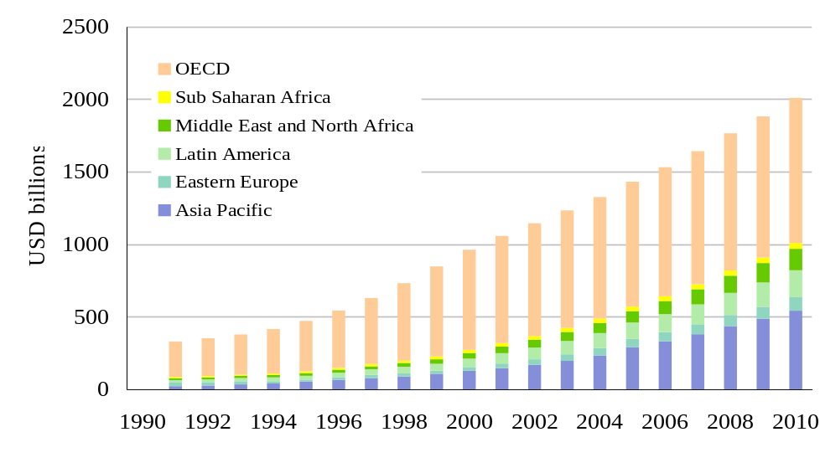
Exhibit 4.31: Telecommunications revenue by region, 1991 to 2010, USD billions [Source Pyramid Research]
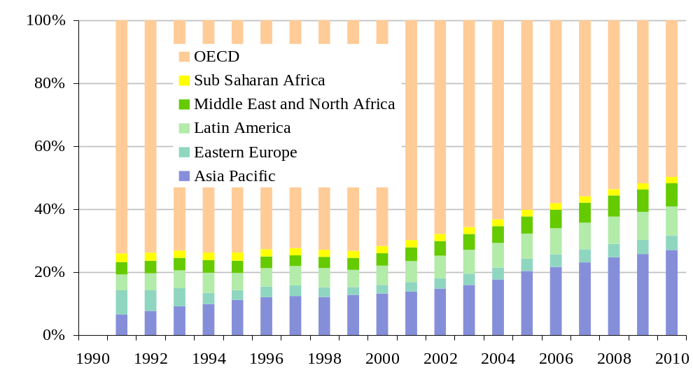
Exhibit 4.32: Share of global telecommunications revenue by region, 1991 to 2010 [Source Pyramid Research]
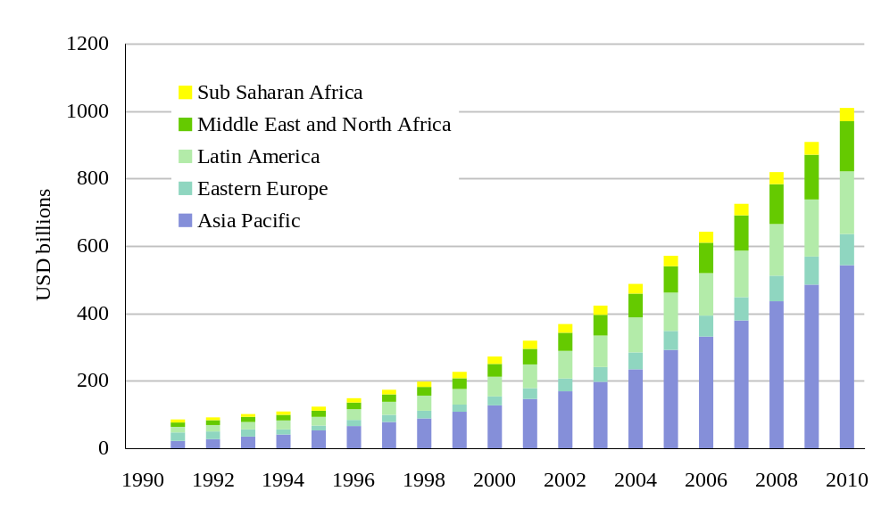
Exhibit 4.33: Telecommunications revenue by region, excluding OECD, 1991 to 2010, USD billions [Source Pyramid Research]
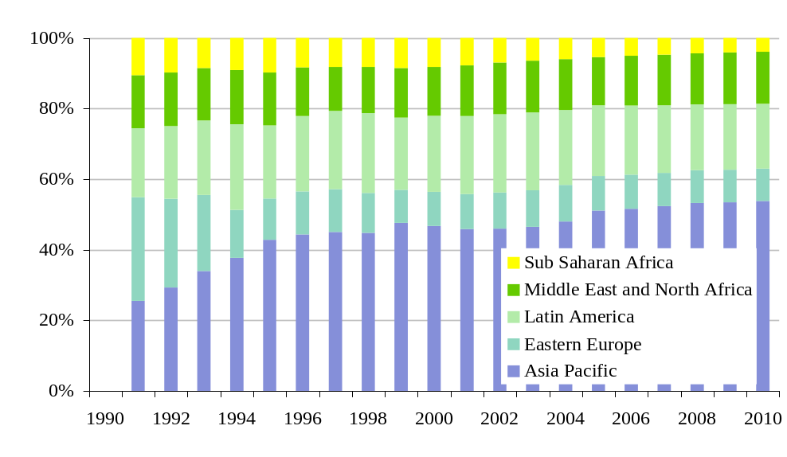
Exhibit 4.34: Share of non-OECD telecommunications revenue by region, 1991 to 2010, [Source Pyramid Research]
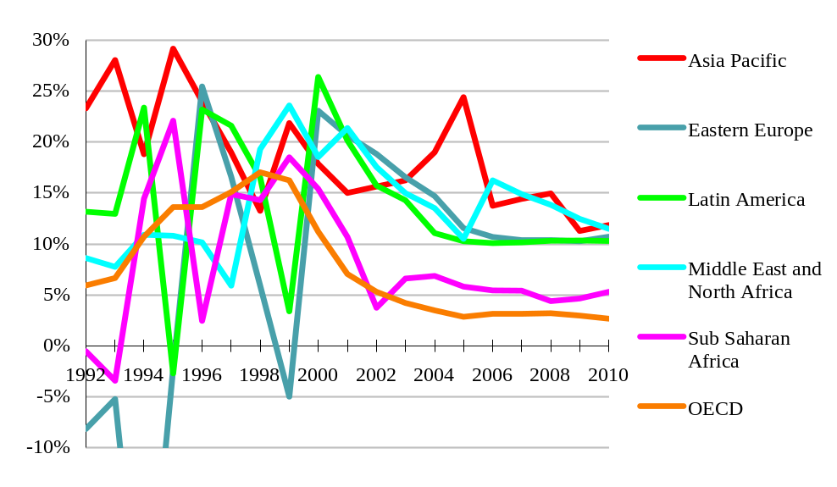
Exhibit 4.35: Annual growth of telecommunications revenue by region, 1991 to 2010, in nominal USD terms [Source Pyramid Research]. The pre-2000 fluctuations are exchange rate effects
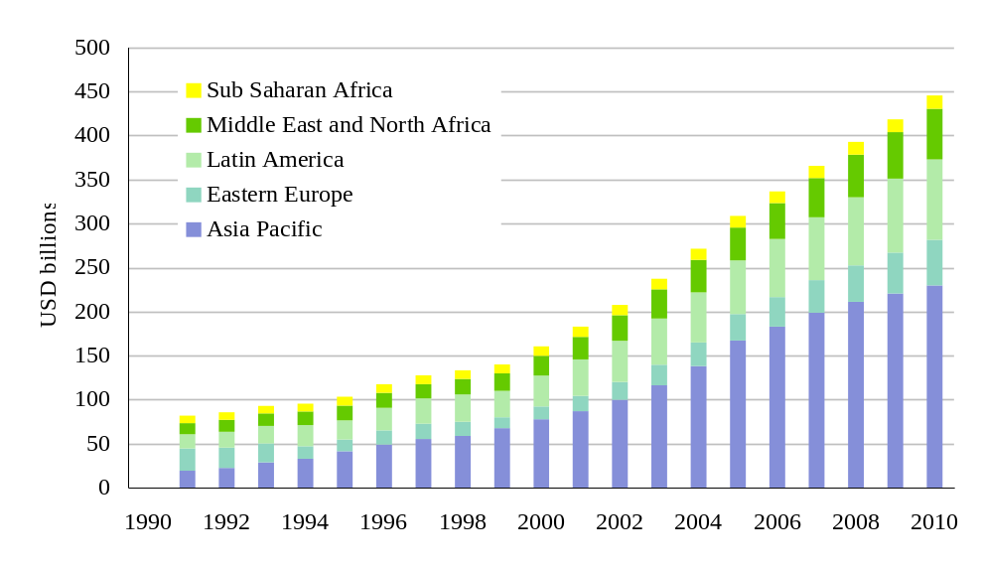
Exhibit 4.36: Fixed telecommunications revenue by region, excluding OECD, 1991 to 2010, USD billions [Source Pyramid Research]
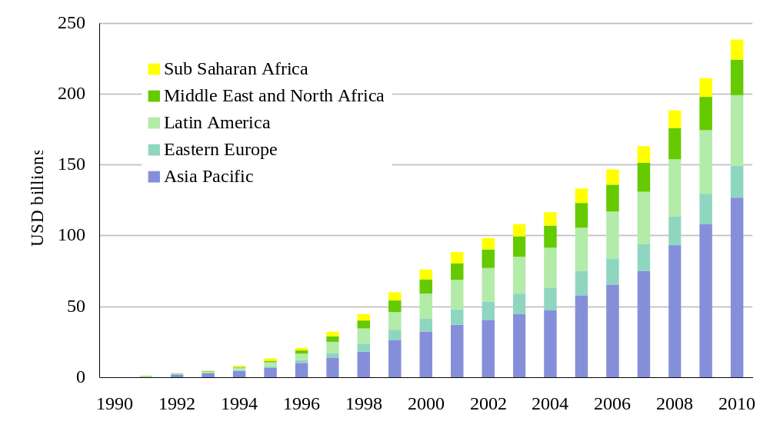
Exhibit 4.37: Mobile telecommunications revenue by region, excluding OECD, 1991 to 2010, USD billions [Source Pyramid Research]
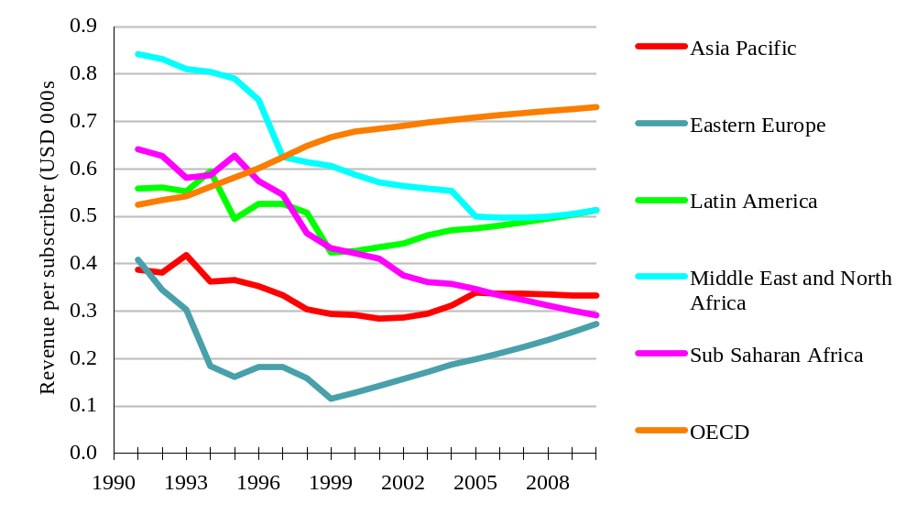
Exhibit 4.38: Fixed telecommunications revenue per subscriber, by region, excluding OECD, 1991 to 2010, USD thousands [Source Pyramid Research]
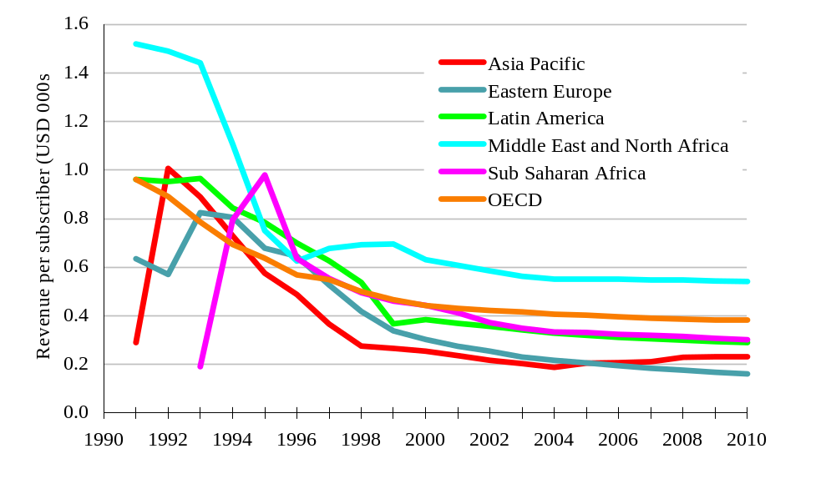
Exhibit 4.39: Mobile telecommunications revenue per subscriber, by region, excluding OECD, 1991 to 2010, USD thousands [Source Pyramid Research]
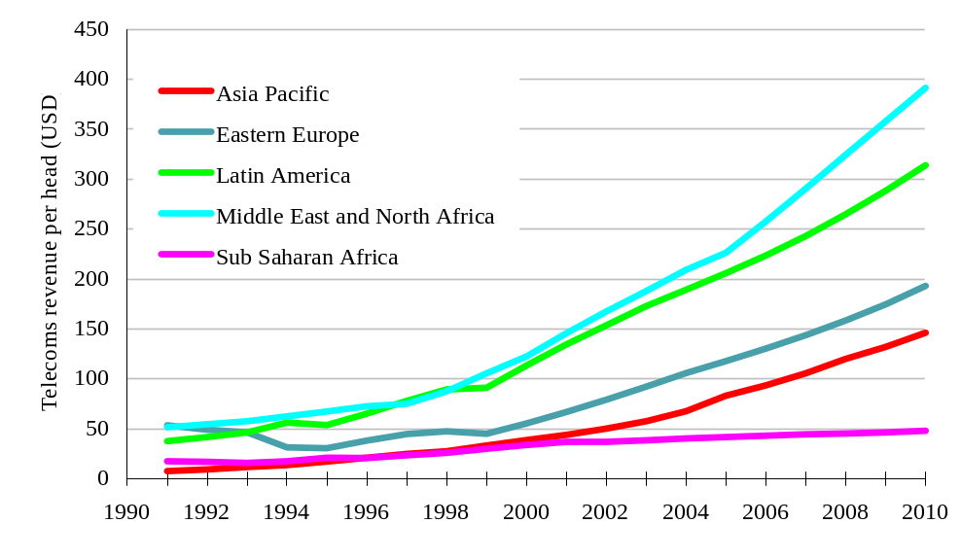
Exhibit 4.40: Telecommunications revenue per capita, by region, excluding OECD, 1991 to 2010, USD [Source Pyramid Research]
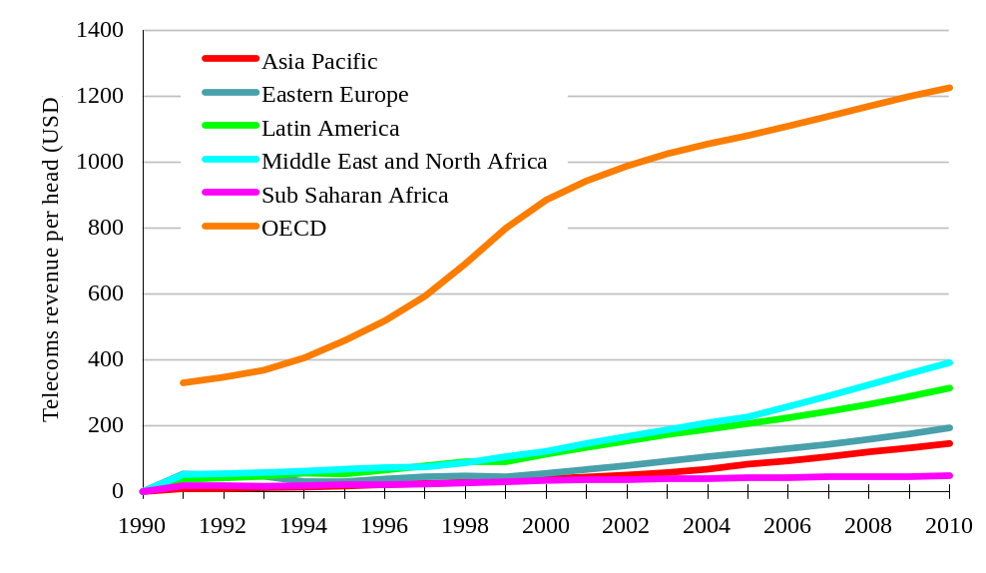
Exhibit 4.41: Telecommunications revenue per capita, by region, including OECD, 1991 to 2010, USD [Source Pyramid Research]
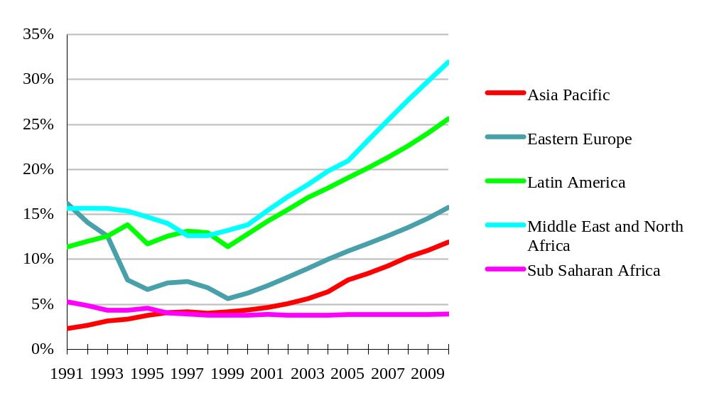
Exhibit 4.42: Telecommunications revenue per capita as a percentage of OECD revenue per capita, by region, 1991 to 2010, [Source Pyramid Research]

Policies and programmes
Summary: We must learn from the successes and failures of past policy and programme initiatives. A growing consensus exists in the policy field, centred on the principle that sector liberalisation is beneficial. However, the detailed design and implementation of policies is still proving to be a challenge. Programmes are even harder to get right, both in theory and in practice. The key ingredients for successful programmes appear to be innovation, energy, integration and tailoring to local circumstances. We suggest a variety of programmes for consideration, ranging from safe to radical.

Why development policy and programme design is a problem

Policy problems
Policy implementation is difficult due to … | There is now a clear consensus among networking experts regarding the basic policy principles of liberal regulation and private ownership. However, translation of policy principles into policy implementation is the key challenge. For every administration that has successfully liberalised and privatised its networking sector, there are several who have either not acted, or have experienced difficulties and obstacles in attempting to follow this path. Several implementation problems are common in the developing and developed worlds.
… powerful vested interests resist changes that harm their position … | A state-owned unregulated networking monopoly in telecommunications or broadcasting may bring little benefit to the ordinary citizen, but can be highly beneficial to some managers, civil servants, trades unions, politicians, suppliers and others. It is not surprising, therefore, that overt and covert resistance to reform can be very determined and highly successful. Many developing countries that accept the policy prescription of liberalisation still cannot overcome these obstacles to change. Even in the developed world in the 1980s and 90s, where institutions and processes were reasonably transparent, the resistance to beneficial reform was stubborn and deep rooted. Merely ‘recommending reform’ does not do much to win this battle.
… concerns over national sovereignty … | Many administrations are concerned that a flow of investment into national networking would be accompanied by a loss of control over the networking sector. Government control of networking, specifically telecoms and broadcasting, is seen as important by many for reasons of internal and external security. The licensing of foreign-backed operators, or the sale of a stake in the monopoly PTT to foreign investors, can both be seen as threats to this control. In a trade-off of development benefit vs issues of sovereignty, development often comes second.
… the need to trade-off short-term pain for the chance of long term benefits … | Many of the optimum networking policies bring short-term pain to developing countries. Loss of tax revenue and dividends from a former monopoly PTT, loss of foreign exchange from settlement payments, loss of duty revenues from reformed tariffs – these may add up to a significant percentage of the public finances in many developing countries. Forgoing valuable revenue today for the promise of a longer term reward (or the promise of avoiding a future penalty) is a tough political choice. We should not be surprised when administrations chose to face the risk tomorrow so they can keep the money today.
… the temptation of short term gain at the expense of the longer term … | This is best illustrated by the common ‘liberalise or privatise’ dilemma. An impoverished government has a difficult decision to take if the privatisation value of a PTT with a ten year monopoly is many times the value obtainable when privatisation is simultaneously accompanied by liberalisation.
… a tendency to ‘technology specificity’ … | Best practice regulation tries to license operators without reference to specific technologies, but in both the developed and developing worlds this is often not achieved. Regulators have a strong urge to manage technologies through the licensing process, and can point to examples where this has brought benefits, and areas where it is essential. However, it is often a sub-optimal approach and, in general, operators should be able to chose the technologies that they deploy to match market demand.
… and the challenge of tailoring policy to local circumstances without diluting the benefits of high level policy principles | Tailoring policy principles to local circumstances is another difficult trade-off that is open to manipulation by vested interests. For example, it may be legitimate to argue that a regulated duopoly may be the optimum market structure for a particular country because of the small size of the market and the expectation of low returns on investment. The security of limited duopoly competition is necessary to encourage investment in networking. However, this argument needs to be substantiated by objective analysis, not lobbying from vested interests. Objectivity is easily drowned out by self-serving distortions.
 | The key message here is that there are huge obstacles to the translation of consensus policy principles into implemented policy measures. We consider remedies and palliatives to these problems later in the chapter.

Programme problems
Programmes are problematic … | There is no equivalent to the policy consensus described above in the field of programmes, partly because most programmes involve spending public money. Intervention and subsidy are always controversial, particularly when they have an international dimension, and rub up against the edges of the pure commercial world as is always the case in networking development. Problems of principle include:
… in theory … | - The distortion of existing markets, by favouring a player through subsidies or penalising a player denied subsidies. For illustration, most observers agree that the Africa ONE cable project (see Section 3.1 above) would bring massive development benefits to Africa relative to the system cost (several hundred million dollars for the basic system). The project is on the brink of obtaining commercial funding, so the injection of development money would be criticised by many as unnecessary, and the flow of money to Africa ONE suppliers (announced as Lucent and Global Crossing) would be criticised by their competitors. Alternatively, to avoid this criticism, the development funding could go to a completely new consortium with new supply tenders, but Africa ONE could then argue that its commercial opportunity was being wrecked by non-commercial interventions. All of the criticisms above have some merit, but at the end of the day, without some development funding an African cable system may never be operational.
 | - The risks and dangers of picking winners. This dilemma has a high profile as there is such a long track record of disappointment in the field of public selection of private ventures. In networking development, the problem is more to do with the picking of ‘winning’ technologies rather than individual players, and the track record is not good. The dilemma can be minimised by the careful design of programmes, but any development initiative remains vulnerable to some degree to this criticism.
… and in practice | The practical problems of programmes include the following:
 | - Programmes are hard to prioritise. Faced with a surplus of candidate programmes chasing a finite pool of resources, it is necessary to prioritise programmes. The criteria for prioritisation are very hard to get right. For example, a flawed programme that is pursued with vigour and enthusiasm must be judged against an elegant idea proposed by a less energetic agency. Large international projects must compete for funds with small local initiatives. Achieving and maintaining the optimum portfolio of programmes is a monumental task.
- Programmes are hard to manage. Funded programme are vulnerable to stagnation, bureaucracy, loss of energy, corruption, loss of focus and a host of other difficulties. Measuring the effectiveness of programmes is extremely difficult. Heavy handed programme oversight can kill the innovation and drive of the programme team, but too light a touch can result in the problems listed above.
- Programmes have to be paid for. Almost all programmes, however innovative and streamlined, cost somebody some money. The clever combination of sources, and the matching of sources to risks and roles can ameliorate, but not eliminate, the problem of funding.
In summary, the design and implementation of networking development programmes must overcome some major obstacles before the desired impacts and benefits can be obtained.

Approaches to overcoming policy and programme difficulties

Addressing policy problems
Resistance can be overcome by … | A variety of approaches can be used to overcome resistance to the implementation of liberalisation and reform in networking:
…reference to others … | - dissemination of experience and best practice. Many of the fears that hold back policy implementation are out of proportion to reality, and can be addressed by the experiences of countries that have pressed ahead with liberalisation. For example, safeguards against loss of sovereignty can ensure that foreign investment does not threaten legitimate national security interests or undermine ultimate government control over developments. Many countries have learned, or are learning how to manage such safeguards without unnecessary constraints on sector development, and these lessons should be presented to more hesitant reformers in a clear form.
…sweetening the medicine… | - integration of policy implementation with appropriate programmes, for example, international assistance to soften the short-term financial impact of a loss of tax, duty or dividend revenues from the public finances. Another key area where policy and programmes need to be closely integrated is ‘subsidy auctions’, where programme assistance with funding the subsidy will often be required. In some cases it may be tempting to address vested interest groups that are resisting reform with programme resources to buy their co-operation, but in general this will be a poor use of resources.
… force of argument… | - informed objectivity must be the basis for balancing sensitivity to local conditions against the risk of diluting the benefits of reform. Objective, independent advisors should be used to counter the lobbying of vested interests with rational, quantitative argument. The pool of global expertise in the networking policy field has grown to the level where no administration should have any difficulty in accessing appropriate advice on policy implementation.
…or creativity and agility | search for innovation and opportunism in policy design and implementation. Rather than merely attempting to repeat prescriptions that have been used elsewhere, there is a place for creative and original thinking in policy matters. Chile’s subsidy auctions and the licensing process for the second GSM operator in the Czech Republic are two of many examples of highly innovative and successful networking policy creativity.
 | Clearly, these approaches will not remove all obstacles on the path to reform, but they may make progress a little quicker.

Addressing programme problems
A variety of approaches can be used … | The following approaches can be used to address the difficulties of intervening in networking development through programme initiatives identified above.
… carefully designed intervention … | - Distortion of markets can be minimised by the careful choice and design of intervention and the use of techniques such as subsidy auctions to allocate funding. Criteria for choosing an area for intervention should include:  - the potential benefit of progress in the specific field, relative to the other specific intervention benefits  - the probability of progress without intervention. If this is high, then intervention may be unnecessary, and the danger of distortion is high - other programme priorities may be more attractive
Programmes such as subsidy auctions are likely to be criticised by losing bidders and others whose interests are not aligned with the objectives of the programme, but if the activity has been well designed on sound theoretical principles, the organisers should be able to rebut such attacks.
…including a networking dimension in other programmes … | - Distortion can also be addressed by the inclusion of a networking dimension in other development programmes to the greatest possible extent. Ensuring that a hospital or schools programme includes an adequate networking dimension is both beneficial to the healthcare or educational objectives and unlikely to cause a major distortion of local networking markets.
… strict prioritisation … | - The problems of programme management can be minimised if the prioritisation of initiatives is pragmatic and ‘hard headed’, based on impact assessments, and giving due weight to the energy, enthusiasm and capabilities of those tasked with implementing the initiative. For example, support for a rural telecoms initiative in a liberalised market, where urban networking activity is healthy and energetic, should take precedence over a similar programme with a state monopoly operator whose behaviour is bureaucratic and lacking in creativity, based on the difference in the likely impact of these two alternatives.
… and maximisation of funding | - Finally, but perhaps most importantly, the maximisation of networking development programme funding will have a material impact on many of the problems of programme management and prioritisation. A well-funded programme of initiatives can be more ambitious, more wide-ranging, better integrated and more effective than one with merely skeleton funding. Networking is a field where threshold effects and fixed cost effects dominate, so the scale and scope of programmes are important determinants of their efficiency and effectiveness. A networking initiative that effects a large area of territory, or a large population, can be used as a foundation for smaller, locally focussed activities to exploit the new networking opportunities.
Although it may seem facile to advocate maximisation of programme funding, we see a substantial opportunity to tap new sources of private and semi-private programme funding (both ‘for profit’ and ‘not-for-profit’ sources):
- the dynamism and performance of the networking sector and the difficulties that many commercial players have in developing world markets combine to make private-public programme co-operation a win-win outcome.
- similarly, there are many far-sighted not-for-profit agencies which now see networking development as a vital component of the wider development portfolio (as claimed in this report) and which should be prepared to support programmes in the networking field.
Both of these developments would have a significant impact on the scale and shape of networking development programmes around the world.

Policy recommendations and suggestions
Is there a political will? | Successful policy measures to address the networking challenge need a foundation of political will and political comprehension. Effective policies will involve painful trade-offs in financial, social, industrial and security matters. Where policy initiatives are not based on political will for change they will almost certainly fail to meet their objectives.
This section discusses policy measures based on an assumption that a political will for change does exist at a national level. However, it must be noted that this assumption is not valid for a very large number of countries at the time of writing. It is not appropriate to make specific diagnoses of this lack of political will for individual countries in this report, but the difficulties identified in section 5.1.1 (above) are common causes.
It should be noted that the degree of political will to address the networking challenge is not simply correlated with the form of government or the level of national prosperity. There are prosperous democracies where there is neither a political will nor a political comprehension of the networking challenge, and there are also poor and non-democratic states where the challenge and opportunities of networking are well understood in political circles.

Policy development is needed in a wide range of areas | In many respects the report revisits the issues covered by Talero and Gaudette (1996) and for information, we repeat the recommendations (see Box). We have structured our policy recommendations in terms of:
- recommendations for policies in the networking sector
- recommendations for wider national government policies
Programme recommendations are addressed in the following section (5.4).
‘Recommendations from Talero and Gaudette [1996]:
Governments should:  - improve their own efficiency  - set fair rules  - catalyse infrastructure projects  - push the education agenda  - jump start the private sector | The World Bank can:  - render advice  - broker knowledge  - mobilise finance  - explore new development frontiers
Suggested priority areas for World Bank ‘information’ initiatives:
- education projects
- rural projects
- government efficiency projects
- specific sectoral reform projects

Recommendations for policies in the networking sector
Liberal licensing, based on objective analysis | As indicated earlier in this report, competition and liberalisation are absolute pre-requisites for accessing the benefits of the networking revolution. The first requirement for introducing competition in the networking arena is the licensing of new entrants.
There should, therefore, be a bias towards liberal licensing of network operators and, particularly, service operators. If the administration is unwilling to liberalise network operations, multiple competitive service providers can still provide some of the benefits of competition, (but the importance of the regulator is then even greater – see below).
The national licensing strategy should be based on a rigorously objective assessment of national goals and local conditions. Too often, national licensing strategies have been based on a combination of half-understood goals, borrowed plans, special pleading from interested parties and cosmetic packaging. The results of such flawed approaches tend to be slow reform, sub-optimal behaviour and lost opportunities. Networking liberalisation is now a mature subject – dozens of countries have undertaken the process using a wide range of approaches – and the developing world should be able to benefit from this maturity and side-step the known pitfalls.
Foreign involvement must be considered rationally | One key area of licensing that should be confronted directly in the planning process is foreign ownership. States that are concerned about the foreign ownership and control of particular types of networking players should understand the trade-offs that they are making if they chose to apply limitations. Experience shows that large countries with attractive markets can apply such limits and still retain the interest and investments of foreign networking players, but for smaller and less attractive markets these limits deter involvement and reduce the flow of investment and expertise. Many of the arguments against foreign involvement are flawed, out of date and are promoted by parties with a vested interest, and the licensing strategy formulation process should rigorously examine such arguments.  We look at five different areas of networking:
The licensing strategy must cover operators in fixed and mobile, domestic and international, infrastructure-based and non-infrastructure-based | - Rights to operate domestic, infrastructure-based, fixed services. It may be that two licensed players is appropriate in a transitional period (incumbent and new entrant) to encourage the new entrant to invest, but this should be tested objectively. For example, it may be that a larger number of operators could be licensed for the major commercial districts, with a duopoly in rural areas. Any duopoly should be time-limited, and the time limit should not be more than 2-5 years. Linking licensing to USO auctions (see below) or to pricing commitments can be highly beneficial.
- Rights to operate infrastructure-based mobile services. In most cases either two, three or four competing operators is appropriate in the mobile sector. There is ample opportunity for innovation in this area – regional licences, domestic roaming obligations, USO auctions, coverage obligations and price obligations all offer the chance to tailor licensing to local objectives. There are two arguments for restricting the number of licensed operators – firstly to encourage investment, and secondly to ensure that all operators have access to sufficient radio spectrum to deliver their services.
- Rights to operate non-infrastructure-based services (i.e. services based on the use other operators’ infrastructure). Class licensing is generally most appropriate for these players (i.e. unlimited numbers of licensed players without the issuing of individual licences – the terms and conditions of the license are common to the whole class of player). Most Internet Service Providers fall into this non-infrastructure-based category, as do resellers, mobile service providers and systems integrators. There has been a marked reluctance to use class licensing in the developing world, but it need not be any less enforceable than more restrictive licensing regimes, and it avoids much of the red tape and opportunities for abuse that are implicit in such regimes.
- Broadcasting rights. This is a highly sensitive area, but it cannot be avoided in any consideration of licensing in the networking sector. In the past, the licensing of broadcasters was the primary mechanism for regulating the materials that were available to the national population. However, this mechanism is breaking down. The boundaries between broadcasting, narrowcasting, webcasting etc. are disappearing as technologies and players merge. It is not appropriate or possible for this report to recommend licensing arrangements for national broadcasting, but licensing must address digital television and radio services, including satellite, terrestrial and cable services, interactive and receive-only. In a 5 year timeframe, broadcaster licensing must be integrated with the wider networking licensing strategy. Governments now need to look beyond operator licensing if they wish to continue to regulate the materials available to their populations.
- International rights. All infrastructure-based fixed and mobile operators should have the rights to construct international infrastructure. This is the area where vested interests and national security concerns combine most strongly to attempt to distort the licensing strategy. The usual arguments cited for restricting international networking more than domestic networking tend to be overstated or simply incorrect. Accelerating international connectivity is essential for participation in the networking revolution and must not be held back by flawed conservatism.
The independent regulation of networking is essential … | The independent regulation of networking provides the transparency and objectivity that is necessary for the development of the networking sector. The benefits of separating political and ministerial responsibilities from regulatory responsibilities are now widely accepted based on the experience of such measures in the USA, Europe and elsewhere. Where regulatory separation has been implemented the independent Regulator is governed by statute, and is insulated from the volatility and conflicting pressures of the political environment. This enables continuity, as the Regulator generally survives changes of government, and transparency, since a government needs to enact new statutes to alter the regulatory mandate. An independent regulator can also deal with the conflict of interests that arises when the networking sector is state-owned.
The scope of independent regulation and the optimum structure of regulation is subject to considerable debate, and can be very different in different local circumstances. For example, telecommunications and broadcasting may be regulated separately or together. The regulator may have judicial status (such as the FCC in the USA) or a less formal and less transparent modus operandi (such as in EU states). We suggest that independent regulation should at least cover competitive practices, pricing, interconnection, international accounting rates and USO. The mandate of the regulator should be to act in the interests of customers.
… acting against anti-competitive behaviour by dominant players | The regulator should play the leading role in detecting and preventing anti-competitive behaviour by dominant networking players, notably the incumbent telecoms operator. This includes the huge range of discriminatory practices that can be deployed against the interests of customers and other players. In most countries, generic competition law is not adequate to address the specific conditions encountered in the networking sector, so the networking regulator will require special powers if regulation is to be effective.
Some form of price regulation is certain to be required | The distortion of networking markets by long periods of state control leads to the requirement for the regulation of prices as part of the liberalisation process. An independent regulator can determine the most appropriate mechanism for addressing local objectives. In some cases the main objective will be to re-balance prices to achieve better alignment with costs. Elsewhere the main objective will be the reduction in overall charges for certain types of customer. Without price regulation, neither incumbent nor new entrant telecoms operators will act in customers’ interests in the transitional period following liberalisation. Of the many mechanisms available for price regulation, index linked price caps are generally the most sound, but there is wide scope for local innovation in this area.
Regulation of interconnection frameworks is needed …  … and arbitration in disputes | The regulator should have a central role in the establishment of effective interconnection agreements between players, particularly agreements with the incumbent operator. Two years after the major EU liberalisation, interconnection is now a mature subject, and international benchmarks and practices are widely understood, so the Regulator will not be in uncharted territory when working on the definition of interconnection frameworks. It is common for the Regulator to be the arbitrator when interconnecting parties cannot reach an agreement within the defined timetable. International comparisons should also assist the Regulator if called upon to determine appropriate interconnection prices in an arbitration process.
A role international accounting rate developments | Although international accounting rates are the responsibility of the incumbent telecoms operator and the relevant government ministry, this issue is of sufficient importance for the sector for the regulator to have a role (as the representative of networking customers, and a counter-balance to the vested interests of the incumbent and the government). The reform of international accounting arrangements is one of the most challenging and sensitive areas in the field of developing world networking, and more than justifies the involvement of the regulator.
Working towards Universal Service is a key goal for the regulator | The greatest opportunity for a regulator to make a positive impact on networking development is in the field of Universal Service. As discussed earlier in this report (Section 4, for example), innovative and beneficial mechanisms exist for directing resources into the area of Universal Service, but these mechanisms are not being widely exploited. At least in part, this is because of the lack of independent regulation of networking – issues of USO do not seem to be high on ministerial agendas, and there is a low level of general awareness amongst non-specialist politicians of the opportunity to address this area, partly based on false assumptions of the costs involved. An independent regulator with a customer-focussed mandate should have both the incentive, the time and the capability to address Universal Service through subsidy auctions, through licensing and through direct influence on the incumbent.

Recommendations for wider national government policies
A wide range of government policies need to be matched the new conditions | The networking revolution is having effects that spread far beyond the traditional boundaries of networking, and is testing legal and regulatory frameworks in many of these areas, often in unexpected ways, and with startling speed. Governments need to go beyond merely reacting to these issues as they arise – the pro-active introduction of measures that facilitate chance is necessary for any country that wants to be at the leading edge of the revolution, either in the developed or the developing world.
Developing world administrations should strive follow developed world best-practice for legislation and regulation that is related to ecommerce, including taxation, disclosure/privacy/ encryption and contract law. This is a demanding objective – most developed countries are struggling to prepare their legal codes and regulatory frameworks to deal with the new challenge. Best practice is not yet apparent.
Other obstacles to ecommerce, such as foreign exchange restrictions and trade policy, should be reduced. Again, this is a challenging area for most developing countries which depend on exchange restrictions and trade constraints for their continuing national economic stability.
Many of these changes will require international co-operation if they are to be resolved. Ideally, this will be through multilateral agreements, but given the complexity, time pressure and divergence of interests in these areas, it is likely that bilateral agreements will also be important. The developed world will not hold all of the cards in these matters – for example, developed world states are particularly concerned about ‘offshore’ threats in areas as diverse as intellectual property, taxation of non-physical transactions (such as the sale of software and taxation of gambling), privacy, detection of organised criminal activity etc. It is, therefore, in the interests of the whole global community to arrive at mutually acceptable resolutions of these issues.
Governments should seek to take advantage of the new networking opportunities to improve their own effectiveness, both through internal administration and all areas of contact with their citizens (as discussed in section 3.1 earlier). Even though many of the mooted developed world initiatives in this field do not appear to translate well into a developing world environment (e.g. internet tax filings, e-commerce social security systems) the underlying potential for developing world governments to reform their bureaucracy is very great, and merits significant attention by policymakers.

Recommendations and suggestions for networking programmes
Programmes should reflect the local status of networking | The most effective programme assistance will be that which recognises the status of networking in the country, region or locality, and is matched to this status. For example, in a country where there is an independent regulator, liberal licensing of network operators, and a clear political understanding of the importance of networking, a very wide range of specific programme opportunities will exist – perhaps assistance with the formulation of e-commerce statute, or the funding of USO subsidies (after auction), or direct investment in a commercial networking venture.
In an environment where there is a clear political will to address the challenge of the networking revolution, but little institutional progress has been made, then the programme options are narrower – focused on
- assisting the government with the formulation of a new telecoms law,
- the establishment of an independent regulator
- design and implementation of a licensing regime,
- assistance with the assessment of detailed options within these overall policy directions
- assistance with the restructuring of the incumbent telecoms operator in preparation for facing new competition.
There is little point in establishing a more diverse set of programmes ahead of these reforms – these resources would be more efficiently deployed in environments where reform is more advanced.
In an environment where the words or actions of government indicate an absence of political will for network oriented reform, the only justifiable programme opportunity is:
- to support efforts aimed at the creation of an understanding of the field, and its importance, in the political class.
This strict assessment of local conditions as a basis for programme prioritisation is the only pragmatic course in a world of scarce programme resources. There is, in our experience, ever less correlation of the local status of networking with the form of government or the affluence of the country. There are authoritarian regimes in low-income countries that grasp the significance of the network revolution and democratic regimes in wealthy countries that do not (even though they may claim to). Therefore these assessment criteria will not necessarily penalise any category of states unfairly.
The basis for programme prioritisation must be the fit with the local status of networking. There is no sense in allocating programme resources to specific networking programmes – such as rural telephony – in local environments where sectoral reform is minimal and networking is low on the political agenda. Unfortunately at this point in time a large part of the developing world matches these criteria (as discussed in Section 4 above).
This observation leads us to the following recommendation:
- We recommend that the World Bank considers significantly stepping up its role as an educator and an opinion former in the field of networking in the developing world.
This initiative should be based on a definitive information base covering the state of networking in the developing world, addressing infrastructure, markets, regulation, institutional status, pricing and other matters. This information base would highlight the status of networking in developing countries, enabling those making good progress with reform to attract investment and expertise, and enabling citizens with less progressive administrations to substantiate their concerns and, perhaps, accelerate progress.
This resource would bring greater transparency to the World Bank’s programme activities, and enable other development institutions to prioritise more effectively.
Through the inclusion of price comparisons, and qualitative assessments of areas such as regulatory status, the information base would certainly be controversial (in the same way that the European Commission courted controversy with its role in the EU networking reform process). We suggest that the threats and opportunities of the networking revolution in the developing world justify the involvement of the Bank in controversy
A higher profile role for the World Bank would help to disseminate awareness and understanding of the measures that are available to those with a will to address the challenge – measures such as USO subsidy auctions that have so far failed to be widely implemented in spite of their clear benefits. The World Bank requires a larger showcase for best practice and the benefits of networking reform.
Additional specific programmes are necessary | We highlight the following areas where additional specific programmes are necessary – these need to be tightly integrated with specific policy objectives and local circumstances:
- support for increased international connectivity. No country can expect to participate in the networking revolution if its international connectivity is restricted to a few hundred voice circuits. A co-ordinated programme of international connectivity upgrades could access significant benefits without massive public-sector funding.
- support for coverage of marginal areas. This is most efficiently achieved by a careful mix of policy development (licences, USO funding, etc.), private finance and public funding to fill key gaps.
- support for low-user initiatives (such as cheap cellular handsets). Close co-ordination with the private sector is essential here to minimise the distortion of market forces, but this is fertile ground for innovative development solutions.
- seedcorn finance for application service providers and other small, niche ventures with low capital needs. Again, public/private collaboration can be used to stimulate the growth of a healthy indigenous SME community.
- programmes that address specific capability gaps (such as IP configuration, HTML creation, etc.) Skills shortages will be a major constraint in many developing markets, and may be efficiently addressed through public/private collaborations.
We conclude with the assertion that a major effort to drive policy reform, complemented by effective, innovative support programmes, can make a material impact on the development outcomes for many countries. This is a crucial period for development, and we predict a widening gap between those states that benefit from the networking revolution, and those that fail to benefit and continue to be locked into vicious circles of deprivation and economic isolation. Every effort should be made to move country outcomes away from this dismal space. Although the challenge is great, none of the necessary steps are beyond the reach of the governments, agencies and networking players which are required to act.
- Literature review and bibliography
  - Introduction
Understanding of the relationship between telecoms development and socio-economic development started in the early 1960s with the identification of the correlation between GDP growth and the increase in teledensity. It has subsequently been refined with sophisticated analysis of causal links, supported by detailed case studies. It is now very widely accepted that telecoms lies at the heart of powerful positive feedback mechanisms that drive development. However, these mechanisms are complex and often constrained by a wide range of subtle cultural and structural barriers which operate between regions, business sectors and strata of society.
The discussion in this annex explores three areas of research:
- the effects of telecoms in developing countries on trade, industry, the environment and human development (Section A2)
- the manifestation of these effects in different development trajectories for countries, regions, business sectors and strata of society (Section A3)
- the integration of telecoms initiatives with other social and economic programmes, tailored to specific national and regional situations (Section A4).
A bibliography is provided in Annex D.
  - The effect of telecoms on developing countries
    - Correlating telecoms development with economic growth
The first key paper in this area, Jipp (1963), plotted the number of lines per 100 people against GDP per head for a wide range of countries and found a strong correlation. Subsequently, Hudson et al (1979), Hardy and Hudson (1981) and Stone (1991) examined the correlations in more detail. They imply that telecoms offers developing countries greater benefits than developed countries, but do not prove it in their work. Hudson (1982), Tyler (1977, 1978) and others extended these correlations to other indicators, such as social development, cost savings for industry and increased transport efficiency. Such correlations have been further refined by Cronin (1991), the DRI (1991), Röller and Waverman (1994), Cohen (1992), Teknibank (1993), Analysys (1992) and others. Analysys (1995) reviewed this body of literature and concluded that many of the key relationships between economic and telecoms metrics have been clearly characterised.
    - Identifying telecoms as a driver of development
A further debate has attempted to address the direction of causality. Is high teledensity the result or the consequence of economic growth? Empirical studies such as Madden and Savage’s 1998 study of Central and Eastern European countries have shown that poor telecoms infrastructure is an impediment to growth in specific cases. However, quantitative evidence to substantiate these claims has been lacking – this field of research has been hampered by sparse data and the fundamental problem that teledensity is not an accurate reflection of demand because it can be severely constrained by supply in developing countries. Consequently, commentators have found it extremely difficult to measure the influence of technology and advanced services on productivity. Nevertheless progress has been made. Röller and Waverman (1994) constructed a series of regression equations that allow the effect of income-driven telecoms demand growth to be separated from the effect of telecoms-driven output growth. Their conclusion is that a strong causality exists in both directions in OECD countries in the period from 1970 to 1990.
This evidence is supported by the work of Cronin (1991) and Cohen (1992). However, their use of generic statistical tests and analysis of input/output matrices is really limited to environments such as the USA where consistent and continuous econometric data is available. Elsewhere, the analyses become less robust. However, other researchers are very much more sceptical about the validity of all such studies, for example Hénault (1996) and Analysys (1995).
    - Determining the role of telecoms in socio-economic systems
Riaz (1997b) makes the point that all of the attempts to investigate the causal relationships discussed above are beset with a serious weakness: their technocratic approach fails to account for the wider social, political and historical context of change. Moreover, often the analyses are based on a snapshot of a country without any examination of time series data. The importance of considering historical developments is emphasised by Moss (1986), who demonstrates that trade and finance activities became focussed on a few critical cities in the world as global commerce developed and as a consequence telecoms infrastructure became concentrated at these locations.
Kontkiewicz-Chachulska and Phan (1998) suggest that the various types of observed telecoms structures may conform to a handful of relatively invariant forms, but are heavily conditioned by political, cultural and institutional legacies. In some cases, the established norms can be so strong that some state monopolies are at risk of being unable to change.
Kim (1992) suggests that causality can be reversed by telecoms policy. He observes that telecoms growth tends to lead economic growth in developing countries where telecoms has priority in planning, and tends to trail in more developed countries where it does not. The general conclusion of this analysis is supported by the Metier report, which examined the positive and negative economic impacts of advanced communications for Europe and concluded that the net benefits are strongly dependent on key policy developments.
The above papers thus suggest that the predominant causal direction of Röller and Waverman’s (1994) two-way causal links can be swayed strongly by government policy and historical context.
Riaz (1997b) also sees a complex interaction between telecoms and IT technologies, and the internationalisation of production, financial transactions and services. He uses the example of Singapore as an illustration. Initially, Singapore’s heavy dependence on producing goods for an international market acted as a driver for the telecoms network to be upgraded, but subsequently this modern infrastructure enabled a second growth phase in services. He draws a similar conclusion in his study of Malaysia, where he sees the development of telecoms infrastructure serving the internationalised business sector rather than the much larger rural community. He concludes that a snapshot or a statistical analysis is not sufficient by itself to explain causality.
Forge (1999) takes a systems view of the emerging electronic economy, whereby telecoms is a fundamental element in a complex system comprising of many positive and negative feedback mechanisms.
Saunders et al (1994) offer the pragmatic observation that telecoms investments generate internal rates of return of approximately 20% and economic rates of return of up to 30%. Additional arguments make play of the ability of telecoms services to substitute for physical transport, to increase productivity and to reduce environmental impacts. These basic lines of reasoning cut through the academic debate to construct a widely accepted rationale for telecoms investments as a driver of economic growth in developing countries.
    - Identifying benefits to national and local governments
Analysys (1998) gives an overview of telegovernment and its benefits. Telegovernment is the use of information and communication technologies (ICTs) by all branches of government to improve services, increase efficiency and increase accountability to the electorate. Internally-orientated initiatives include those to share information between departments using an intranet. The benefits are reduced cost, waste, errors and time spent processing paperwork. Examples of externally-orientated initiatives include public access to government policy documents and the electronic completion of tax forms. These initiatives reduce the cost and environmental impact of disseminating information, while increasing the degree of interactivity for the public.
Levin supports the view that ICT projects facilitate the creation of open, transparent, accountable and democratic governance. She stresses that this involves more than open access to government information on the Internet. It requires an exchange of information and views between government, the NGO community and private sectors.
Telegovernment initiatives discussed in the literature vary widely in purpose and nature:
- CODESRIA’s Democratic Governance Institute brings together researchers from all over Africa to share experiences and encourage debate on establishing democracies in Africa. CODESRIA uses e-mail for simple, fast and cheap dissemination of information and the Internet for access to international sources.
- the State of Bihar in India is developing a comprehensive decentralised geographical information system to facilitate development activities. Other similar projects are underway in Chile, Costa Rica and Saint Lucia.
- the SADC Electronic Network connects SADC’s dispersed offices and secretariat in Gaborone. The network will enable integration within the region and provide SADC with access to essential management information.
- the Electoral Institute of South Africa (EISA) is a resource for encouraging debate and facilitating the transition to democracy in the region. Email and a web site are considered crucial for gathering and disseminating large volumes of up-to-date information efficiently.
- Morocco’s Public Administration Support Project employs networking technologies to enhance the efficiency of its Ministries of Finance and Planning through efficient sharing of information and improved co-ordination.
- the UNDP’s Sustainable Development Network is establishing a networked computing solution in five cities in Pakistan to share information, knowledge and expertise locally, nationally and globally.
    - Identifying benefits to trade and industry
Some commentators express the view that the positive impact of telecoms on trade and industry has not been convincingly demonstrated. Hénault (1996) find little evidence to suggest that the new information technology creates jobs on a massive scale from his study of the OECD statistics. Capello (1994) reported on the European Commission’s STAR programme in Southern Italy and stated that “Although this programme has achieved the aim of stimulating a local demand for advanced telecommunications networks and services, it has hardly generated any significant regional performance. Firms located in the south do not show an improvement in their business performance related to the adoption of new telecommunications technologies”.
However, Braga (1995), Saunders et al (1994) and Analysys (1995, 1998) present a series of arguments for how advanced technologies will make an increasing impact on manufacturing, wholesale, retail, distribution, financial and business services. The need for integration of small and medium sized enterprises in efficient networks is perhaps the most compelling argument for developing countries. Efficient communications along the length of the supply chain is essential for driving down costs and improving responsiveness, so that SMEs can compete in their local markets and export markets against increasing foreign competition. These arguments are supported by many pilot studies in developing countries which have shown promising results and are strongly promoted by a range of organisations:
- Saunders et al (1994) presents a series of examples of how telecoms can have a significant impact on transport operations. Firstly, there is the substitution effect which increases economic efficiency. Secondly, telecoms enables improved scheduling, repair and maintenance of transport fleets.
- Acacia (1997) reports that trials in Brazil have demonstrated the value of a central online resource for isolated rural lawyers. Eleven rural centres are linked to the Instituto Apoio Juridico Popular. The project has expanded to offer community leaders advice about legal issues relating to land tenure.
- Graham (1997) describes the co-operatives information system in Tanzania. The project uses linked databases to improve the efficiency of collecting, storing and retrieving data in the agricultural co-operatives movement.
- Graham (1997) also reports how the Association for Caribbean Transformations Agricultural Information System is developing a networked computing system aimed at helping small-scale producers. Future phases will use the system to encourage trade between regions by disseminating information on market opportunities.
- Saunders et al (1994) present a pair of case studies from Jamaica and Nepal demonstrating the value of national and international communications in accelerating the development of tourism. The Jamaican example focuses on the need to meet visitors needs for modern communications and how the availability of services influences their travel plans. The Nepalese study concentrates on the increased efficiency of booking accommodation and travel.
    - Identifying benefits to society
The ITU (1999) describes the strong contribution that Internet access and services can make to development. Telemedicine is cited as a good example of how the Internet can assist with remote diagnoses, dissemination of medical knowledge and tracking of epidemics. Telelearning has also become established, with six of the largest distance learning universities located in the developing countries. The benefits are clear, but there are significant barriers for institutions which have extremely limited funds for purchasing the necessary hardware and access. Some organisations, such as Educor in South Africa, have raised funds on the stock market to support its expansion plans. However, this example is a rarity.

Telemedicine
Saunders et al (1994) provide a series of examples showing how the availability of basic telecoms can transform the response of health services to emergencies. Telemedicine uses more advanced networking services and applications to offer medical support to remote locations. Graham (1997) presents two telemedicine case studies:
- the HealthNet project aims to improve access to medical information in developing countries using the HealthSat store-and-forward satellite system. The project includes all aspects of implementation including obtaining radio licences, establishing ground stations and training local personnel.
- community-based health information and planning in Kenya is being enabled by decentralised geographical information system to track health and environmental issues. The project will also implement a community-based health information system.
Other commercial resources will also be of use. Health Online is a new Internet portal offering information on medical products and therapies. One database of many on the system contains 8 million articles in 20 languages. The resource is being developed for Europe in the first instance, but the potential of this type of system for the developing world is clear.

Telelearning
Multimedia-assisted long-distance education will play a critical role in determining a developing country’s economic and social development according to the UNDP. Education via the radio, television, and telephone has proved and will continue to prove useful. However, it is the interactive nature of Internet-based teaching resources which offers a step change in the effectiveness of distance learning. UNESCO also sees tremendous potential for ICTs to enhance the teaching-learning process, increasing not only the effectiveness of the educational process, but also its overall efficiency. These benefits extend from classroom activities into the administration of teaching institutions. They are especially important in developing countries, where the teaching staff can be isolated from their colleagues in remote locations with scarce resources. However, UNESCO is cautious in suggesting ICTs as a panacea. More research is still needed on how best to employ them as effective teaching tools. A selection of case studies from the literature is presented below:
- Projects in Senegal and Kenya show that two-way voice and data communications makes distance learning more efficient. Although set-up costs are relatively high, it is believed that the cost of distance learning will be cost effective in the long run.
- Uninet is a project situated in Pretoria, which provides a focus for the networking efforts of the research and academic community in South Africa. The Uninet office has installed and runs a network of circuits and routers. Eight schools route their Internet traffic directly via Uninet, 10-20 do so indirectly and around 200 use dial-up access. The demand for national and especially international bandwidth is growing rapidly, generated by advanced multimedia and other bandwidth-intensive applications.
- EDUNET is a UNDP sponsored programme in Pakistan which provides a central online library of educational material.

Social development
Networks in the community also facilitate political and social functions. Work in developing countries commonly features public access points, as the relatively high cost of an individual connection can often present an insuperable barrier, particularly in rural areas. Telecentres are being promoted by the Acacia Initiative as community hubs for building ICT skills in the general population with a focus on young people and women. The aim is to give marginalised rural communities the necessary equipment and skills to manage their own development. The results show that “in every place where successful telecentres have been established there is a visible and identifiable change in the skills and capacities of the people and institutions”.
There is an important role for networking technologies in supporting human rights groups in developing countries, which are entirely reliant on sharing information between their members and with international organisations. For example, the African Regional Centre for Computing facilitated the establishment of JUSTNET, which is a legal and human rights discussion forum. GreenNet has been particularly active in using Internet technologies to help human rights, gender, and environmental organisations with training and resources. Bellanet launched a web-to-email gateway on January 1999 to enable people to surf the Web who were previously constrained from having free access by repressive institutional barriers.
ICT can also help interest groups to co-ordinate locally, nationally and internationally. For example, the Association for Progressive Communications and Partner Networks implemented a Gender and Information programme. This programme gave women in Africa, Asia and Latin America with the necessary technical skills, computers, hardware and networking to plan the UN’s Fourth World Conference on Women and disseminate results.
  - Development trajectories
    - Debating progressive and regressive development paths
Communication and information theorists are in clear agreement that telecoms is fundamental to the development of the information society, which will drive future economic growth by increasing productivity. There is much greater debate about the trajectories which might result from developments in telecoms. While most authors agree that advanced telecoms services will steadily converge with IT and media services, there is disagreement about whether the result will be a progressive decentralised ‘global village’ or a regressive widening of the information gap. For example, Mowlana (1996) questions the possibility of achieving the true global village. He suggests that there will always be states which fail to gain international representation through global communications due to ethnic divisions and political problems. An elite of nations will apply their greater wealth, information and connectivity to control global politics and economics.
    - Analysing the effects of cohesion between the state and interest groups
Singh (1999) describes a framework for analysing the interplay of telecoms and development. He sees the environment defined by the three factors: economic conditions, technology and ideas. Within this environment the interaction of the state and interest groups shape future outcomes:
- ‘catalytic states’ are characterised by good resources and the freedom to implement a development programme. There is cohesion between the government and business interest groups to drive economic growth through liberalisation. Singapore and South Korea are examples of strongly catalytic states. It is significant that they were proactive in forming strong international coalitions for trade and development. Mexico and Malaysia are near catalytic, because they needed the shock of economic crises to initiate programmes for liberalisation and privatisation. They also suffer from weaker cohesion between the state and interest groups, which creates inertia.
- ‘dysfunctional states’ are controlled by a wide variety of interest groups. Continual compromise restricts manoeuvrability and the ability to achieve significant development. China and Brazil are offered as examples by Singh.
- ‘predatory states’ are unresponsive to internal or external pressures and serve one or two interest groups. These regimes are not stable and so there are fewer examples. Singh presents Myanmar as a case study.
Within this framework, Singh sees very different rates of progress. The catalytic states have the opportunity to far outpace the dysfunctional states and the predatory are likely to regress. Even within the catalytic states there is a wide distribution of performance depending on the degree of cohesion. Singh suggests this will lead to a dramatic widening of the information gap between countries over time unless effective policy initiatives are undertaken in the weaker countries. While it may be impossible to launch effective policies in the predatory states at least their instability presents periodic opportunities to lift them onto a progressive path of development.
The way in which dysfunctional states stall is well illustrated by the countries of Sub-Saharan Africa. The necessary reforms are occurring only very slowly, because there is no consensus on the benefits that might be secured by more rapid progress. All of the interest groups are in favour of the status quo and none are pushing for change: businesses can see no advantages; the residential population does not want to be subject to tariff reforms, which will inevitably increase charges for local calls; management and staff are concerned about potential job losses and a decline in their status; governments are reluctant to lose their direct control of telecoms operations, which are strongly linked with ideas of sovereignty.
Petrazzini (1995) finds that the course of liberalisation and privatisation in Mexico and Argentina has been significantly slowed by interested parties fearing rises in tariffs, employee wage declines and redundancies. The business interests that were seeking reform actually wanted to create another monopoly.
Furthermore, Wheatley (1998) suggests that a lack of cohesion between the population and large businesses can entrench cross-subsidies from large users to small. This is because the individual customers have votes and can lobby the government to maintain unbalanced tariffs with low charges for line rentals and local calls. The large businesses have no vote and can have less power in this situation.
    - Identifying the need for clarity in policy, regulation and processes
Jussawalla in Mody et al (1995) highlights the importance of an imported deregulation policy being compatible with the ability and willingness of the state to make the necessary cultural shift.
Undertaken as part of a study to reassure German legislators contemplating liberalisation, Analysys (1992) demonstrates that liberalisation in OECD countries has had a positive sector impact, although developing world experience of liberalisation was too sparse for meaningful analysis at that point.
Dokeniya (1999) describes the problems of managing a multiplicity of actors and interest groups during the course of liberalisation in India. It highlights the need to construct a clear framework for the market with streamlined bureaucracy and appropriate legislation, if the private sector is to invest with confidence. Pressure for change is consolidating through open debate and it is this consensus which will drive reform forward.
Petrazzini (1995) showed that the outcome of liberalisation and privatisation varies greatly from one country to another, depending of the relationships between the state, society and business: privatisation is dependent on support from international actors for guidance, expertise and finance; liberalisation is more dependent on local economic conditions. The study concludes that states with a concentration of power at the top and a freedom from democratic pressures tend to drive more successful telecoms reforms. However, Jussawalla in Mody et al (1995) notes that such authoritarian regimes are unlikely to promote the sharing of electronic information and may slow the development of Internet usage and ecommerce.
In addition to the differences in development trajectories between countries, there can be significant differences within countries by region, by sector or by strata of society. Krishnaswamy (1998) describes how the south Indian state of Kerala has followed a different path compared with the rest of the country. Kerala has a “dismal economic performance”, with state domestic product per head significantly below the average for India. However, it has achieved the third highest teledensity among the 15 states. Krishnaswamy suggests that the regional government’s emphasis on social development was fundamental in creating the demand for telecoms and the development of infrastructure. This is reflected in Kerala’s social development being higher than for any other state when assessed by a variety of metrics. Its relatively high standards of literacy and education have enabled an acceptance of, and demand for, telephony.
    - Internet growth – heightening differences in development?
The ITU’s study of the ‘Internet for development’ reveals extreme differences between regions. The global growth rate has been extremely high. The network has increased from 213 host computers and several thousand users in August 1981 to more than 43 million Internet hosts in January 1999 and approximately 150 million users. More than 200 countries were connected to the global network in July 1998. However, only 5.4% of Internet hosts were located outside developed countries in January 1999. The divergence between the developed and the developing world is greater than for telephony, principally because the equipment cost is so much higher for end users. Other contributory factors include low levels of literacy, the predominance of the English language on Internet resources, and limited availability of IT skills.
The UNDP (1999) sees a possibility that small and medium-sized enterprises in poor isolated regions will not make the leap into the global market via ecommerce, but will be further marginalised. It perceives the major barriers to be lack of investment, skills and telecoms infrastructure. These are compounded by language barriers and an unfamiliarity with the use of credit cards.
The ITU suggests that the penetration of ecommerce is likely to be even more marked than Internet access, because the parcel delivery systems in developing countries can be slow, unreliable and costly. There are also problems with the efficiency of customs clearance processes.
The discrepancies in Internet take-up between the developed and developing are subject to increasing scrutiny. The Internet Society produced a world map of international connectivity, which assigns each country to one of four categories. However, Press et al (1998) find that this picture shows that the scale is too coarse and too focussed on physical infrastructure to give an accurate reflection of overall Internet development. The Cyberspace Policy Research Group has produced a metric called ‘openness’ to reveal a much wider spectrum of development. Openness is consists of two elements: transparency which measures the amount of data made available through an agency’s Web site; and accessibility which measures how easy it is to use the Web site and interact with the agency. On this basis, the Group reports that diffusion of the Web is very rapid in all but the least developed countries. It also observes that the diffusion and use of the Internet is heavily determined by cultural influences. It also saw some evidence of a correlation between early entry to using the Internet and the openness of the Web site created.
Press et al (1997) reference this work but take a different approach, integrating six factors in one Internet-diffusion rating:
- pervasiveness – users per 1000 population
- geographical dispersion – distribution of points of presence beyond the capital into other cities, towns and rural areas
- sector dispersion – distribution of users across industrial, service and residential segments
- connectivity infrastructure – backbone capacity and international connectivity
- organisation infrastructure – degree of competition among ISPs
- sophistication of use – degree of innovation.
Press et al are also producing a framework for interpreting the results in terms of Internet success determinants, government policies and multinational issues. The data gathering and analysis continues, but initial results are available from the MOSAIC group. The initial conclusions are that global diffusion of the Internet may be extremely fast, but the geographical distribution of progress is very much less uniform than earlier studies had suggested. This supports the view that while the Internet offers a fast development path, it also opens a wide information gap between countries with and without access.
This threat of the creation of the ‘information rich’ and the ‘information poor’ is recognised by the Global Knowledge Partnership. It believes that the information revolution will bypass billions of people unless action is taken to change the course of its development. This picture is reinforced by the UNDP. The UNDP cite the Human Development Report which estimates that only 12% of Internet users and 4% of registered domain sites are within developing and transition economies. The distribution of secure Internet servers is similarly skewed, with only 4.3% outside technologically advanced OECD countries. At present, it sees the gap widening between the information haves and have-nots, despite the progress that has been made in the Africa and other developing regions. Developing countries are lagging five years behind the United States in ecommerce and two to three years behind Europe. US companies in particular have gained significant first mover advantage.
This view is also supported by the Acacia initiative, which reports that, while some sectors in Africa are adopting networking technologies, “for the most part they are overwhelmingly used by the wealthier and predominantly urban elites”. South Africa has the highest teledensity in the region, but there are still “huge disparities among different sectors of the population”.
    - Exploring the potential for catch-up and leapfrogging
The UNDP has a strong belief that IT “provides developing countries with a golden opportunity…to leapfrog themselves well into the 21st century”. This view is moderated, but supported by Madden and Savage (1999). Their econometric model suggests that there is technology catch-up effect for telecoms, where non-industrialised countries show higher productivity growth. Kayani and Dymond (1997) offer further support, but within a tightly constrained description of leapfrogging – they refer to the opportunity for developing countries to increase rural teledensity more rapidly and at lower costs than ever before, because of new technologies and competitive industry structures.
Kelly and Petrazzini (1997) state that the least developed countries may have an opportunity to move faster than those with existing analogue systems. This is because they will be able to roll-out an integrated digital network from the start with the complication of interfacing with legacy systems. Kibati and Krairit (1999) suggest that new wireless technologies offer developing countries an attractive options for rolling-out data services. The Economist (1999) highlights the advantages of mobile phones in gaining rapid telecoms penetration in developing countries and speculates that some developing countries may leap ahead of developed countries into an advanced wireless environment, where the majority of calls and transactions are made on mobiles.
  - Policy implications
    - Designing policies for comprehensive development
The introduction to the 1999 World Bank Report offers a clear summary of current views on successful development policy:
- sustainable development needs to encompass all aspects of the society, economy and environment
- development initiatives need to complement each other and be integrated under one policy
- there is no simple roadmap for development, and governments must have freedom to manoeuvre within a basic set of policy fundamentals
- good implementation processes are essential.
These are based on the Bank’s practical experience of stimulating development. The conclusion can be reduced to the fact that there are no simple answers. The paper describes the evolution from focussing on single issues in economic development to more sensitive nurturing of development across a variety of fronts. This transition has also led to a swing away from programmes with a government focus towards those that work with a diverse range of actors in the public and private sectors. The emphasis on processes and governance has steadily increased to ensure the successful implementation of policy. The result is a more balanced portfolio of programmes within development programmes.
    - Integrating telecoms with comprehensive development
This general policy direction for sustainable development is entirely compatible with other authors’ considerations of telecoms policy in particular. It certainly aligns with the arguments presented by Singh. Singh writes that “the special-interest-driven dysfunctional state is perhaps the most representative of the developing world today”. Through the examples of India and Brazil, he examines whether telecoms can be employed to enable dysfunctional states to accelerate their development, and concludes that there is no simple answer in the form of a supply-push policy. Instead, the state must first build consensus and gain respect for a comprehensive development policy. It then needs to manage the implementation of this policy with sufficient strength to stay on course and sufficient flexibility to accommodate the demands of all interest groups.
The importance of building consensus is considered in Taylor’s analysis of India. Telecoms needs to be established as a development issue in which all interest groups are stakeholders. If it becomes a partisan issue, then it will be at risk at every election, which will deter investment. The need to manage the debate with all of the different interest groups during liberalisation is also highlighted in Warren’s study of Australia, Japan and the USA.
Krishnaswamy’s paper on Kerala shows that when good social development policy is integrated with telecoms initiatives, then regions with a poor economic performance can break away from the Jipp curve to achieve high teledensities. The state of Kerala is now well positioned for future growth.
There is considerable consensus in the literature about the essential policy actions, which are necessary under the high-level concept of a comprehensive and flexible development policy as discussed above. Wellenius et al (1993) provide a clear summary of the lessons learned over 25 years:
- policy makers see telecoms as an integral part of financial services, media, transport, and tourism offering vital links for manufacturing, wholesale and retail. Telecoms investments are strategic investments which are essential for a country to compete in the global economy.
- traditionally, arguments based on economies of scale implied that monopolies were the best solution for telecoms. However, rapid changes in technology and demand strained the operations that were nationalised in the 1960s to the limit, which resulted in poor service and long waiting lists. These organisations struggle to make progress because they are starved of investment, organised like a government department and suffer from government interference. The World Bank started to support telecoms development from the mid-1960s by financing physical infrastructure projects. It then moved into strengthening accounting, planning and pricing functions. By the 1970s, projects addressed organisation and management.
- By the mid-1980s, it became clear that no practical amounts of support could enable nationalised monopolies to answer the urgent need for investment, flexibility and new scales of economy. Impetus for reform was created by the general liberalisation of trade, clear public dissatisfaction with telecoms services, incursions by foreign telecoms operators, and the financial community’s interest in investing in telecoms. This created waves of liberalisation and privatisation in many countries. The World Bank supported such reforms with three to five year financing packages.
- In later years, the World Bank has moved to take a wider view of telecoms support by aiming to create conditions that will lead to increased investment, higher efficiency and more choice. It avoids forcing countries onto a particular development path and is sensitive to cultural, political and structural factors.
The poor performance of nationalised operators is described in Mustafa et al (1997). The incumbents are failing to use their available resources effectively. They are consequently not meeting demand and not providing services at adequate levels of quality. In many cases, customers are willing to pay for good services, but the incumbents cannot deliver. The availability of funds for investments is severely limited by the widespread failure to collect revenues efficiently and the high cost of capital. The incumbents need assistance on many fronts including management, planning and accounting. However, the only lasting solution is privatisation and liberalisation in order to bring the necessary business skills, investment and flexibility. Mustafa et al offer useful guidance for policy formulation:
- if the market is small and growing slowly, with demand substantially met by the incumbent, then a policy to support and develop the incumbent in meeting residential and rural demand is appropriate. Benin is an example of a country in this category
- if the market is large and growing quickly, then the market should be opened to competition to ensure that the business sector is not held back by a lack of affordable, high-quality and innovative services. Ghana is an example of a country in this category
- If the market is large and growing slowly, because the incumbent is failing to meet demand, then complementary new entrants should be introduced to ensure the efficient delivery of basic services. Tanzania is an example of a country in this category.
    - Encouraging competition and investment
Chowdary (1998) states that there is a clear imperative for liberalisation, privatisation and competition in developing countries. Liberalisation opens the way for developing countries to use the utitilities’ existing ducts, pylons and rights of way for the rapid construction of low-cost telecoms networks. In addition to the clear benefits for a developing country, the need to act is driven by the gradual erosion of the incumbent’s revenues by call-back services and Internet telephony. Chowdary cites the example of the explosive growth in ‘illegal’ cable television in India as an example of the efficiency of the private sector – 25 million homes have been served in just four years by 80 000 private operators, in contrast to 5 million homes receiving telephone connections during a 114 year monopoly.
Jussawalla (1999) endorses this view by stating that policies of open economies and export-orientated investment is essential for economic progress. There is no place for the maintenance of state-owned monopolies in telecoms.
However, Yan et al (1998) promote China as an example of how a policy of restrained liberalisation has made effective progress. They argue that China has encouraged telecoms investment without recourse to full privatisation and liberalisation. Yan et al believe that the approach has been successful because it was sympathetic to the cultural norms in China and did not send shock waves by attempting a radical transformation.
    - Reducing high accounting rates
One of the main barriers to reform is a dependency on very high accounting rates. Braga et al (1999) describes how some operators rely on settlement payments for most of their revenues. The national government can also be dependent on these payments when they amount to a substantial proportion of the foreign exchange reserves. There are a number of mechanisms for reducing the accounting rates to a reasonable level founded on cost-based reforms and transparent pricing. However, none of these overcome the main barrier, that lowering the accounting rates can give rise to severe transient cashflow problems for the operator and the government. Therefore, Braga et al assert that the World Bank needs to offer both technical and finance assistance to encourage countries to step into line. The resultant growth in traffic and revenues more than offsets any short-term losses.
    - Regulating the market and introducing cost-based pricing
Dokeniya (1999) emphasises the need for streamlined bureaucracy and clear legislation, in addition to strong regulation, if competitors are to be encouraged to invest. Mody et al (1995) find the need to protect private capital from unstable political environments through institutional support structures to be more important than the issue of actual ownership.
Kelly (1998) notes that the accounting rate system is in danger of collapse, traffic is rapidly building on the Internet, and peering arrangements will start to dominate. Developing countries will therefore experience a decline in settlement payments, new costs for the leased lines necessary for Internet connections, and new costs for peering. Policy measures need to address this potential barrier to developing countries trying to gain Internet access. Future international regulations and charging systems will have to account for Internet telephony and other high-priority high-volume multimedia traffic.
Analysys (1995) focuses on the specific issues concerning the introduction of advanced services. For instance, the dominant incumbent may overprice new services to avoid cannibalisation of existing revenues. This problem may be associated with cross-subsidies from long-distance, international and advanced services to allow cheap line rentals and local calls. The report recommends early infrastructure liberalisation and assertive price regulation. Tariff rebalancing is necessary to ensure that prices reflect costs. As with accounting rate reforms, it may be necessary to cushion the shock of such tariff reforms with appropriate soft loans.
Wellenius et al (1993) agrees with the final bullet from the summary of the 1999 World Bank Annual Report. New policies need to be underpinned with practical implementation measures. For telecoms, this primarily means establishing independent regulation to foster competition and reform pricing. Success is most likely when the changes are led at the highest level of political authority with clear rules and processes, which are not subject to discretionary government intervention. It is necessary to steer a pragmatic course which continually narrows the gap between development and commercial objectives.
The earlier sections show that there is a strong split between developing countries that are achieving rapid growth in Internet penetration and entering into ecommerce, and those that are struggling to get started. ITU (1999) suggests that development initiatives need to focus on the provision of affordable equipment, and that the postal systems might require liberalisation to allow efficient and cost effective delivery of goods ordered by ecommerce.
The Internet has expanded rapidly with very little regulation, but this is likely to change as the commercial presence on the Internet increases. National regulation in both developed and developing countries will need revision to protect privacy and intellectual property rights on the Internet. New legislation will be required to govern ecommerce transactions. Telecoms policies may need refining, if competition among Internet Service Providers is to be developed. Developing countries need to keep pace with the developed world in these areas of regulation, if they going to encourage private investment in infrastructure, content provision and ecommerce. However, the velocity of technological change is so fast that regulators will not be able to directly control every aspect of the market. Therefore, the regulators must select points of leverage, where they can realistically help to shape the patterns of change and especially the distribution of benefits. The creation of a liberal trade and investment regime is essential for developing countries to benefit from the internationalization of services.
    - Promoting Internet diffusion
The work of Press and the MOSAIC group on Internet diffusion describes six Internet success determinants. These factors are well-known, self-explanatory and clearly very relevant for designing development policies:
- telecommunications infrastructure – need for investment in adequate local access, national network and international connectivity as a prerequisite for growth
- personal computing – need for a competitive market to sell and support computers and software to reduce prices
- human capital – need for educated technicians and users to reach a critical mass which can be the seed for future growth
- sectoral demand and awareness – need for publicity and training to raise demand which is essential to start on a virtuous circle of rising traffic and falling prices
- competitive environment – need for competition among telecoms operators and ISPs to improve quality and reduce prices.
Press (1996) had previously examined the role of governments in addressing the first point above: the development of network infrastructure. He concluded that government support is still necessary to seed the development of networking through short-duration focussed projects, which engender the strong commitment of participating companies and organisations. He has also commented specifically on developing countries, where he found that low-cost appropriate-technology networks can make significant contributions to the communications infrastructure and provide international links. He indicates that commercial involvement in network deployment is important for fast efficient progress.
The Global Knowledge Partnership (1997) emphasises the need for partnership between civil communities, commercial companies, national governments and international agencies if the networking revolution is to be an inclusive development that does not create an information elite. It specifically cautions governments against trying to pick winners. It advocates a liberal attitude to licensing new fixed, wireless and satellite operators. Government intervention should be limited to creating an open and fair regulatory environment, which is consistent with those in neighbouring countries. Governments should not expect to gain substantial payments for licences, but should focus on setting conditions in the licenses to help ensure developmental benefits. This view on licence payments is supported by Taylor (1998) and Dokeniya (1999) with reference to the process of liberalisation in India.
The UNDP’s ECommerce for Developing Countries (EC-DC) initiative aims to use business role models to create a “snowball” effect. The initiative focuses on sectors that attract inward investment, such as exporters and tourism, to engage greater financial resources and buying power than is available within the developing country.
    - Using subsidies to catalyse development
Kayani and Dymond (1997) argue that neither liberalisation or privatisation is sufficient to stimulate adequate increases in rural teledensity. There need to be clear policy objectives backed by financial subsidies to drive investment into rural areas, otherwise any national telecoms initiative is likely to widen the gap between urban and rural areas. Their recommended policy measures include:
- price deregulation as an option that allows operators to set tariffs on a regional basis to match the characteristics of the market
- asymmetric interconnection and revenue-sharing regimes in favour of the rural operator to help recognise the differing incremental costs between urban and rural networks
- retention of some direct cross-subsidies to balance costs and revenues in the context of rural service targets that are defined in the licences
- rural development funds financed by placing a levy on national and urban carriers.
Kayani and Dymond recommend an initial focus on telecoms investments which have the potential to generate the highest revenues, such as services to businesses, institutions and the deployment of payphones. Secure revenue streams from users who experience very high benefits provides a foundation for further expansion. Expansion of the network should attempt to take into account all of the socio-economic factors to achieve balance between urban and rural development.
Wheatley (1998) emphasises the importance of efficient pricing. He makes the point that users must be able to express their view on where the next $100 of investment should be spent through a market mechanism, which relies on moving prices closer to cost at the margin. This will become more important as the choice of services expands. He recognises that some cross-subsidies will have to exist to enable operators to meet universal service requirements. However, he recommends transparency in the management of these cross-subsidies.
Wellenius (1997a) uses the example of Chile to demonstrate that competition is fundamental to the acceleration of rural telecoms development. He observes that limited government subsidies are sufficient to ensure that social objectives are balanced with commercial objectives. Competitive bidding for the subsidies, with little scope for discretionary awards, places the efficient use of subsidies in the hands of the market. Small subsidies can catalyse significant private sector investments in this way.
    - Sharing development experience
Bellanet, PICTA, AISI , the Acacia Initiative, GK-AIMS and many other organisations are focussed on sharing information and facilitating discussions to further development. There is a strong emphasis on practical demonstration projects, which endeavour to close the gap between urban and rural areas. The work of leading agencies in this area is summarised in Annex B.

Enclosed as a separate document
- Country comparison analyses
This annex examines the relationships between a range of economic, social and networking indicators, looking at the figures for the global set of countries. These relationships are discussed and hypotheses are developed concerning the causalities that may be at work, or may be emerging in the new networked environment.
We do not attempt a full statistical analysis of these relationships, for a number of reasons – primarily because the datasets used are historical rather than forward-looking, and our concern is with the development of relationships in the future. Also, there are a wide range of statistically-based studies in the literature of development economics and network economics (see Annex D), which we do not need to duplicate.

Standard economic relationships
Exhibit C.1 shows the classic correlation between output (GDP) and telecoms revenue, on a per capita basis. Telecoms revenue is taken as the ‘least bad’ simple indicator of networking activity, and although it is still an imperfect measure of networking it is at least available as a time series for most countries on a reasonably comparable basis. It should be noted that the causality between output and networking activity has never been established (adequately) on a statistical basis, but the general hypothesis is that there is a balanced two-way causality.
Showing this relationship on linear axes (rather than logarithmic axes), and with population size included, illustrates the huge imbalance of economic output and telecoms spending between the developed and developing world. One statement of the networking development challenge is to say that the strong historical relationship between economic output and networking activity needs to be broken – networking activity needs to rise away from the past trendline. This breakage may then be able to feed through into increased economic activity, although it is hard to predict the precise nature of economic progress that would be stimulated by this increased network activity.
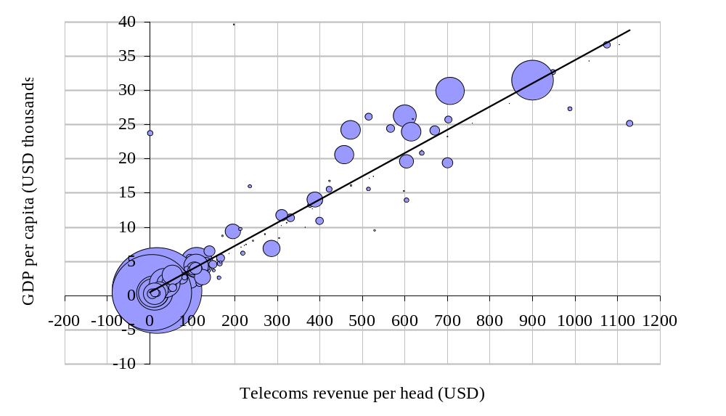
Exhibit C.43: Output and telecoms revenue per capita [Source: WDI 99, ITU] (Size of bubble denotes country population)
Fortunately, as discussed in the main report, the networking revolution provides ample opportunities for the historical relationship, and causalities, between economic output and networking activity to be broken (see Chapter 1).
Exhibit C.2a shows the same chart as it is more usually presented, with logarithmic axes. This method of presentation illustrates the under-populated zone in the middle of the output and networking distributions. This zone can partly be explained by the averaging implicit in the figures for large countries such as China, India and Indonesia, which masks the existence of regions and population sub-groups with much higher (and much lower) levels of economic and networking activity.
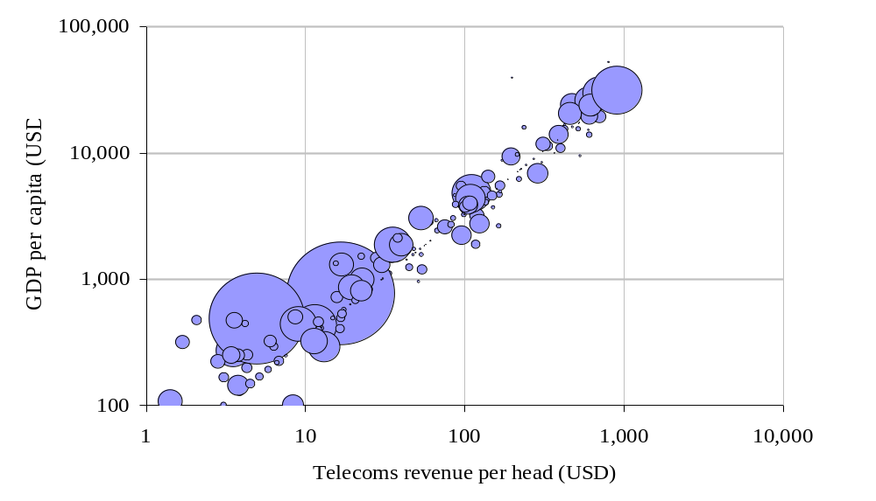
Exhibit C.44a: Output and telecoms revenue per capita, logarithmic axes [Source: WDI 99, ITU] (Size of bubble denotes country population)
However, even allowing for this effect, there appears to have been a bifurcation of development paths that has led to this sparse region on the chart. The development challenge can be seen as the need to move into this middle zone. Again, it is conceivable that the disruptive effect of the networking revolution may alter development dynamics in ways that reduce the historical bifurcation problem.
Telecoms revenue is an imperfect indicator of networking activity, regardless of whether market exchange rates or purchasing power parity rates are used. Exhibit C.2b (overleaf) shows the other commonly used indicator – fixed line penetration – and its relationship to per capita output. This is a more dispersed relationship than for telecoms revenue, and is a bowed distribution, showing that fixed line penetration in mid-range countries runs ahead of per capita output. Fixed lines in less developed countries are, on average, used less, and generate less revenue, than fixed lines in developing countries, particularly in this mid-range group. This is not an intuitive observation, as the opposite hypothesis could be put forward (that less developed countries would make greater use of a scarce network resource) but it is a readily explainable observation – lines are deployed to give a required level of network coverage, which is likely to be relatively high, and the resultant intensity of use is therefore below the level seen in more affluent countries.
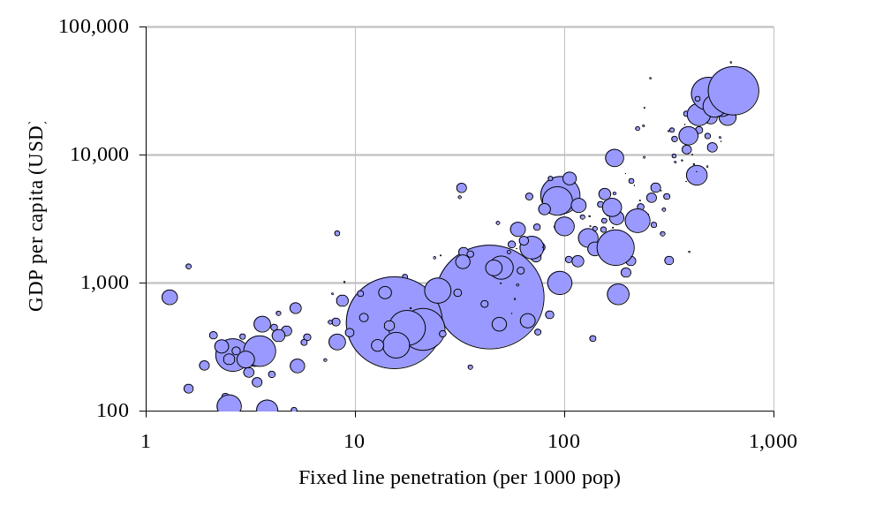
Exhibit C.2b: Output and fixed line penetration per capita [Source: WDI 99, ITU] (Size of bubble denotes country population)
It seems likely that a much wider range of causal relationships (between networking activity and economic activity) will exist in the future as networking becomes more diverse and multi-faceted. In the past, networking effectively equated with fixed voice telephony and the broadcast media, but it now includes mobile communications, the Internet and all of the applications and solutions that are supported by networks. The deployment and usage patterns of each of these components will vary widely, and their interaction with local activities will also vary widely, so it seems reasonable to expect a wider range of causal relationships and a weakening of the historically strong and simple correlation between economic output and networking activity.

Social and demographic relationships
The nature of these new causal relationships will be based on the absolute level of affluence at local and national level, the mix of economic activity, locally and nationally, and other factors such as the level of education, health and social cohesion. Understanding these interactions, even at a qualitative level, will be very difficult, and the prospects for statistically sound analysis are very poor, given the difficulty experienced in demonstrating robust causalities in the simpler pre-revolutionary network world.
Exhibit C.3 shows the relationship between the UN’s Human Development Index (HDI) and economic activity (GDP per capita) for the global set of countries where this data is available. The HDI is a synthetic index of a range of indicators covering health, education and other social parameters. The chart shows how the widest spread of HDI scores occurs among countries with output per capita of below around USD5000, illustrating very clearly that low economic output is not well correlated with low human development indicators – there are many low output countries with reasonable levels of health, education and social cohesion.
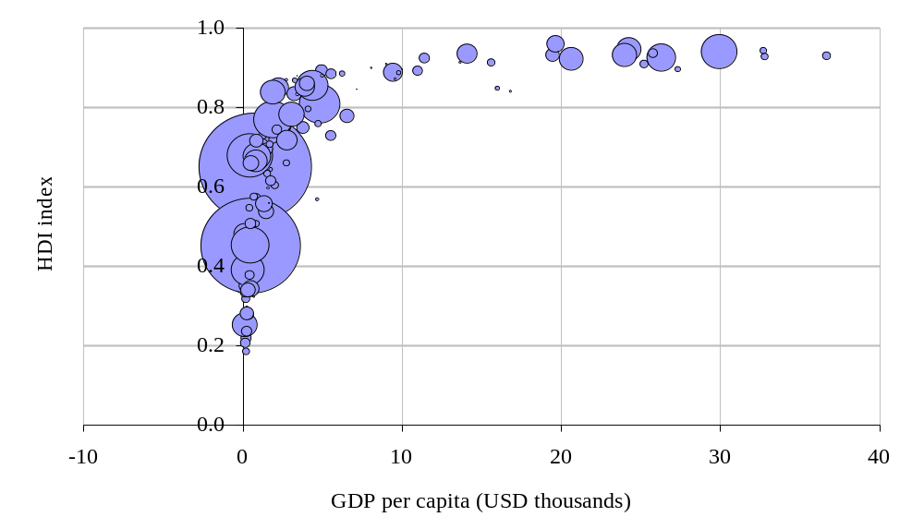
Exhibit C.45: Output per capita and Human Development Index [Source: WDI 99, ITU] (Size of bubble denotes country population)
However, the hypothesis that reasonable levels of health, education and social cohesion might form a good basis for increased levels of networking is contradicted by Exhibit C.4. Unsurprisingly, given the strong correlation of output and telecoms revenue, the HDI–telecoms revenue relationship is very similar to the HDI–output relationship. Many countries with reasonable HDI figures have levels of networking activity that are comparable to those with low HDI figures.
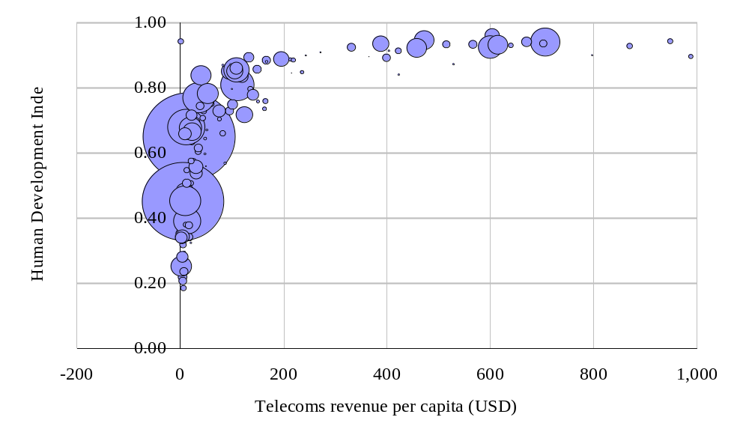
Exhibit C.46: Telecoms revenue per capita and Human Development Index [Source: WDI 99, ITU] (Size of bubble denotes country population)
In the future, we expect that those countries with a high HDI score will be best placed to exploit the networking revolution to their advantage. A good level of education in the population is likely to be a strong indicator for success, as discussed later in this annex. Social cohesion, political stability and institutional performance are also likely to be positive indicators, providing a good basis for investment in networking (foreign and domestic) and developing patterns of network usage.
Since HDI is likely to be an important indicator for networking development prospects, we go on to look at relationships with specific measures related to individual and societal development
Exhibit C.5 shows the relationship between output per capita (GDP) and income inequality (using the GINI coefficient as the measure of income inequality – a high GINI coefficient indicates a highly skewed national income distribution). The chart shows how the lower output countries have a much wider range of income distributions than the higher output countries, including a number of countries with very highly skewed income distributions. (The USA has a more highly skewed income distribution than is seen for most of its OECD peer group.) It should be noted that GINI coefficient data is not available for a large number of countries, including several OECD countries.
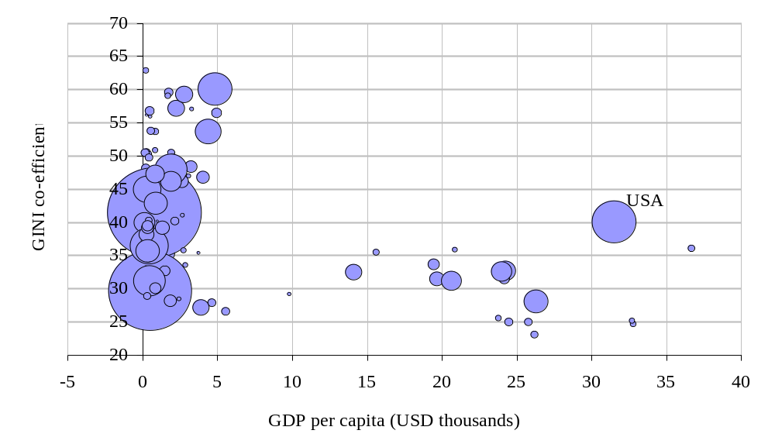
Exhibit C.47: Output per capita and income inequality (GINI coefficient) [Source: WDI 99, ITU] (Size of bubble denotes country population. Note that data is missing for many countries)
This diversity of income distributions is likely to translate into a diversity of paths for network development. For example, in countries with a small, affluent elite, and a majority population in poverty (‘high GINI’), there may be a good investment case for high-grade mobile services and broadband fixed services covering very small areas, and targeting a very small subscriber base. This could then serve as a base for eventual expansion of services with a more universal service objective.
A country with the same average output per head, but a more even distribution of incomes, may find the initial investment case for networking is less attractive – a large investment is necessary to cover a large subscriber base, and individual subscriber spending may be relatively low. However, the development impact of this investment may be much greater, and much more rapid, than the ‘high GINI’ country, due to the network externality effect in the larger subscriber base.
There is great uncertainty surrounding the interaction between income inequality and networking development, with a range of hypotheses suggested by the empirical evidence to date. This uncertainty is compounded by the non-correlation of income inequality with the HDI (as illustrated in Exhibit C.6):
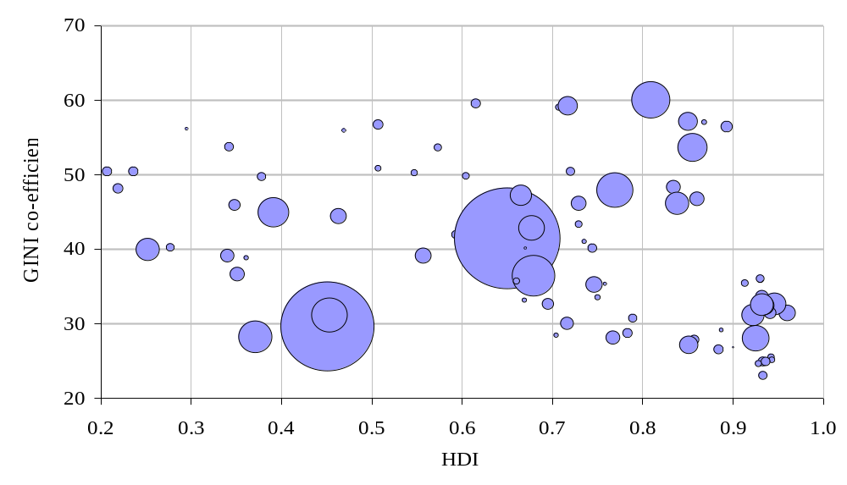
Exhibit C.48: Human Development Index and income inequality (GINI coefficient) [Source: WDI 99, ITU] (Size of bubble denotes country population. Note that data is missing for many countries)
Individual human development indicators, such as literacy and life expectancy, show broadly similar patterns when plotted against networking indicators – a very wide variation for countries with the lowest levels of networking and a consistently high figure for those with higher levels of networking. Charts C.7 and C.8 illustrate this with telecoms revenue per capita as the networking indicator.
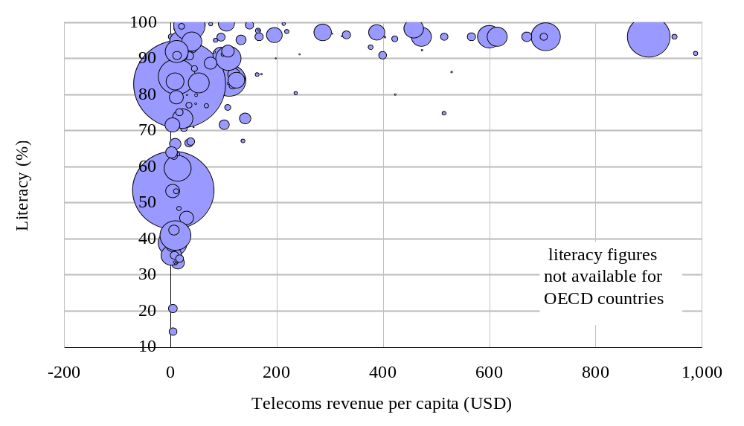
Exhibit C.49: Literacy and telecoms revenue per capita [Source: WDI 99, ITU] (Size of bubble denotes country population)
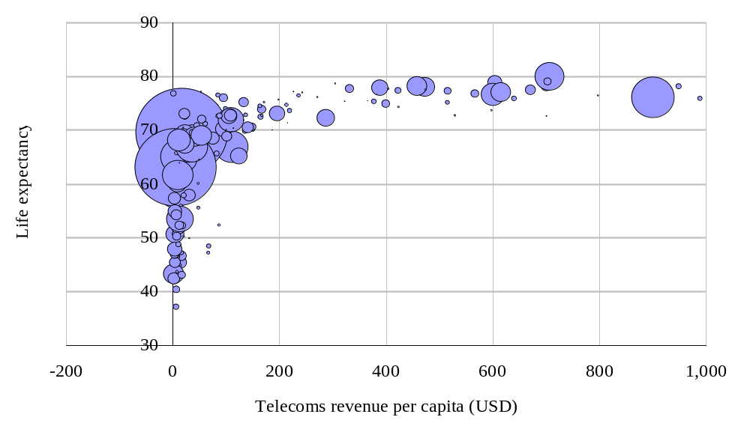
Exhibit C.50: Life expectancy and telecoms revenue per capita [Source: WDI 99, ITU] (Size of bubble denotes country population)

Correlations with TV penetration
Other networking activities also have a relationship with human development. Broadcast TV, for example, can have a positive impact on literacy, awareness of public health issues, and perhaps even social cohesion (through entertainment, news and sport) and institutional development (through current affairs). However, meaningful indicators are scarce. Exhibit C.9 shows how TV penetration relates to telecoms revenue per capita, illustrating how TV penetration can exceed one for every ten inhabitants even in countries where telecoms spending is a few dollars per capita per year.
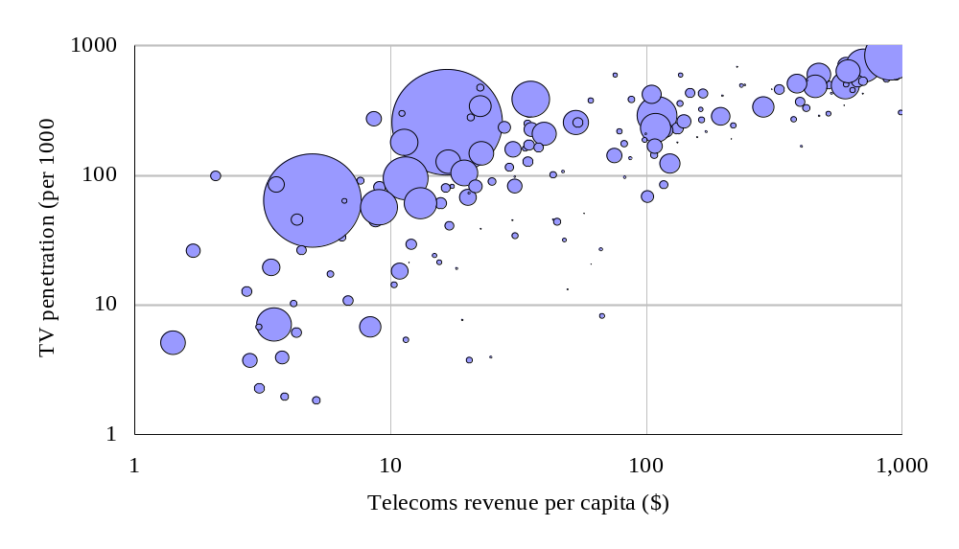
Exhibit C.51: TV penetration and telecoms revenue per capita, logarithmic scales [Source: WDI 99, ITU] (Size of bubble denotes country population)
Exhibit C.10 shows how TV penetration is slightly more correlated with literacy rates than is the case for telecoms revenue and literacy (Exhibit C.7 above). However, the overall shape of the plot is similar for both of these networking indicators.
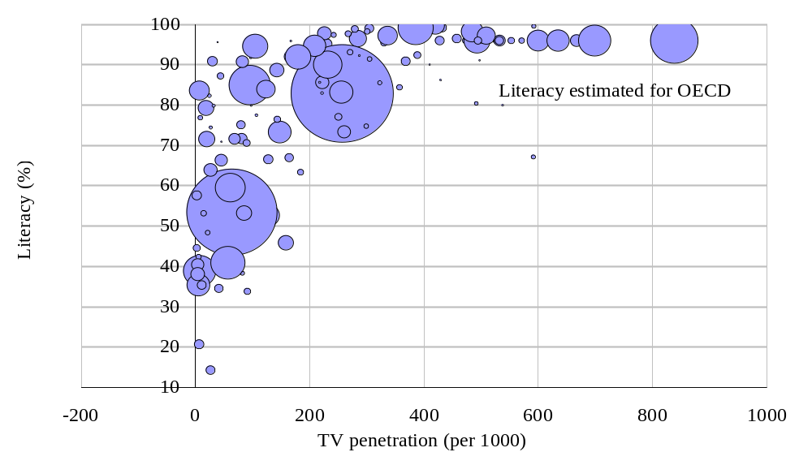
Exhibit C.52: Literacy and TV penetration [Source: WDI 99, ITU] (Size of bubble denotes country population)

Population density relationships
It seems plausible to suggest that networking and population density and distributions should be related – the unit costs of deploying networks are inversely related to local population density, even for wireless networks, and low demand density is often cited as an explanation for low networking investment levels in developing markets.
The following two exhibits (C.11 and C.12) show how such relationships are not simple, at least at national level.
Exhibit C.11 shows national population density to be uncorrelated with telecoms revenue per capita. At a sub-national level there is generally a correlation between local population density and local spending on telecoms, but this is not a simple relationship. Local economic activity is positively correlated with local population density within a country, and also positively correlated with local telecoms spending. This linkage is the primary driver of the local density-to-telecoms spend correlation. However, in less densely populated areas the need for telecoms can be higher than in denser areas, and a higher proportion of income or turnover may be spent on communications services. This secondary effect is, however, generally masked by the primary economic effect (above).
Given the likely complexity of these effects, and the averaging introduced by looking a national figures, we should not be surprised by the lack of a clear relationship in Exhibit C.11 below.
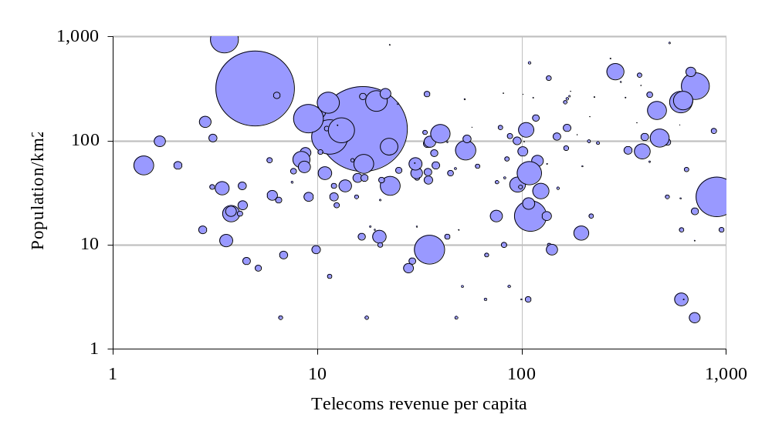
Exhibit C.53: National population density and telecoms revenue per capita [Source: WDI 99, ITU] (Size of bubble denotes country population)
Exhibit C.12 explores the relationship between the density of economic activity, at a national level, and per capita spending on telecoms. This can be seen as a revised version of C.11, modifying population density using output per head. The resulting relationship is still surprisingly dispersed (given that this is a log-log plot), which parallels the hypothesis that national population density is not a particularly useful indicator for networking activity, in spite of the importance of local population density and local demand density as determinants of network infrastructure and networking activity.
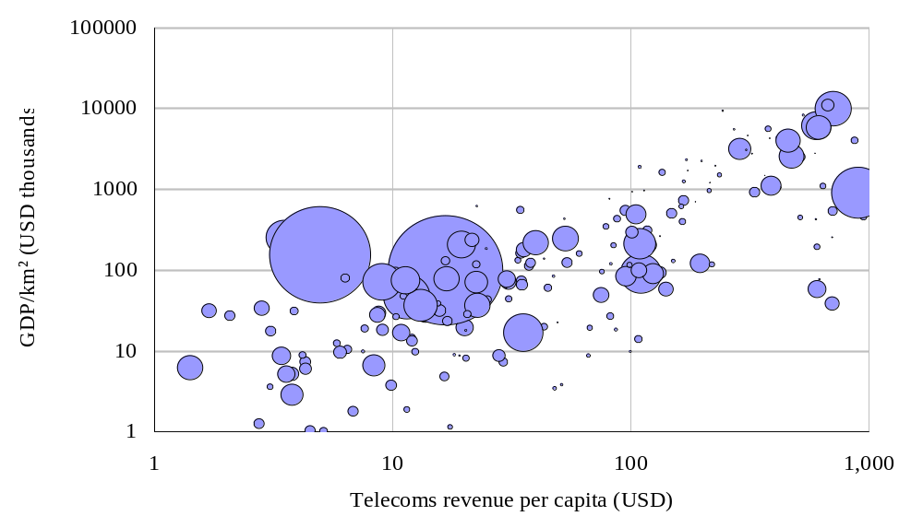
Exhibit C.54: National output density (GDP/km²) and telecoms revenue per capita [Source: WDI 99, ITU] (Size of bubble denotes country population)

Relationships with mobile and Internet indicators
Mobile telecoms holds great promise for developing countries as an accelerator of networking development, and hence an important driver of overall development (see Section 3.1.1 of the main report). However, Exhibit C.13 (overleaf) illustrates that, for most developing countries, the mobile revolution is still in its early stages. The dotted line on the chart shows fixed–mobile parity, and the solid line shows the regression relationship between fixed and mobile penetration. Developing countries that can achieve mobile penetration rates of greater than 10% should start to see material development benefits, equivalent to a significant boost to their fixed line penetration, but achieved for a fraction of the infrastructure costs. It should, of course, be noted that mobile growth rates are currently very high, and WDI 99 data reflects 1998 or 1997 country data.
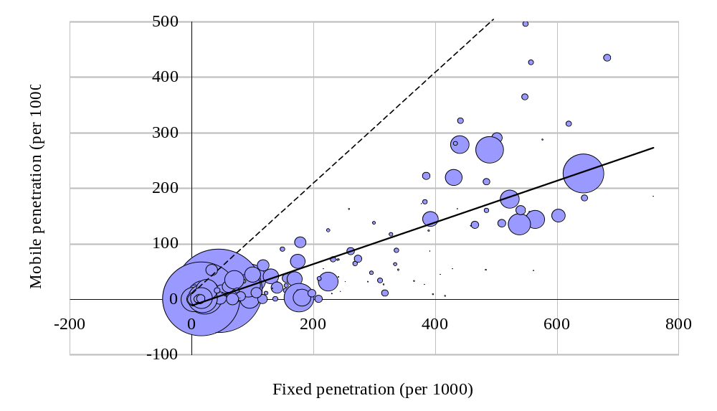
Exhibit C.55: Mobile penetration and fixed penetration [Source: WDI 99, ITU] (Size of bubble denotes country population)
As for mobile communications, the Internet presents significant opportunities for accelerated development. However, meaningful indicators for Internet activity are particularly difficult, and no single indicator captures more than a small part of the overall picture. Exhibits C.14 and C.15 show two commonly cited indicators with good data coverage – PC penetration and Internet hosts per capita.
Exhibit C.14 confirms that PC penetration remains very low in all countries with low levels of networking activity. The chart also illustrates the strength of US PC penetration relative to its OECD peer group. For countries to take advantage of the Internet opportunity, PC penetration must rise substantially. This is a much more challenging obstacle than increasing mobile penetration, for reasons of device cost, infrastructure cost, user training and support. A fully functional PC requires significant support resources, stretching developing countries in an area where many have known problems and weaknesses.
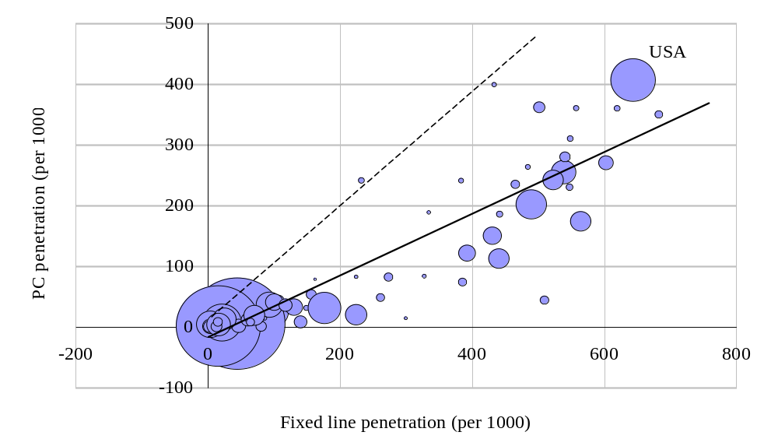
Exhibit C.56: PC Penetration and Fixed Penetration [Source: WDI 99, ITU] (Size of bubble denotes country population)
The per capita number of Internet hosts is an indicative (and indirect) measure of Internet activity in a country. Exhibit C.15 shows how the distribution of Internet hosts is related to telecoms revenue. Countries that are taking full advantage of the Internet opportunity are likely to show host numbers climbing above this curve, as a leading indicator for national Internet activity. No country shows this effect in the WDI 99 data.
To summarise the message of the three preceding exhibits, although mobile communications and the Internet hold great promise as drivers of development, there is no significant indication in the dataset of ‘trend-breaking’ progress in either of these areas for developing countries. While this is partly due to the age of the data in the main international datasets, it is also a current effect. This confirms the material challenge facing developing countries that look to the networking revolution as a driver of change.
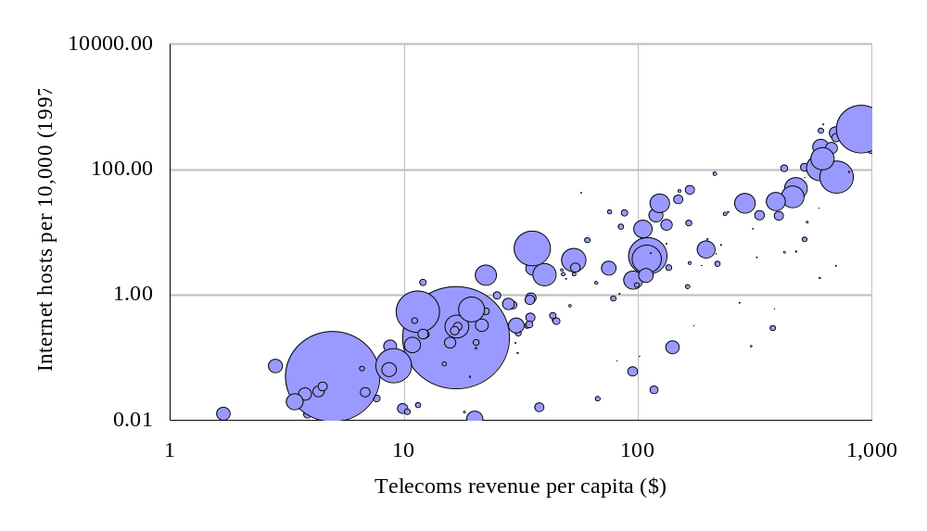
Exhibit C.57: Internet hosts and telecoms revenue per capita, logarithmic scales [Source: WDI 99, ITU] (Size of bubble denotes country population)

Participation in global networking
This section considers the obstacles to participation in the global networking phenomenon. Exhibits C.16 and C.17 illustrate the relationship between the cost of international calls and economic output per head, focusing on the cost of calls to the USA.
Exhibit C.16 illustrates the negative correlation between prosperity and the cost of international calls. It also shows the very wide dispersion of international call charge rates. Although the dataset refers to calls to the USA, this relationship is broadly representative of call charges to other international destinations. This inverse relationship is explainable by three factors.
- Firstly, and most importantly, lower output countries are correlated with low levels of liberalisation and high levels of public ownership and control. In these conditions, international call charges can be kept high as a form of taxation. The suppression of demand for outbound calls also increases the imbalance between inbound and outbound calls, driving a further source of revenue (see Exhibit C.17).
- Secondly, the distances covered to reach the US tend to be greater for lower output countries. OECD countries need to traverse 3 to 4,000 miles to reach the US – the average distance for developing countries is 6 to 8,000 miles.
- Thirdly, lower output countries will tend to have much thinner (lower capacity) links to the US (or to their nearest major communications node). Thinner links have much higher unit costs than high capacity links
Whatever the balance of explanations, the impact of expensive international call charges in the developing world is significant, and almost certainly outweighs the short-term revenue benefits of high prices. As high capacity, affordable international networking develops as the nervous system of the global economy, high costs and thin links are isolating many developing countries from the opportunity to participate in this revolution.
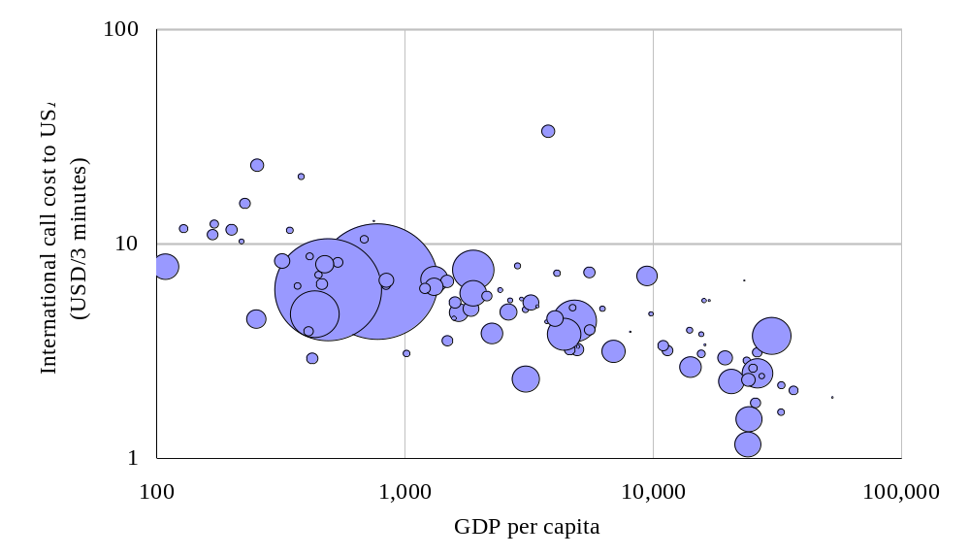
Exhibit C.58: Cost of calling USA and output per capita [Source: WDI 99, ITU] (Size of bubble denotes country population)
It is also expensive to call to many developing countries, due to the high settlement rates that they levy on incoming calls. Most international settlement rates remain confidential, but rates from the USA are published, and are shown in Exhibit C.17. Again, there is a strong inverse correlation with output per capita. Many developing countries rely on network settlement payments as a major source of foreign currency income – a form of international aid, but this cashflow is at the expense of network development and all of the opportunities that network development can offer. In the medium term, high settlement rates are as damaging as high prices for outbound international calls.
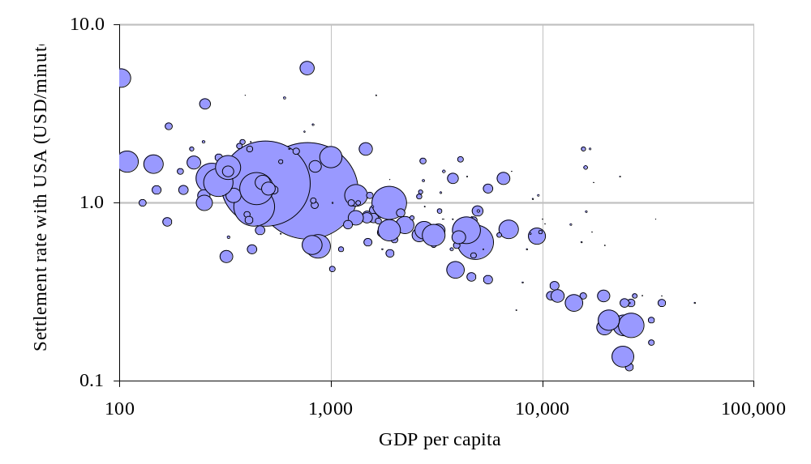
Exhibit C.59: US settlement rates and output per capita [Source: WDI 99, ITU] (Size of bubble denotes country population)

Supply constraints
The final exhibit, C18, shows the relationship between waiting lists for network connections and output per capita. Waiting lists have been a long-standing feature of the telecoms business, and have been used as a measure of unmet demand and a measure of operator efficiency. However, in recent years, liberalisation has eliminated waiting lists in many markets (other than those waiting the duration of the standard leadtime from order to delivery for a new connection). For this reason, waiting lists have taken a much lower profile in telecoms analysis.
Exhibit C.18 is included as a reminder that waiting lists still exist. The sum total waiting list in the (incomplete) 1997 dataset is over 28 million lines, relative to the 780 million lines identified as being in service. It seems appropriate to conclude this annex with the observation that network development is still a supply challenge as much as a demand challenge, and that both of these challenges need to be addressed if the developing world is to benefit from participating in the global networking revolution.
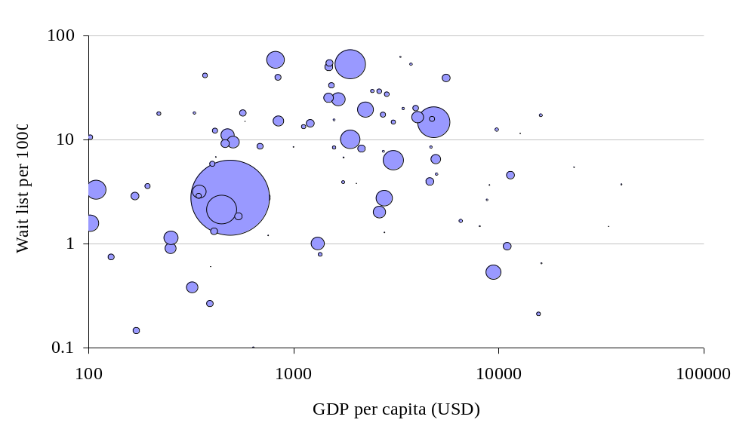
Exhibit C.60: Waitlist per 1000 inhabitants and output per capita. [Source: WDI 99, ITU] (Size of bubble denotes country population)
- Bibliography
Akerlof G (1970): ‘The Market for Lemons: Qualitative Uncertainty and the Market Mechanism’, Quarterly Journal of Economics, 84
Analysys (1992): An International Comparison of Telecommunications Infrastructure and Government Licensing Conditions, Analysys Report Number 92244 for Bundesministerium für Post und Telekommunikation
Analysys (1994): ‘The cost to BT of its universal service obligations’, Report for OFTEL
Analysys (1995): The Impact of Advanced Communications on European Growth and Trade, Final Report of the METIER Project for the European Commission
Analysys (1998): Cambridge 2020: Meeting the Challenge of Growth, Cambridge: Analysys Publications
Analysys (1999a): Reinventing the Telco: Strategies for Global Competition, Cambridge: Analysys Publications
Analysys (1999b): Data over Mobile: Commercial Strategies for Operators, Cambridge: Analysys Publications
Analysys (1999c): Next Generation Networks: Integrated IP Architectures, Cambridge: Analysys Publications
Analysys (1999d): Will Wireless Win? Prospects for Mobile and Fixed Operators, Cambridge: Analysys Publications
Analysys (1999e): IP local loop: Accessing the Next Generation Network, Cambridge: Analysys Publications
Analysys (1999f): Business-to-Business Ecommerce: Opportunities and Threats for Network Operators, Cambridge: Analysys Publications (forthcoming)
Arrow K (1979): ‘The Economics of Information’ in The Computer Age: a Twenty Year View, ed. Dertouzos and Moses, Cambridge MA: MIT Press
Bell D (1973): The Coming of Post-industrial Society: a Venture in Social Forecasting, New York: Basic Books
Beniger J (1986): The Control Revolution: Technological and Economic Origins of Information Society, Cambridge MA: Harvard University Press
Bond J (1997a): ‘The Drivers of the Information Revolution – Cost, Computing Power and Convergence’, Public Policy for the Private Sector, Number 118, http://worldbank.org/html/fpd/notes/118/118summary.html
Bond J (1997b): ‘Telecommunications is Dead, Long Live Networking’, Public Policy for the Private Sector, Number 119, http://worldbank.org/html/fpd/notes/119/119summary.html
Braga C (1995): The Impact of the Internationalization of Services on Developing Countries, www.worldbank.org/fandd/english/0396/articles/070396.htm
Braga C (1997a): ‘Liberalizing Telecommunications and the Role of the World Trade Association’, Public Policy for the Private Sector, Number 120, http://worldbank.org/html/fpd/notes/120/120summary.html
Braga C (1997b): ‘The Private Sector and the Internet’, Public Policy for the Private Sector, Number 122, http://worldbank.org/html/fpd/notes/122/122summary.html
Braga C et al (1999): ‘Developing Countries and Accounting Rates Reform – a Technological and Regulatory El Nino?’, Public Policy for the Private Sector, Number 173, http://worldbank.org/html/fpd/notes/173/173summary.html
Byron I and Gagliardi R: Communities and the Information Society: The Role of Information and Communication Technologies in Education http://www.idrc.ca/acacia/studies/ir-unesco.htm
Cairncross F (1997): The Death of Distance, Cambridge MA: Harvard Business School Press
Capello R (1994): Spatial Economic Analysis of Telecommunications Network Externalities, Report for the European Commission
Castells M (1996): ‘Relationships of Advanced Information Technology, Economic Organisation and the Social Structure of Cities’, MIT Colloquium on Advanced Information Technology, Low-Income Communities and the City
Chale E (1997): Distance Learning for Change in Africa: A Case Study of Senegal and Kenya, http://www.idrc.ca/acacia/03230/04-dlear/index.html
Chowdary T (1998): ‘Telecom Liberalization and Competition in Developing Countries’, Telecommunications Policy, Volume 22, Number 4/5
Cohen R (1992): The Impact of Broadband Communication on the US Economy and on Competitiveness, Washington DC: Economic Strategy Institute
Cronin F (1991): ‘Telecommunications Infrastructure and Economic Growth’, Telecommunications Policy, Volume 15, Number 6
Cronin F et al (1993): ‘Telecommunications and Growth’, Telecommunications Policy, Volume 17, Number 9, December 1993
d’Orville H (1998): The Information and Knowledge Revolutions – the Advent and Impact of Generic Technologies, http://www.undp.org/comm/techn.htm
Deibert R (1997): Parchment, Printing and Hypermedia: Communication and World Order Transformation, New York: Columbia University Press
Demchak C et al (1997): Governance in an Information Age: Early Patterns of Global Diffusion of the Web and Openness across Public Agencies, http://www.cyprg.arizona.edu/cygovn97.htm
Demchak C et al (1998): Comments from Configuring Public Access Agencies in Cyberspace: Openness and Effectiveness, http://www.cyprg.arizona.edu/Tilburg98F.htm
Dokeniya A (1999) ‘Reforming the State: Telecom Liberalization in India’, Telecommunications Policy, Volume 23, Number 2
DRI (1991): The Contribution of Telecommunications Infrastructure to Aggregate and Sectoral Efficiency, New York: McGraw-Hill
Economist (1995): ‘The Death of Distance’, Economist Telecoms Supplement
Economist (1997): ‘A Connected World’, Economist Telecoms Supplement
Economist (1999): ‘The World in your Pocket’, Economist Telecoms Supplement
Forge S (1999): Towards a Theory of Electronic Capitalism, draft release 2.0
Fuchs R (1999): Case Histories from the Global Telecentre Movement, http://www.idrc.ca/acacia/engine/
Gates W (1995): The Road Ahead, New York: Viking Books
Gates W (1999): Business @ the Speed of Thought, New York: Warner Books
Gilder G: ‘Telecosm’ articles published in Forbes from 1992 to 1996,
http://www.forbes.com/asap/gilder/
Global Knowledge Partnership (1997): Global Connectivity for Africa Conference 1997: Key Issues for Decision Makers, http://www.globalknowledge.org/keyissues.html
Graham M (1997): Use of Information and Communication Technologies in IDRC Projects: Lessons Learned, http://www.idrc.ca/acacia/outputs/op-eval.htm
Hardy A and Hudson H (1981): The Role of the Telephone in Economic Development: an Empirical Analysis, Washington DC: Keewatin Communications
Hénault G (1996): Employment and Income Generating Activities Derived from Internet Access, http://www.idrc.ca/acacia/studies/ir-henlt.htm
Huber P (1989): ‘Telecom Apartheid’, Forbes, 27 November 1989
Huber P (1993): ‘Telephony Unbottled’, Forbes, 18 January 1993
Hudson H (1982): ‘Towards a Model for Predicting Development Benefits from Telecommunications Investment’, in Jussawalla and Lamberton, Communication Economics and Development, New York Pergamon Press
Hudson H et al (1979): The Role of Telecommunications in Socioeconomic Development, Report prepared for the ITU, Boston: Information Gatekeepers Inc.
Innis H (1950): Empire and Communications, Oxford: Clarendon Press
Institute of Governance (1996): Information and Communications Technologies and Governance: Linkages and Challenges,
http://www.idrc.ca/acacia/studies/ir-gove.htm#government efficiency and economic benefits of ICTs
ITU (1999): Challenges to the Network – Internet for Development, Geneva: ITU
Jipp A (1963): ‘Wealth of National and Telephone Density’, Telecommunications Journal, July 1963
Jussawalla M (1999): ‘The Impact of ICT Convergence on Development in the Asian Region’, Telecommunications Policy, Volume 23, Number 3-4
Kayani R and Dymond A (1997): ‘Options for Rural Telecommunications Development’, World Bank Technical Paper, Number 359
Kelly T (1998): ‘Internet Telephony: Regulatory Issues’, presentation to the Internet Society’s Geneva Chapter on 6 May 1998
Kelly T (1998b): Internet Peering: What Does it Mean for Developing Countries?, http://www.itu.int/ti/papers/Peering/Peering%20article.doc
Kelly T and Petrazzini B (1997): ‘What Does the Internet Mean for Development?’ paper delivered at the Telecom 99 Interactive Development Symposium, Geneva, 11 September 1997, http://www.itu.int/ti/papers/home.htm
Kibati M and Krairit D (1999): ‘The Wireless Local Loop in Developing Regions’, Communications of the ACM, Volume 42, Number 6
Kim H (1992): ‘Causality between the Telecoms Sector and the National Economy’, Proceedings of the Pacific Telecommunications Council 14th Annual Conference, Honolulu: PTC
Knoch C (1997): Uninet – The South African Academic and Research Network, http://www.idrc.ca/acacia/outputs/op-unin.htm#Summary
Kontkiewicz-Chachulska H and Phan D (1998): ‘From Path-dependent Processes of Structural Change to a Diversity of Market Models in Central European Countries’ Telecommunications’ in Telecommunications and Socio-Economic Development, ed. Macdonald and Madden, Amsterdam: Elsevier Science BV
Krishnaswamy G (1998): ‘Where the Poor have Access to Telephones: Telecommunications and Development in the Indian State of Kerala’ in Telecommunications and Socio-Economic Development, ed. Macdonald and Madden, Amsterdam: Elsevier Science BV
Levin L (1996): Report to the IDRC on the Use of Information and Communications Technologies in Sub-Saharan Africa in the Area of Governance, http://www.idrc.ca/acacia/studies/ir-lev.htm
Machlup F (1962): The Production and Distribution of Knowledge in the United States, Princeton NJ: Princeton University Press
McLuhan M and Powers B (1989): The Global Village, New York: Oxford University Press
Madden G and Savage S (1998): ‘CEE Telecommunications Investment and Economic Growth’, Information Economics and Policy, Number 10
Madden G and Savage S (1999): ‘Telecommunications Productivity, Catch-up and Innovation’, Telecommunications Policy, Volume 23, Number 1
Manji F et al (1998): Enhancing the Capacity of Human Rights and Advocacy Organizations in Southern Africa, http://www.idrc.ca/acacia/04053/index.html
Mody et al (1995): Telecommunications Politics: Ownership and Control of the Information Highway in Developing Countries, Mahwah NJ: Erlbaum
MOSAIC Group (1998): The Global Diffusion of the Internet Project: an Initial Inductive Study, www.agsd.com/gdi97/gdi97.html
Moss M (1986): ‘Urban Development in a Global Economy’ in Telecommunications: a Strategic Perspective on Regional, Economic and Business Development, ed. Estabrooks and Lamarche, Moncton, Canada: Canadian Institute for Research on Regional Development
Mowlana H (1996): Global Communication in Transition: the End of Diversity?, Thousand Oaks CA: Sage
Mustafa M et al (1997): ‘Telecommunications Policies for Sub-Saharan Africa’, World Bank Discussion Paper, Number 353
Negroponte N (1995): Being Digital, New York: Knopf
Negroponte N: articles published in Wired from 1993 to 1998, http://nicholas.www.media.mit.edu/people/nicholas/wired/
O’Brien R (1983): Information, Economics and Power: the North-South Dimension, Boulder CO: Westview Press
OECD (1996): OECD Employment Outlook 1996: the OECD Jobs Study: Technology, Productivity, and Jobs Creation, Paris: OECD
Pavlic B and Hamelink C (1985): The New International Economic Order: Links between Economics and Communications, Paris: UNESCO
Performance and Innovation Unit (1999): ecommerce@its.best.uk,
http://www.cabinet-office.gov.uk/innovation/
Petrazzini B (1995): The Political Economy of Telecommunications Reform in Developing Countries: Privatisation and Liberalisation in Comparative Perspective, Westport CT: Praeger
Pitroda S (1993): ‘Development, Democracy, and the Village Telephone, Harvard Business Review, Volume 71, Number 6
Porat M (1977): The Information Economy: Definition and Measurement, Washington DC: Office of Telecommunications - US Department of Commerce
Porter M (1990): The Competitive Advantage of Nations, London and Basingstoke: The Macmillan Press Ltd
Press L (1995): ‘Developing Networks in Less Industrialized Nations’, IEEE Computer, Volume 28, Number 6
Press L (1996): ‘Seeding Networks: the Federal Role’, Communications of the ACM, Volume 139, Number 10
Press L (1997a): ‘Will Commercial Networks Prevail in Emerging Nations?’, OnTheInternet, March/April 1997
Press L (1997b): ‘Notes on Framework to Characterize the Global Diffusion of the Internet’, INFO ’97, Havana, http://som.csudh.edu/fac/lpress/articles/fmwkpres.htm
Press L et al (1998): ‘An Internet Diffusion Framework’, Communications of the ACM, Volume 41, Number 10, http://som.csudh.edu/fac/lpress/articles/acmfrwk.htm
Raja S (1999): ‘Harmonised third generation plan wins broad industry approval’, Financial Times Mobile Communications, 10 June 1999, Number 265
Riaz A (1997a): ‘Telecommunications in the Economic Growth of Malaysia’, Journal of Contemporary Asia, Volume 27, Number 4
Riaz A (1997b): ‘Role of Telecommunications in Economic Growth’, Media, Culture and Society, Volume 19
Röller and Waverman L (1994): Impact of Telecommunications Infrastructure on Economic Growth and Development, ICCP Draft Working Paper, Paris: OECD
Saunders et al (1994): Telecommunications and Economic Development, Baltimore MD: John Hopkins University Press
Singh J (1999): Leapfrogging Development? the Political Economy of Telecommunications Restructuring, Albany, NY: State University of New York Press
Stone P (1991): The Relative Importance of Telecommunications Investments on Selected Measures of Socio-Economic Development, Research Report Number 13, Centre for Telecommunications Management, School for Business Administration, University of Southern California
Talero E and Gaudette P (1996): ‘Harnessing Information for Development – A Proposal for a World Bank Group Strategy’, World Bank Discussion Paper, Number 313
Taylor R (1998): ‘Telecommunications Liberalization: the Lessons of India’ in Telecommunications and Socio-Economic Development, ed. Macdonald and Madden, Amsterdam: Elsevier Science BV
Teknibank et al (1993): The Impact of the Accelerated Adoption of Broadband Communications in the European Community, Study for the European Commission DGXIII
Tyler M et al (1977): ‘The Contribution of Telecommunications to the Conservation of Energy Resources’ Special Publication Number 77-17, Washington DC: Office of Telecommunications – US Department of Commerce
Tyler M et al (1978): ‘Implications for Transport’ in Impacts of Telecommunications on Planning and Transport, ed. Smith, Research Report Number 24, London: Department of Transport and Department of the Environment
UNDP (1999a): The Emerging Economies and the Internet, United Nations Development Update, Number 29
UNDP (1999b): Human Development Report 1999, New York: Oxford University Press
UNESCO (1999): The 1999 World Communication and Information Report, http://www.unesco.org/webworld/com_inf_reports/com_inf_99_eng.html
Warren T (1998): ‘The Political Economy of Telecommunications Services Trade and Investment Policy: Australia, Japan and the US’ in Telecommunications and Socio-Economic Development, ed. Macdonald and Madden, Amsterdam: Elsevier Science BV 1998
Wellinius B et al (1993): ‘Telecommunications: World Bank Experience and Strategy’, World Bank Discussion Paper, Number 192
Wellenius B (1997a): ‘Extending Telecommunications Service to Rural Areas – the Chilean Experience’, Public Policy for the Private Sector, Number 105, http://worldbank.org/html/fpd/notes/105/105summary.html
Wellenius B (1997b): ‘Telecommunications Reform – How to Succeed’, Public Policy in the Private Sector, Number 130, http://worldbank.org/html/fpd/notes/130/130summary.html
Wenders, J T (1987): Economics of Telecommunications, Ballinger, USA
Wheatley J (1998): ‘Practical Issues in Overseas Investment: Some Examples from Africa, Eastern Europe and Russia’ in Telecommunications and socio-economic development, ed. Macdonald and Madden, Amsterdam: Elsevier Science BV
Whyte A (1998): Telecentre Research Framework for Acacia, http://www.idrc.ca/acacia/04066/index.html
Williamson O (1985): The Economic Institutions of Capitalism, New York: Free Press
World Bank (1999): 1999 World Development Report, Washington DC: World Bank
Yan X et al (1998): ‘Competition without Privatisation: the Chinese Path’, in Telecommunications and Socio-Economic Development, ed. Macdonald and Madden, Amsterdam: Elsevier Science BV

Web sites
African Information Society Initiative
http://www.bellanet.org/partners/aisi/
Bellanet
http://www.bellanet.org
Global Knowledge Activity Information Management System http://gkaims.globalknowledge.org/
GreenNet
http://www.gn.apc.org/
International Development Research Centre, Acacia Initiative, http://www.idrc.ca/acacia/acacia_e.htm
Partnership for Information and Communication Technologies in Africa http://www.bellanet.org/partners/picta/

Talero E and Gaudette P (1996): ‘Harnessing Information for Development – A Proposal for a World Bank Group Strategy’, World Bank Discussion Paper, Number 313
The term ‘networking’ is used in this report in preference to ‘telecommunications’, ‘information’ or any of the other alternatives. Each term has its imperfections, but we have used ‘networking’ because it captures both the linkage of individuals, organisations, locations and systems, and the flow of information, transactions and communication over these links. Moreover, the term is used to cover all forms of communication (voice, data and video) for all purposes (business, personal, educational, entertainment, etc.).
Other network externality effects have yet to approach their threshold levels, but may do so. Smartcards and videotelephony are two examples that could demonstrate strong network externality effects within the next few years.
See ‘The middleman must add value’ in Gates W (1999): Business @ the Speed of Thought, New York: Warner Books
Analysys (1999f): Business-to-Business Ecommerce: Opportunities and Threats for Network Operators, Cambridge: Analysys Publications (forthcoming); Gates W (1999): Business @ the Speed of Thought, New York: Warner Books
Gates W (1995): The Road Ahead, New York: Viking Books
See, for example, the weekly column written by Peter Cochrane, BT’s Chief Technologist, in the Telegraph, available at http://www.labs.bt.com/library/cochrane/telegraph/
For example, Saunders et al (1994): Telecommunications and Economic Development, Baltimore MD: John Hopkins University Press
World Bank (1999): 1999 World Development Report, Washington DC: World Bank, p14
See Porter M (1990): The Competitive Advantage of Nations, London and Basingstoke: The Macmillan Press Ltd
World Bank (1999): 1999 World Development Report, Washington DC: World Bank
Those who are only able to participate through the occasional use of payphones (or equivalent services) are deemed to be below this threshold
We use the term ‘policy’ to denote any mechanism (regulatory, legislative, executive, etc) that does not require funding, and the term ‘programme’ to denote any mechanism that requires funding, either public or private, domestic or international.
See Section 5
The term ‘networking’ is used in this report in preference to ‘telecommunications’, ‘information’ or any of the other alternatives. Each term has its imperfections, but we have used ‘networking’ because it captures both the linkage of individuals, organisations, locations and systems, and the flow of information, transactions and communication over these links. Moreover, the term is used to cover all forms of communication (voice, data and video) for all purposes (business, personal, educational, entertainment, etc.).
However strong the correlations, the robust demonstration of causality relationships between networking and economics remains elusive (See Annex A). In qualitative terms it is reasonable to suggest that there is a two-way causality between economic progress and networking progress.
For example, universal telephony enables family relationships to be maintained even though family members are widely dispersed. Broadcast television and radio have had a significant impact on behaviour. The shape and behaviour of political and administrative institutions have been materially affected by broadcasting and other communications developments. See Annex A for more detail.
See, for example Gates W (1995), The Road Ahead, and (1999), Business @ the Speed of Thought, for examples of mainstream expectations of radical transformation driven by networking developments
Other network externality effects have yet to approach their threshold levels, but may do so. Smartcards and videotelephony are two examples that could demonstrate strong network externality effects within the next few years.
Analysys (1999d): Will Wireless Win? Prospects for Mobile and Fixed Operators, Cambridge: Analysys Publications
Gates W (1999): Business @ the Speed of Thought, New York: Warner Books; Performance and Innovation Unit (1999): ecommerce@its.best.uk, http://www.cabinet-office.gov.uk/innovation/
Negroponte N (1995): Being Digital, New York: Knopf ; Gilder G: ‘Telecosm’ articles published in Forbes from 1992 to 1996, http://www.forbes.com/asap/gilder/
Economist (Oct 1999)
Greenspan (Jan 1999)
Gates W (1995): The Road Ahead, New York: Viking Books
See, for example, the weekly column written by Peter Cochrane, BT’s Chief Technologist, in the Telegraph, available at http://www.labs.bt.com/library/cochrane/telegraph/
We present Pyramid’s projections for the developing world in Chapter 4
World Bank (1999): 1999 World Development Report, Washington DC: World Bank
For example, Saunders et al (1994): Telecommunications and Economic Development, Baltimore MD: John Hopkins University Press
See Analysys (1994): Rural Telecommunications Handbook, Cambridge: Analysys Publications for more detail on such systems
For example, in Sri Lanka, Mexico and Indonesia
Analysys (1999d): Will Wireless Win? Prospects for Mobile and Fixed Operators, Cambridge: Analysys Publications; Hodulik J (1999): Without a Net: Initiating Coverage of Winstar and Teligent, New York: Paine Webber Equity Research
Motorola Inc. news release, Thursday, May 14, 1998
Economist (1999): ‘The World in your Pocket’, Economist Telecoms Supplement
For profiles of a wide range of satellite projects, see http://www.analysys.com/products/satellite/database.htm
The ‘Internet cloud’ concept is used to demarcate the access network from the space further into the network, where the end user is concerned with the routeing or flow characteristics of his packets of data (although there may be congestion and performance problems within the Internet cloud). An urban user in a well-connected city may be a few kilometres from the cloud. A developing world user may be many hundreds of kilometres from the edge of the Internet cloud, linked by a succession of thin and overloaded access connections. Although the term is not very precise, it matches the shifting topology of IP networks.
The forces driving hubbing in communications networks are even stronger than those that created hub and spoke topologies in the air transport industry – packets of data do not mind ‘changing planes’ unlike human passengers.
See the International Cable Protection Committee’s submarine cable database at http://www.iscpc.org/home.htm
See http:// www.dsl.com and http://www.catv.org/modem
For example, the experience of operators in Colombo, Sri Lanka, and Johannesburg, South Africa, where there is a striking contrast between the well developed infrastructure in the sites occupied by multi-national corporations and the much lower level of provision in the rest of the central business district.
See http://www.mdc.com.my for further information
Talero E and Gaudette P (1996): ‘Harnessing Information for Development – A Proposal for a World Bank Group Strategy’, World Bank Discussion Paper, Number 313
There is a growing body of more encouraging evidence – see http://www.worldbank.org and http://www.worldbank.org/infoDev
World Bank (1999): 1999 World Development Report, Washington DC: World Bank, p14
World Bank (1999): 1999 World Development Report, Washington DC: World Bank
It will be difficult to substantiate examples of this effect because it is almost certain to be an ‘invisible substitution’ – for example, if new networking enables more of the financial and legal work associated with a privatisation to be conducted in, say, New York, Paris or Johannesburg rather than by ‘in-country’ practitioners it is not possible to prove that local practitioners would have taken a larger slice of the work in the absence of new networking. Most arguments that ‘better networking may less than a good thing’ are vulnerable to easy and dismissive counter arguments.
Talero E and Gaudette P (1996): ‘Harnessing Information for Development – A Proposal for a World Bank Group Strategy’, World Bank Discussion Paper, Number 313
Analysys (1994): ‘The cost to BT of its universal service obligations’, Report for OFTEL. Wenders, J T (1987): Economics of Telecommunications, Ballinger, USA.
Those who are only able to participate through the occasional use of payphones (or equivalent services) are deemed to be below this threshold
UNDP (1999b): Human Development Report 1999, New York: Oxford University Press
See Annex C
We use the term ‘policy’ to denote any mechanism (regulatory, legislative, executive, etc) that does not require funding, and the term ‘programme’ to denote any mechanism that requires funding, either public or private, domestic or international. Inevitably there are grey areas – for example, establishing an independent regulator is ‘policy’ but raising development funds to pay the costs of an independent regulator is a ‘programme’ – but in general the distinction is visible.
The primary source for this estimation is the income/consumption breakdown by population quintiles in World Development Indicators 1999
Specifically telecoms revenue per capita, fixed and mobile penetration and the price of various call types
Note that this hypothesis is highly contentious, and cannot be validated robustly. There are several counter hypotheses asserting that increased inequality effects are more complex and more transient. A simple Gini plot (as here) can only illustrate the issue at a most superficial level. It certainly appears to be legitimate to assert that network-driven development may lead to income distribution effects that are different to those observed historically.
See World Trade Organisation: http://www.wto.org/services/tel.htm
The licensing processes for second GSM operators in the Czech Republic and Belgium provide examples of this approach.
See a description of a similar initiative in Chile in Wellenius B (1997a): ‘Extending Telecommunications Service to Rural Areas – the Chilean Experience’, Public Policy for the Private Sector, Number 105, http://worldbank.org/html/fpd/notes/105/105summary.html
This is not to say that the correct choice is always simultaneous liberalisation, but a two year monopoly will generally do less harm to sector development than a ten year monopoly.
For example, the common licensing of GSM operators in Europe in the early 1990s ensured the creation of a strong pan-European standard.
For example, when managing radio spectrum, it is generally necessary to be very specific about which technologies can operate in which bands.
See Wellenius (1997) ‘Extending Telecommunications Service to Rural Areas – the Chilean Experience’ Note Number 105, Public Policy for the Private Sector, Washington DC, World Bank
Jipp A (1963): ‘Wealth of National and Telephone Density’, Telecommunications Journal, July 1963
Hudson H et al (1979): The Role of Telecommunications in Socioeconomic Development, Report prepared for the ITU, Boston: Information Gatekeepers Inc; Hardy A and Hudson H (1981): The Role of the Telephone in Economic Development: an Empirical Analysis, Washington DC: Keewatin Communications; Stone P (1991): ‘The Relative Importance of Telecommunications Investments on Selected Measures of Socio-Economic Development, Research Report Number 13, Centre for Telecommunications Management, School for Business Administration, University of Southern California
Hudson H (1982): ‘Towards a Model for Predicting Development Benefits from Telecommunications Investment’ in Jussawalla and Lamberton, Communication Economics and Development, New York: Pergamon Press; Tyler M et al (1977): ‘The Contribution of Telecommunications to the Conservation of Energy Resources’, Special Publication Number 77-17, Washington DC: Office of Telecommunications - US Department of Commerce; Tyler M et al (1978): ‘Implications for Transport’ in Impacts of Telecommunications on Planning and Transport’, ed. Smith, Research Report Number 24, London: Department of Transport and Department of the Environment
Cronin F (1991): ‘Telecommunications Infrastructure and Economic Growth, Telecommunications Policy, Volume 15 Number 6; Cronin F et al (1993) ‘Telecommunications and Growth, Telecommunications Policy, Volume 17 Number 9; DRI (1991): ‘The Contribution of Telecommunications Infrastructure to Aggregate and Sectoral Efficiency’ New York: McGraw-Hill; Röller and Waverman L (1994): Impact of Telecommunications Infrastructure on Economic Growth and Development, ICCP Draft Working Paper, Paris OECD 1994; Cohen R (1992): The Impact of Broadband Communication on the US Economy and on Competitiveness, Washington DC: Economic Strategy Institute; Teknibank et al (1993): The Impact of the Accelerated Adoption of Broadband Communications in the European Community, Study for the European Commission DGXIII; Analysys (1992): An International Comparison of Telecommunications Infrastructure and Government Licensing Conditions, Analysys Report Number 92244 for Bundesministerium für Post und Telekommunikation
Analysys (1995): The Impact of Advanced Communications on European Growth and Trade, Final Report of the METIER Project for the European Commission
Madden G and Savage S (1998): ‘CEE Telecommunications Investment and Economic Growth’, Information Economics and Policy, Number 10
Castells M (1996): ‘Relationships of Advanced Information Technology, Economic Organisation and the Social Structure Of Cities’, MIT Colloquium on Advanced Information Technology, Low-Income Communities and the City
Röller and Waverman L (1994): Impact of Telecommunications Infrastructure on Economic Growth and Development, ICCP Draft Working Paper, Paris OECD 1994
Cohen R (1992): The Impact of Broadband Communication on the US Economy and on Competitiveness, Washington DC: Economic Strategy Institute; Cronin F (1991): ‘Telecommunications Infrastructure and Economic Growth’, Telecommunications Policy, Volume 15, Number 6; Cronin F et al (1993) ‘Telecommunications and Growth, Telecommunications Policy, Volume 17, Number 9
Kim H (1992): ‘Causality between the Telecoms Sector and the National Economy’, Proceedings of the Pacific Telecommunications Council 14th Annual Conference, Honolulu: PTC
Hénault G (1996): Employment and Income Generating Activities Derived from Internet Access, http://www.idrc.ca/acacia/studies/ir-henlt.htm; Analysys (1995): The Impact of Advanced Communications on European Growth and Trade, Final Report of the METIER Project for the European Commission
Riaz A (1997b): ‘Role of Telecommunications in Economic Growth’, Media, Culture and Society, Volume 19
Moss M (1986): ‘Urban Development in a Global Economy’ in Telecommunications: a Strategic Perspective on Regional, Economic and Business Development, ed. Estabrooks and Lamarche, Moncton, Canada: Canadian Institute for Research on Regional Development
Kontkiewicz-Chachulska H and Phan D (1998): ‘From Path-dependent Processes of Structural Change to a Diversity of Market Models in Central European Countries’ Telecommunications’ in Telecommunications and Socio-Economic Development, ed. Macdonald and Madden, Amsterdam: Elsevier Science BV
Kim H (1992): ‘Causality between the Telecoms Sector and the National Economy’, Proceedings of the Pacific Telecommunications Council 14th Annual Conference, Honolulu: PTC
Analysys (1995): The Impact of Advanced Communications on European Growth and Trade, Final Report of the METIER Project for the European Commission
Röller and Waverman L (1994): Impact of Telecommunications Infrastructure on Economic Growth and Development, ICCP Draft Working Paper, Paris: OECD
Riaz A (1997b): ‘Role of Telecommunications in Economic Growth’, Media, Culture and Society, Volume 19
Riaz A (1997a): ‘Telecommunications in the Economic Growth of Malaysia’, Journal of Contemporary Asia, Volume 27, Number 4
Forge S (1999): Towards a Theory of Electronic Capitalism, draft release 2.0
Saunders et al (1994): Telecommunications and Economic Development, Baltimore MD: John Hopkins University Press
Analysys (1998): Cambridge 2020: Meeting the Challenge of Growth, Cambridge: Analysys Publications
Levin L (1996): Report to the IDRC on the Use of Information and Communications Technologies in Sub-Saharan Africa in the Area of Governance, http://www.idrc.ca/acacia/studies/ir-lev.htm
Levin L (1996): Report to the IDRC on the Use of Information and Communications Technologies in Sub-Saharan Africa in the Area of Governance, http://www.idrc.ca/acacia/studies/ir-lev.htm
Graham M (1997): Use of Information and Communication Technologies in IDRC Projects: Lessons Learned, http://www.idrc.ca/acacia/outputs/op-eval.htm
Levin L (1996): Report to the IDRC on the Use of Information and Communications Technologies in Sub-Saharan Africa in the Area of Governance, http://www.idrc.ca/acacia/studies/ir-lev.htm
Levin L (1996): Report to the IDRC on the Use of Information and Communications Technologies in Sub-Saharan Africa in the Area of Governance, http://www.idrc.ca/acacia/studies/ir-lev.htm
Institute of Governance (1996): Information and Communications Technologies and Governance: Linkages and Challenges, http://www.idrc.ca/acacia/studies/ir-gove.htm#government efficiency and economic benefits of ICTs
Graham M (1997): Use of Information and Communication Technologies in IDRC Projects: Lessons Learned, http://www.idrc.ca/acacia/outputs/op-eval.htm
Hénault G (1996): Employment and Income Generating Activities Derived from Internet Access, http://www.idrc.ca/acacia/studies/ir-henlt.htm; OECD (1996): OECD Employment Outlook 1996: the OECD Jobs Study: Technology, Productivity, and Jobs Creation, Paris: OECD
Capello R (1994): Spatial Economic Analysis of Telecommunications Network Externalities, Report for the European Commission
Braga C (1995): The Impact of the Internationalization of Services on Developing Countries, www.worldbank.org/fandd/english/0396/articles/070396.htm; Saunders et al (1994): Telecommunications and Economic Development, Baltimore MD: John Hopkins University Press; Analysys (1998): Cambridge 2020: Meeting the Challenge of Growth, Cambridge: Analysys Publications; Analysys (1995): The Impact of Advanced Communications on European Growth and Trade, Final Report of the METIER Project for the European Commission
Saunders et al (1994): Telecommunications and Economic Development, Baltimore MD: John Hopkins University Press
Graham M (1997): Use of Information and Communication Technologies in IDRC Projects: Lessons Learned, http://www.idrc.ca/acacia/outputs/op-eval.htm
Graham M (1997): Use of Information and Communication Technologies in IDRC Projects: Lessons Learned, http://www.idrc.ca/acacia/outputs/op-eval.htm
Graham M (1997): Use of Information and Communication Technologies in IDRC Projects: Lessons Learned, http://www.idrc.ca/acacia/outputs/op-eval.htm
Saunders et al (1994): Telecommunications and Economic Development, Baltimore MD: John Hopkins University Press
ITU (1999): Challenges to the Network – Internet for Development, Geneva: ITU
Saunders et al (1994): Telecommunications and Economic Development, Baltimore MD: John Hopkins University Press
Graham M (1997): Use of Information and Communication Technologies in IDRC Projects: Lessons Learned, http://www.idrc.ca/acacia/outputs/op-eval.htm
d’Orville H (1998): The Information and Knowledge Revolutions – the Advent and Impact of Generic Technologies, http://www.undp.org/comm/techn.htm
d’Orville H (1998): The Information and Knowledge Revolutions – the Advent and Impact of Generic Technologies, http://www.undp.org/comm/techn.htm
Byron I and Gagliardi R: Communities and the Information Society: The Role of Information and Communication Technologies in Education http://www.idrc.ca/acacia/studies/ir-unesco.htm
Chale E (1997): Distance Learning for Change in Africa: A Case Study of Senegal and Kenya, http://www.idrc.ca/acacia/03230/04-dlear/index.html
Knoch C (1997): Uninet – The South African Academic and Research Network, http://www.idrc.ca/acacia/outputs/op-unin.htm#Summary
Byron I and Gagliardi R: Communities and the Information Society: The Role of Information and Communication Technologies in Education http://www.idrc.ca/acacia/studies/ir-unesco.htm
d’Orville H (1998): The Information and Knowledge Revolutions – the Advent and Impact of Generic Technologies, http://www.undp.org/comm/techn.htm; Institute of Governance (1996): Information and Communications Technologies and Governance: Linkages and Challenges, http://www.idrc.ca/acacia/studies/ir-gove.htm#government efficiency and economic benefits of ICTs
Fuchs R (1999): Case Histories from the Global Telecentre Movement, http://www.idrc.ca/acacia/engine/; Whyte A (1998): Telecentre Research Framework for Acacia, http://www.idrc.ca/acacia/04066/index.html
Manji F et al (1998): Enhancing the Capacity of Human Rights and Advocacy Organizations in Southern Africa, http://www.idrc.ca/acacia/04053/index.html
Levin L (1996): Report to the IDRC on the Use of Information and Communications Technologies in Sub-Saharan Africa in the Area of Governance, http://www.idrc.ca/acacia/studies/ir-lev.htm
See http://www.gn.apc.org/
See http://gkaims.globalknowledge.org/
Graham M (1997): Use of Information and Communication Technologies in IDRC Projects: Lessons Learned, http://www.idrc.ca/acacia/outputs/op-eval.htm
Arrow K (1979): ‘The Economics of Information’ in The Computer Age: a Twenty Year View, ed. Dertouzos and Moses, Cambridge MA: MIT Press; Williamson O (1985): The Economic Institutions of Capitalism, New York: Free Press; Akerlof G (1970): ‘The Market for Lemons: Qualitative Uncertainty and the Market Mechanism’, Quarterly Journal of Economics, 84; Machlup F (1962): The Production and Distribution of Knowledge in the United States, Princeton NJ: Princeton University Press; Porat M (1977): The Information Economy: Definition and Measurement, Washington DC: Office of Telecommunications - US Department of Commerce; Bell D (1973): The Coming of Post-industrial Society: a Venture in Social Forecasting, New York: Basic Books; Beniger J (1986): The Control Revolution: Technological and Economic Origins of Information Society, Cambridge MA: Harvard University Press
Innis H (1950): Empire and Communications, Oxford: Clarendon Press; McLuhan M and Powers B (1989): The Global Village, New York: Oxford University Press; Deibert R (1997): Parchment, Printing and Hypermedia: Communication and World Order Transformation, New York: Columbia University Press; Pavlic B and Hamelink C (1985): The New International Economic Order: Links between Economics and Communications, Paris: UNESCO; O’Brien R (1983): Information, Economics and Power: the North-South Dimension, Boulder CO: Westview Press; Pitroda S (1993): ‘Development, Democracy, and the Village Telephone, Harvard Business Review, Volume 71, Number 6; UNESCO (1999): The 1999 World Communication and Information Report, http://www.unesco.org/webworld/com_inf_reports/ com_inf_99_eng.html
Mowlana H (1996): Global Communication in Transition: the End of Diversity?, Thousand Oaks CA: Sage
Singh J (1999): Leapfrogging Development? the Political Economy of Telecommunications Restructuring, Albany, NY: State University of New York Press
Mustafa M et al (1997): ‘Telecommunications Policies for Sub-Saharan Africa’, World Bank Discussion Paper, Number 353
Petrazzini B (1995): The Political Economy of Telecommunications Reform in Developing Countries: Privatisation and Liberalisation in Comparative Perspective, Westport CT: Praeger
Wheatley J (1998): ‘Practical Issues in Overseas Investment: Some Examples from Africa, Eastern Europe and Russia’ in Telecommunications and socio-economic development, ed. Macdonald and Madden, Amsterdam: Elsevier Science BV
Mody et al (1995): Telecommunications Politics: Ownership and Control of the Information Highway in Developing Countries, Mahwah NJ: Erlbaum
Dokeniya A (1999) ‘Reforming the State: Telecom Liberalization in India’, Telecommunications Policy, Volume 23, Number 2
Petrazzini B (1995): The Political Economy of Telecommunications Reform in Developing Countries: Privatisation and Liberalisation in Comparative Perspective, Westport CT: Praeger
Mody et al (1995): Telecommunications Politics: Ownership and Control of the Information Highway in Developing Countries, Mahwah NJ: Erlbaum
Krishnaswamy G (1998): ‘Where the Poor have Access to Telephones: Telecommunications and Development in the Indian State of Kerala’ in Telecommunications and Socio-Economic Development, ed. Macdonald and Madden, Amsterdam: Elsevier Science BV
ITU (1999): Challenges to the Network – Internet for Development, Geneva: ITU
UNDP (1999): The Emerging Economies and the Internet, United Nations Development Update, Number 29
Press L et al (1998): ‘An Internet Diffusion Framework’, Communications of the ACM, Volume 41, Number 10, http://som.csudh.edu/fac/lpress/articles/acmfrwk.htm
Demchak C et al (1998): Comments from Configuring Public Access Agencies in Cyberspace: Openness and Effectiveness, http://www.cyprg.arizona.edu/Tilburg98F.htm
Demchak C et al (1997): Governance in an Information Age: Early Patterns of Global Diffusion of the Web and Openness across Public Agencies, http://www.cyprg.arizona.edu/cygovn97.htm
Press L (1997b): ‘Notes on Framework to Characterize the Global Diffusion of the Internet’, INFO ’97, Havana, http://som.csudh.edu/fac/lpress/articles/fmwkpres.htm
MOSAIC Group (1998): The Global Diffusion of the Internet Project: an Initial Inductive Study, www.agsd.com/gdi97/gdi97.html
See http://www.globalknowledge.org/GK97/storyline.html
UNDP (1999): The Emerging Economies and the Internet, United Nations Development Update, Number 29
See http://www.idrc.ca/acacia/acacia_e.htm
See http://sdnhq.undp.org/about
Madden G and Savage S (1999): ‘Telecommunications Productivity, Catch-up and Innovation’, Telecommunications Policy, Volume 23, Number 1
Kayani R and Dymond A (1997): ‘Options for Rural Telecommunications Development’, World Bank Technical Paper, Number 359
Kelly T and Petrazzini B (1997): ‘What Does the Internet Mean for Development?’ paper delivered at the Telecom 99 Interactive Development Symposium, Geneva, 11 September 1997, http://www.itu.int/ti/papers/home.htm
Kibati M and Krairit D (1999): ‘The Wireless Local Loop in Developing Regions’, Communications of the ACM, Volume 42, Number 6
Economist (1999): ‘The World in your Pocket’, Economist Telecoms Supplement
World Bank (1999): 1999 World Development Report, Washington DC: World Bank
Singh J (1999): Leapfrogging Development? the Political Economy of Telecommunications Restructuring, Albany, NY: State University of New York Press
Taylor R (1998): ‘Telecommunications Liberalization: the Lessons of India’ in Telecommunications and Socio-Economic Development, ed. Macdonald and Madden, Amsterdam: Elsevier Science BV
Warren T (1998): ‘The Political Economy of Telecommunications Services Trade and Investment Policy: Australia, Japan and the US’ in Telecommunications and Socio-Economic Development, ed. Macdonald and Madden, Amsterdam: Elsevier Science BV 1998
Krishnaswamy G (1998): ‘Where the Poor have Access to Telephones: Telecommunications and Development in the Indian State of Kerala’ in Telecommunications and Socio-Economic Development, ed. Macdonald and Madden, Amsterdam: Elsevier Science BV
Wellinius B et al (1993): ‘Telecommunications: World Bank Experience and Strategy’, World Bank Discussion Paper, Number 192
Mustafa M et al (1997): ‘Telecommunications Policies for Sub-Saharan Africa’, World Bank Discussion Paper, Number 353
Chowdary T (1998): ‘Telecom Liberalization and Competition in Developing Countries’, Telecommunications Policy, Volume 22, Number 4/5
Jussawalla M (1999): ‘The Impact of ICT Convergence on Development in the Asian Region’, Telecommunications Policy, Volume 23, Number 3/4
Yan X et al (1998): ‘Competition without Privatisation: the Chinese Path’, in Telecommunications and Socio-Economic Development, ed. Macdonald and Madden, Amsterdam: Elsevier Science BV
Braga C et al (1999): ‘Developing Countries and Accounting Rates Reform – a Technological and Regulatory El Nino?’, Public Policy for the Private Sector, Number 173, http://worldbank.org/html/fpd/notes/173/173summary.html
Dokeniya A (1999) ‘Reforming the State: Telecom Liberalization in India’, Telecommunications Policy, Volume 23, Number 2
Mody et al (1995): Telecommunications Politics: Ownership and Control of the Information Highway in Developing Countries, Mahwah NJ: Erlbaum
Kelly T (1998b): Internet Peering: What Does it Mean for Developing Countries?, http://www.itu.int/ti/papers/Peering/Peering%20article.doc
Analysys (1995): The Impact of Advanced Communications on European Growth and Trade, Final Report of the METIER Project for the European Commission
Wellinius B et al (1993): ‘Telecommunications: World Bank Experience and Strategy’, World Bank Discussion Paper, Number 192; World Bank (1999): 1999 World Development Report, Washington DC: World Bank
ITU (1999): Challenges to the Network – Internet for Development, Geneva: ITU
Braga C (1997b): ‘The Private Sector and the Internet’, Public Policy for the Private Sector, Number 122, http://worldbank.org/html/fpd/notes/122/122summary.html
Braga C (1997a): ‘Liberalizing Telecommunications and the Role of the World Trade Association’, Public Policy for the Private Sector, Number 120, http://worldbank.org/html/fpd/notes/120/120summary.html
Braga C (1995): The Impact of the Internationalization of Services on Developing Countries, www.worldbank.org/fandd/english/0396/articles/070396.htm
MOSAIC Group (1998): The Global Diffusion of the Internet Project: an Initial Inductive Study, www.agsd.com/gdi97/gdi97.html
Press L (1996): ‘Seeding Networks: the Federal Role’, Communications of the ACM, Volume 139, Number 10
Press L (1995): ‘Developing Networks in Less Industrialized Nations’, IEEE Computer, Volume 28, Number 6
Press L (1997a): ‘Will Commercial Networks Prevail in Emerging Nations?’, OnTheInternet, March/April 1997
See http://www.globalknowledge.org/GK97/storyline.html
Global Knowledge Partnership (1997): Global Connectivity for Africa Conference 1997: Key Issues for Decision Makers, http://www.globalknowledge.org/keyissues.html
Dokeniya A (1999) ‘Reforming the State: Telecom Liberalization in India’, Telecommunications Policy, Volume 23, Number 2; Taylor R (1998): ‘Telecommunications Liberalization: the Lessons of India’ in Telecommunications and Socio-Economic Development, ed. Macdonald and Madden, Amsterdam: Elsevier Science BV
UNDP (1999): The Emerging Economies and the Internet, United Nations Development Update, Number 29
Kayani R and Dymond A (1997): ‘Options for Rural Telecommunications Development’, World Bank Technical Paper, Number 359
Wheatley J (1998): ‘Practical Issues in Overseas Investment: Some Examples from Africa, Eastern Europe and Russia’ in Telecommunications and socio-economic development, ed. Macdonald and Madden, Amsterdam: Elsevier Science BV
Wellenius B (1997a): ‘Extending Telecommunications Service to Rural Areas – the Chilean Experience’, Public Policy for the Private Sector, Number 105, http://worldbank.org/html/fpd/notes/105/105summary.html
See http://www.bellanet.org; http://www.bellanet.org/partners/picta; http://www.bellanet.org/partners/aisi; http://www.idrc.ca/acacia; http://gkaims.globalknowledge.org/
UNDP (1999b): Human Development Report 1999, New York: Oxford University Press.
The network externality effect is the increased value of a network to a user as the number of users on the network increases. In the limiting case, there is no value at all in a network with only one user.

